­­

The Hundred pages SQL Notes

Mrunal Wankhede

To be a good Data scientist, you need to know how to work and play with data and to do that, you need to be very well versed in SQL.

­­

Learning SQL

Theory and Pratical

INDEX

Part-1

-------------------------------------Theory Part---------------------------------------

DBMS Tutorial:

* **Database…………………………………………………….……….6**
* From Spreadsheets to Databases……………………………………….………….….6
* **Data Base Management System (DBMS)………………….…..7**
* DBMS allows users the following tasks…………………………………….………..7
* Advantages of DBMS………………………………………………………….…………..…8
* Disadvantages of DBMS……………………………………………………….……………8
* **Database platform Options……………………………………...9**
* **Types of Databases………………………..……………………..9**
* Centralized Database……………………………………………………………………...9
* Distributed Database……………………………………………………………………….10
* Relational Database………………………………………………………………………….11
* NoSQL Database……………………………………………………………………………….11
* Cloud Database…………………………………………………………………………………12
* Object-oriented Databases……………………………………………………………...13
* Hierarchical Databases…………………………………………………………………....13
* Network Databases………………………………………………………………………....13
* Personal Database…………………………………………………………………………….13
* Operational Database………………………………………………………………………14
* Enterprise Database………………………………………………………………………….14
* **What is RDBMS……………………………………………………14**
* What is Table…………………………………………………………………………………….15
* What is Field……………………………………………………………………………………..16
* What is Row and Record………………………………………………………………….16
* What is Column…………………………………………………………………………………16
* **Difference Between DBMS and RDBMS……………………..16**
* **DBMS Architecture………………………………………………17**
* 1-Tier Architecture…………………………………………………………………………….18
* 2-Tier Architecture……………………………………………………………………………18
* 3-Tier Architecture……………………………………………………………………………19
* **Data Models in DBMS……………………………………………20**
* Hierarchical Model…………………………………………………………………………..20
* Network Model………………………………………………………………………………..21
* Entity-relationship Model……………………………………………………………….22
* Relational Model……………………………………………………………………………..22
* **Data Model Schema and Instance……………………………23**
* **Database Language……………………………………………..24**
* Data Definition Language (DDL)………………………………………………….25
* Data Manipulation Language (DML)…………………………………………..25
* Data Control Language (DCL)………………………………………………………25
* Transaction Control Language (TCL)……………………………………………26
* **ACID Properties in DBMS………………………………………26**
* Atomicity…………………………………………………………………………………………27
* Consistency………………………………………………………………………………………28
* Isolation……………………………………………………………………………………………29
* Durability………………………………………………………………………………………..29

Relational Data Model:

* **Relational Model Concept…………………………………..…31**
* **Join Operations………………………………………………….32**
* Natural Join…………………………………………………………………………………….33
* Outer Join………………………………………………………………………………………..33
* Left Outer join………………………………………………………………………....34
* Right Outer join…………………………………………………………………….....35
* Full Outer Join…………………………………………………………………………..35
* Equi Join………………………………………………………………………………………….36
* **Integrity Constraints…………………………………………..37**
* Domain Constraints………………………………………………………………………37
* Entity integrity Constraints………………………………………………………….38
* Referential Integrity Constraints…………………………………………………38
* Key Constraints…………………………………………………………………………….39

Normalization

* **DBMS Normalization…………………………………………..40**
* First Normal Form…………………………………………………………………41
* Second Normal Form……………………………………………………………42
* Third Normal Form……………………………………………………………….44

Transaction

* **Transactions in DBMS……………………………………….46**
* **Transaction Property………………………………………..47**
* Atomicity……………………………………………………………………………….48
* Consistency…………………………………………………………………………….49
* Isolation………………………………………………………………………………….49
* Durability………………………………………………………………………………49
* **States of Transaction…………………………………………50**
* Active State…………………………………………………………………………….50
* Partially Committed………………………………………………………………50
* Committed……………………………………………………………………………...50
* Failed State……………………………………………………………………………..51
* Aborted……………………………………………………………………………………51
* **What is a Schedule……………………………………………51**
* Serial Schedule……………………………………………………………………..52
* Non-Serial Schedule…………………………………………………………….53
* Serializable Schedule……………………………………………………………54

SQL:

* **Why to learn SQL…………………………………………55**
* **SQL is useful for a lot of things!..............................55**
* **What can SQL do?..................................................56**
* **Applications of SQL………………………………………56**
* **SQL terms………………………………………………….56**

**Part-2**

**-------------------------------------SQL Tutorial-------------------------------------**

* **SELECT…………………………………………………………….58**
* **SELECT DISTINCT……………………………………………….59**
* **OPERATORS………………………………………………………59**
* **WHERE……………………………………………………………..62**
* **AND, OR, NOT…………………………………………………….62**
* **ORDER BY…………………………………………………………63**
* **RANDOM…………………………………………………………...63**
* **INSERT INTO……………………………………………………...64**
* **NULL VALUES…………………………………………………….65**
* **UPDATE…………………………………………………………….65**
* **DELETE…………………………………………………………….66**
* **TOP………………………………………………………………….66**
* **MIN AND MAX……………………………………………………..67**
* **COUNT, AVG, SUM……………………………………………….67**
* **LIKE…………………………………………………………………68**
* **WILDCARDS……………………………………………………….69**
* **IN…………………………………………………………………….69**
* **BETWEEN………………………………………………………….70**
* **ALIASES……………………………………………………………70**
* **JOINS……………………………………………………………….71**
* Inner Join……………………………………………………………………………………….71
* Left Join…………………………………………………………………………………………72
* Right Join………………………………………………………………………………………72
* Full Join…………………………………………………………………………………………73
* **SELF JOIN………………………………………………………….74**
* **UNION……………………………………………………………....74**
* **GROUP BY………………………………………………………….75**
* **HAVING……………………………………………………………..76**
* **EXISTS………………………………………………………………77**
* **ANY, ALL……………………………………………………………77**
* **SELECT INTO………………………………………………...……78**
* **INSERT INTO SELECT…………………………………………...79**
* **CASE……………………………………………………………...…79**
* **COMMENTS……………………………………………………….80**

**Part-3**

**-------------------------------------SQL Database----------------------------------**

* **CREATE DB……………………………………………………….82**
* **DROP DB…………………………………………………………..82**
* **BACKUP DB………………………………………………………83**
* **RENAME DB……………………………………………………...84**
* **CREATE TABLE………………………………………………….84**
* **DROP TABLE……………………………………………………..85**
* **RENAME TABLE…………………………………………………85**
* **ALTER TABLE……………………………………………………85**
* **CONSTRAINTS…………………………………………………..86**
* **NOT NULL…………………………………………………………87**
* **UNIQUE….………………………………………………………..87**
* **PRIMARY KEY…………………………………………………….87**
* **FOREIGN KEY…………………………………………………….90**
* **CHECK……………………………………………………………..92**
* **DEFAULT………………………………………………………….93**
* **CREATE INDEX…………………………………………………..94**
* **AUTO INCREMENT………………………………………………95**
* **DATES……………………………………………………………...96**
* **VIEWS………………………………………………………………97**
* **SUB-QUERIES…………………………………………………….98**

**References**

Part - 1

-------------------------Theory------------------------

DBMS Tutorial

Database:

First, we need to understand **what is Data?** Number, Integers, Decimal, Float, String, Boolean etc. all this are Data.

When you have these kind of lots of data, you need to store this data somewhere and specially in 21 Century, because we have social media, every second there is terabytes data uploaded on internet.

**Where to store this much data?**

That’s where we need **Database.** Database is a collection of information organized for easy access, management and maintenance. A database is an organized collection of data so that it can be easily accessed.

**For** **Example**: The college Database organizes the data about the admin, staff, students and faculty etc. Using the database, you can easily retrieve, insert and delete the information.

The data, store in database, is in the row and column format, which is called table.

Every website, software need some kind of software. There is no internet without the database.

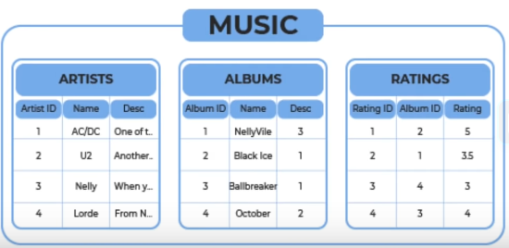

From Spreadsheets to Databases:

* **Spreadsheets**:
* One-time analysis
* Quickly need to chart something out
* Reasonable data set size
* Ability for untrained people to work with data.
* **Databases**:
* Data Integrity
* Can handle massive amounts of data
* Quickly combine different datasets
* Easily maintain relationship between datasets
* Automate steps for re-use. Like creating a view in athena
* Can support data for websites and applications (so most websites and web applications or mobile applications are linked to some sort of database to store their data and retrieve their data)

Data Base Management System (DBMS):

To manage these databases, **Database Management System** **(DBMS)** are used.

Database management system is a **software** which is used to manage the database.

For example: MySQL, Oracle, etc are a very popular commercial DBMS which is used in different applications.

DBMS provides an interface to perform various operations like database creation, storing data in it, updating data, creating a table in the database and a lot more.

Using DBMS, we can overcome many problems such as – Data Redundancy, Data inconsistency, Easy access, more organized and understandable and so on.

Suppose we have a laptop and we want to perform some operation but in our laptop there is no operating system, so how can we give a command to perform operation.

Like operating system DBMS works for database.

* Whether adding new files.
* Inserting data
* Retrieving data
* Modifying data
* Removing data
* Removing files

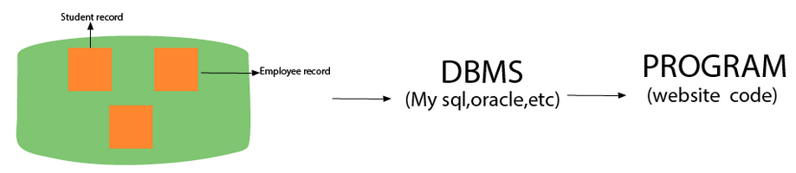

DBMS allows users the following tasks

* **Data Definition:** It is used for creation, modification, and removal of definition that defines the organization of data in the database.
* **Data Updating:** It is used for the insertion, modification, and deletion of the actual data in the database.
* **Data Retrieval:** It is used to retrieve the data from the database which can be used by applications for various purposes.
* **User Administration:** It isused for registering and monitoring users, maintain data integrity, enforcing data security, dealing with concurrency control, monitoring performance and recovering information corrupted by unexpected failure.

Advantages of DBMS

* **Controls database redundancy** (*Data redundancy occurs when the same piece of data exists in multiple places*) **:** It can control data redundancy because it stores all the data in one single database file and that recorded data is placed in the database.
* **Data sharing:** In DBMS, the authorized users of an organization can share the data among multiple users.
* **Easily Maintenance:** It can be easily maintainable due to the centralized nature of the database system.
* **Reduce time:** It reduces development time and maintenance need.
* **Backup:** It provides backup and recovery subsystems which create automatic backup of data from hardware and software failures and restores the data if required.
* **Multiple user interface:** It provides different types of user interfaces like graphical user interfaces, application program interfaces.

Disadvantages of DBMS

* **Cost of hardware and software:** It requires a high speed of data processor and large memory size to run DBMS software.
* **Size:** It occupies a large space of disks and large memory to run them efficiently.
* **Complexity:** Database system creates additional complexity and requirements.
* **Higher impact of failure:** Failure is highly impacted the database because in most of the organization, all the data stored in a single database and if the database is damaged due to electric failure or database corruption then the data may be lost forever.

Database platform Options:

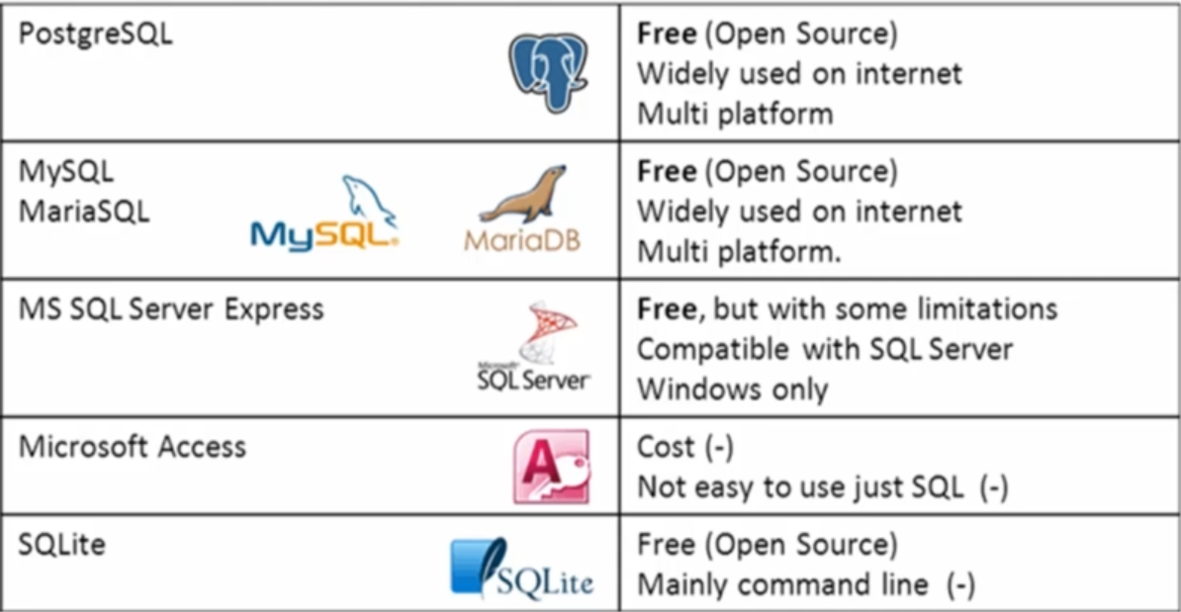

Types of Databases:

There are various types of databases used for storing different varieties of data:

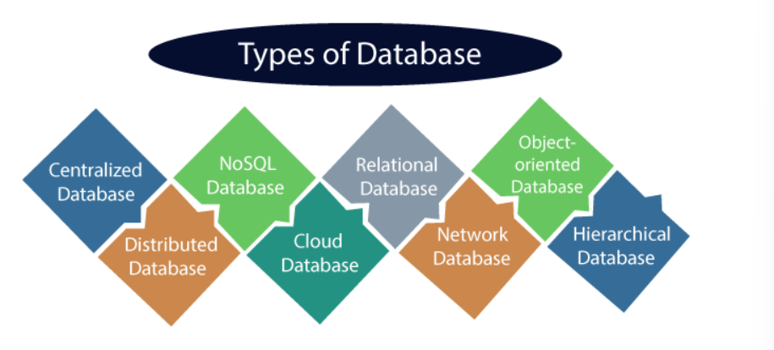

1. Centralized Database

It is the type of database that stores data at a centralized database system. It comforts the users to access the stored data from different locations through several applications. These applications contain the authentication process to let users access data securely. An example of a Centralized database can be Central Library that carries a central database of each library in a college/university.

**Advantages:**

* It has decreased the risk of data management, i.e, manipulation of data will not affect the core data.
* Data consistency is maintained as it manages data in a central repository.
* It provides better data quality, which enables organizations to establish data standards.
* It is less costly because fewer vendors are required to handle the data sets.

**Disadvantages:**

* The size of the centralized database is large, which increases the response time for fetching the data.
* It is not easy to update such an extensive database system.
* If any server failure occurs, entire data will be lost, which could be a huge loss.

1. Distributed Database

Unlike a centralized database system, in distributed systems, data is distributed among different database systems of an organization. These database systems are connected via communication links. Such links help the end-users to access the data easily. Examples of the Distributed database are Apache Cassandra, HBase, lgnite, etc.

We can further divide a distributed database system into:

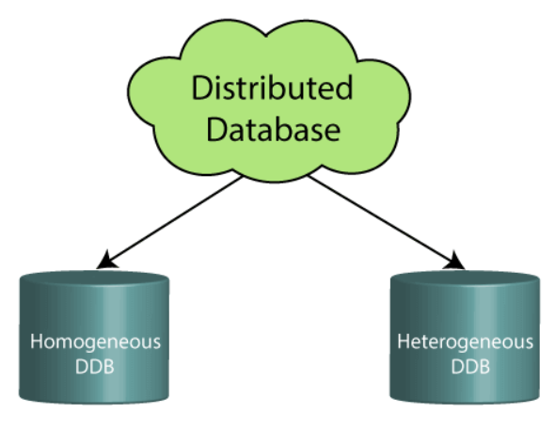

* **Homogeneous DDB:** Those database systems which execute on the same operating system and use the same application process and carry the same hardware devices.
* **Heterogeneous DDB:** Those database systems which execute on different operating systems under different application procedures, and carries different hardware devices.

**Advantages of Distributed Database:**

* One server failure will not affect the entire data set.

1. Relational

This database is based on the relational data model, which stores data in the form of rows(tuple) and columns(attributes), and together forms a table (relation). A relational database uses SQL for storing, manipulating, as well as maintaining the data. E.F. Codd invented the database in 1970. Each table in the database carries a key that makes the data unique from others.

**Examples**: Relational databases are MySQL, Microsoft SQL Server, Oracle, etc.

**Properties of Relational Database:**

There are following four commonly known properties of a relational model known as ACID properties, where:

**A means Atomicity:** This ensures the data operation will complete either with success or with failure. It follows the 'all or nothing' strategy. For example, a transaction will either be committed or will abort.

**C means Consistency:** If we perform any operation over the data, its value before and after the operation should be preserved. For example, the account balance before and after the transaction should be correct. i.e., it should remain conserved.

**I means Isolation:** There can be concurrent users for accessing data at the same time from the database. Thus, isolation between the data should remain isolated. For example, when multiple transactions occur at the same time, one transaction effects should not be visible to the other transactions in the database.

**D means Durability:** It ensures that once it completes the operation and commits the data, data changes should remain permanent.

1. NoSQL Database

Non-SQL/Not Only SQL is a type of database that is used for storing a wide range of data sets. It is not a relational database as it stores data not only in tabular form but in several different ways. It came into existence when the demand for building modern applications increased. Thus, NoSQL presented a wide variety of database technologies in response to the demands. We can further divide a NoSQL database into the following four types:

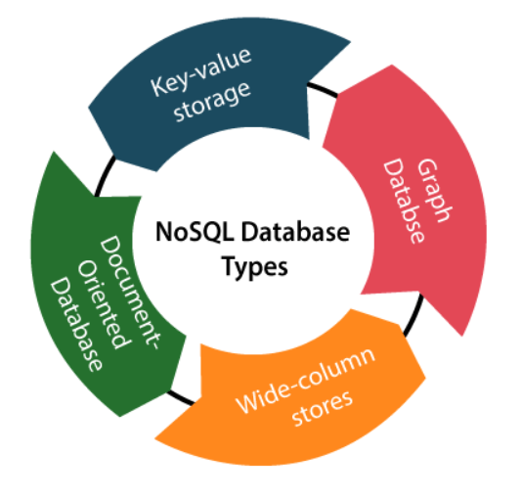

* 1. **Key-value storage:** It is the simplest type of database storage where it stores every single item as a key (or attribute name) holding its value, together.
  2. **Document-oriented Database:** A type of database used to store data as JSON-like document. It helps developers in storing data by using the same document-model format as used in the application code.
  3. **Graph Databases:** It is used for storing vast amounts of data in a graph-like structure. Most commonly, social networking websites use the graph database.
  4. **Wide-column stores:** It is similar to the data represented in relational databases. Here, data is stored in large columns together, instead of storing in rows.

1. Cloud Database

A type of database where data is stored in a virtual environment and executes over the cloud computing platform. It provides users with various cloud computing services (SaaS, PaaS, IaaS, etc.) for accessing the database. There are numerous cloud platforms, but the best options are:

* Amazon Web Services(AWS)
* Microsoft Azure
* Google Cloud SQL, etc.
* Kamatera
* PhonixNAP
* ScienceSoft

1. Object-oriented Databases

The type of database that uses the object-based data model approach for storing data in the database system. The data is represented and stored as objects which are similar to the objects used in the object-oriented programming language.

1. Hierarchical Databases

It is the type of database that stores data in the form of parent-children relationship nodes. Here, it organizes data in a tree-like structure.

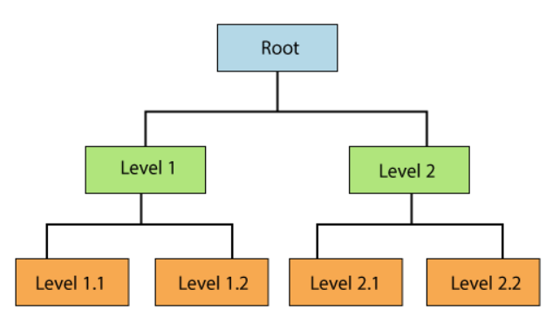

Data get stored in the form of records that are connected via links. Each child record in the tree will contain only one parent. On the other hand, each parent record can have multiple child records.

1. Network Databases

It is the database that typically follows the network data model. Here, the representation of data is in the form of nodes connected via links between them. Unlike the hierarchical database, it allows each record to have multiple children and parent nodes to form a generalized graph structure.

1. Personal Database

Collecting and storing data on the user's system defines a Personal Database. This database is basically designed for a single user.

**Example**: Microsoft Access

**Advantage of Personal Database**

* It is simple and easy to handle.
* It occupies less storage space as it is small in size.

1. Operational Database

The type of database which creates and updates the database in real-time. It is basically designed for executing and handling the daily data operations in several businesses. For example, An organization uses operational databases for managing per day transactions.

1. Enterprise Database

Large organizations or enterprises use this database for managing a massive amount of data. It helps organizations to increase and improve their efficiency. Such a database allows simultaneous access to users.

**Advantages of Enterprise Database:**

* Multi processes are supportable over the Enterprise database.
* It allows executing parallel queries on the system.

What is RDBMS

**RDBMS** stands for **R**elational **D**ata**B**ase **M**anagement **S**ystems.

All modern database management system like SQL, MS SQL Server, IBM DB2, ORACLE, My-SQL and Microsoft Access are based on RDBMS.

It is called Relational Database Management System (RDBMS) because it is based on relational model introduced by E.F.Codd.

A **relational database management system** or **RDBMS** is a database system that stores and fetches data in the form of tables. Thus the data is stored in the form of rows and columns. DBMS such as **My-SQL** and **ORACLE** are based on the principle of relational DBMS.

In RDBMS, data is stored in tabular format. Data is represented in terms of tuples (rows) in RDBMS.

For example,

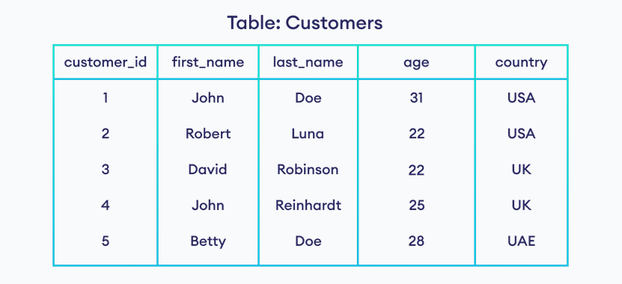

Here, *Customers* is a table inside the database.

Relational database is most commonly used database. It contains number of tables and each table has its own primary key.

Due to a collection of organized set of tables, data can be accessed easily in RDBMS.

What is Table

The RDBMS database uses tables to store data. A table is a collection of related data entries and contains rows and columns to store data.

A table is the simplest example of data storage in RDBMS.

Let's see the example of student table.

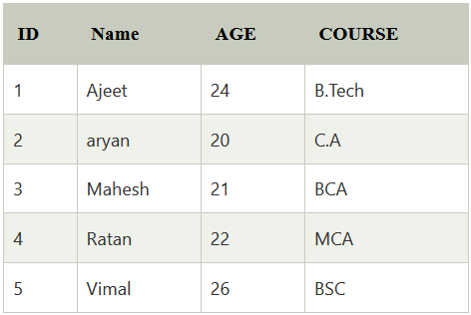

## What is field

Every table is broken up into smaller entities called **fields**. Field is a smaller entity of the table which contains specific information about every record in the table. In the above example, the field in the student table consist of id, name, age, course.

A field is a column in a table that is designed to maintain specific information about every record in the table.

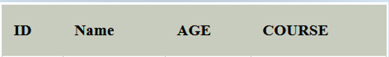

## What is row or record

A row of a table is also called record. It contains the specific information of each individual entry in the table. It is a horizontal entity in the table. For example: The above table contains 5 records.

Let's see one record/row in the table.



## What is column

A column is a vertical entity in the table which contains all information associated with a specific field in a table. For example: "name" is a column in the above table which contains all information about student's name.

## How Does a Relational Database Work?

**Relational Databases** use tables to store data about related objects. Each column contains data attributes, whereas each row holds a record of unique data known as **Key**.

**Relational Databases** or **RDBMS** are managed using **SQL** short form for **Structured Query Language**. Therefore, **SQL** codes are used to retrieve information from relational databases by doing various interactive operations like [JOIN](https://www.scaler.com/topics/sql/joins-in-sql/), TRUNCATE, etc.

## How a Relational Database Model is Structured?

A **relational database model** represents how data is stored in tables, which helps form relations between data values.

Consider a relational table named **EMPLOYEE** with attributes **EMP_ID**, **NAME**, **ADDRESS**, **AGE**.

**EMPLOYEE TABLE:**

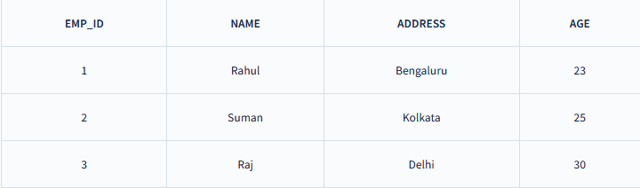

Well, there are some important **terminologies** that you should keep in mind while forming a **relational database**.

* **Attribute***:* Attributes are properties that define the relational database. Eg: EMP_ID, NAME etc.
* **Relation Schema**:A relational schema defines its relation with other attributes altogether. E.g., EMPLOYEE (EMP_ID, NAME, ADDRESS, AGE).
* **Degree***:* Degree is defined by several attributes we have in a relational table. E.g., The degree of the EMPLOYEE table is 4
* **Cardinality**:Cardinality is defined by the number of tuples in a relation. E.g., The cardinality of the EMPLOYEE table is 3.
* **NULL Values***:* The values or data which are unknown are kept as NULL.

## Benefits of Relational Databases

The following are some of the benefits of using relational databases.

* **Security**: In a RDBMS, some tables might need to be **confidential** according to the use case. For example, tables with **username** and **password** should be **authorized** to only the user who has **access**. Therefore, relational databases provide this functionality to restrict access to some tables to specific users.
* **Speed**: The speed is higher due to its **simplicity** and **ease**. Users can do various **optimization** on tables which further increases the speed of the database.
* **Simplicity**: A **relational database model** is much simpler as compared to other **network models**. It is free from complex structuring and query processing. Due to this, it doesn't require **complex queries** to perform certain tasks. A simple **SQL** query can handle all the requests on a relational database.
* **Accuracy**: **Relational databases** use foreign and primary keys to make tables interrelated. This feature ensures that **no duplicate data** exists in the databases, making it more accurate.
* **Accessibility**: Relational databases do not require any specific path to access data. Modifying data in the table is also easy. It can be done by changing a column or row based on the current requirement.
* **Multi-User**: Relational databases can be accessed by multiple users simultaneously. Even if there are data changes, the users can access them without facing any crashes in the database.

## Drawbacks of Relational Databases

The following are some of the drawbacks of using relational databases.

* **Performance**: The performance of a relational database depends on the number of tables present. If the number of tables is high, the **response time** for each query will be **slower**. Moreover, the presence of **huge amounts of data** makes it challenging to find any particular information.
* **Cost**: Using a relational database for enterprise use might be costly as we need to purchase specific software, along with a professional technician who will maintain the system.
* **Complexity**: A relational database can be **complex** sometimes when the amount of data increases.
* **Physical Storage**: A huge amount of physical storage is required for relational databases. Maximum storage can be attained through proper optimization of the database.

## Conclusion:

* **Relation databases** are data stored in the form of tables, and the relation between tables are maintained with the help of **primary** and **foreign keys**.
* The most popular relational databases that are used are:
  1. MySQL
  2. PostgreSQL
  3. DB2
* Relational databases help in maintaining **security** and provide **high-speed** in doing database transactions. The design of the databases has **simplicity** and **high accuracy**. It also helps in providing **accessibility** to **multiple users**.
* Though relational databases provide many advantages over other database systems. It still requires huge **physical storage** due to which the **cost** of maintaining a relational database is high. Also, maintaining a huge amount of data can increase the **complexity** of database tables.

Difference between DBMS and RDBMS

Although DBMS and RDBMS both are used to store information in physical database but there are some remarkable differences between them.

The main differences between DBMS and RDBMS are given below:

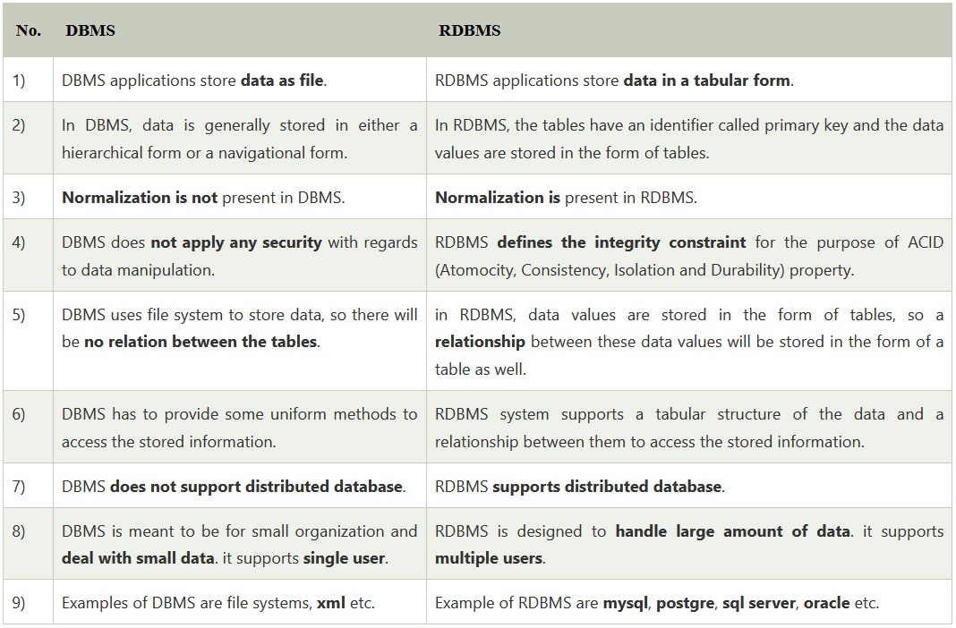

After observing the differences between DBMS and RDBMS, you can say that RDBMS is an extension of DBMS. There are many software products in the market today who are compatible for both DBMS and RDBMS. Means today a RDBMS application is DBMS application and vice-versa.

DBMS Architecture

* The DBMS design depends upon its architecture. It helps to design, develop, implement, and maintain the database management system. A DBMS architecture allows dividing the database system into individual components that can be independently modified, changed, replaced, and altered. It also helps to understand the components of a database.
* The basic client/server architecture is used to deal with a large number of PCs, web servers, database servers and other components that are connected with networks.
* The client/server architecture consists of many PCs and a workstation which are connected via the network.
* DBMS architecture depends upon how users are connected to the database to get their request done.
* A [Database](https://www.guru99.com/introduction-to-database-sql.html) stores critical information and helps access data quickly and securely. Therefore, selecting the correct Architecture of DBMS helps in easy and efficient data management.

## Types of DBMS Architecture:

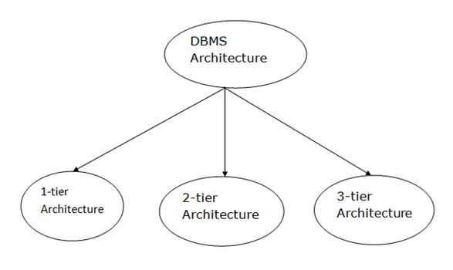

Database architecture can be seen as a single tier or multi-tier. But logically, database architecture is of two types like: **2-tier architecture** and **3-tier architecture.**

### 1-Tier Architecture

* In this architecture, the database is directly available to the user. It means the user can directly sit on the DBMS and uses it.
* Any changes done here will directly be done on the database itself. It doesn't provide a handy tool for end users.
* The 1-Tier architecture is used for development of the local application, where programmers can directly communicate with the database for the quick response.
* A simple one tier architecture example would be anytime you install a Database in your system and access it to practice SQL queries. But such architecture is rarely used in production. MP3 player, MS Office come under the one-tier application.



## 2-Tier Architecture

* A **2-Tier Architecture** in DBMS is a Database architecture where the presentation layer runs on a client (PC, Mobile, Tablet, etc.), and data is stored on a server called the second tier. Two tier architecture provides added security to the DBMS as it is not exposed to the end-user directly. It also provides direct and faster communication.
* The user interfaces and application programs are run on the client-side.
* The server side is responsible to provide the functionalities like: query processing and transaction management.
* To communicate with the DBMS, client-side application establishes a connection with the server side.

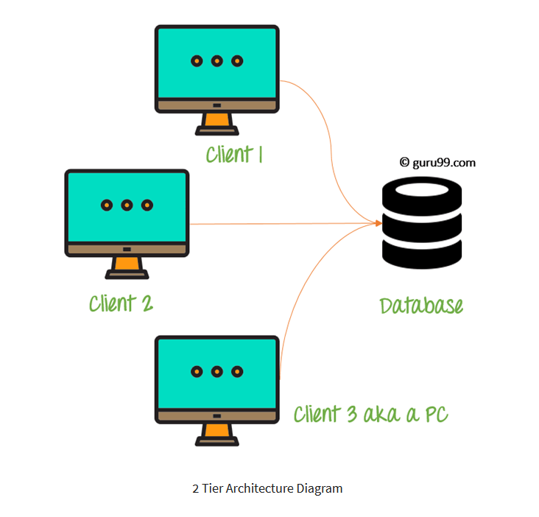

In the above 2 Tier client-server architecture of database management system, we can see that one server is connected with clients 1, 2, and 3.

3-Tier Architecture

* The 3-Tier architecture contains another layer between the client and server. In this architecture, client can't directly communicate with the server.
* Three Tier architecture contains a presentation layer, an application layer, and a database server. A “tier” in this case can also be referred to as a “layer”.
* 3-Tier database Architecture design is an extension of the 2-tier client-server architecture. A 3-tier architecture has the following layers:

1. Presentation layer (your PC, Tablet, Mobile, etc.)
2. Application layer (server)
3. Database Server

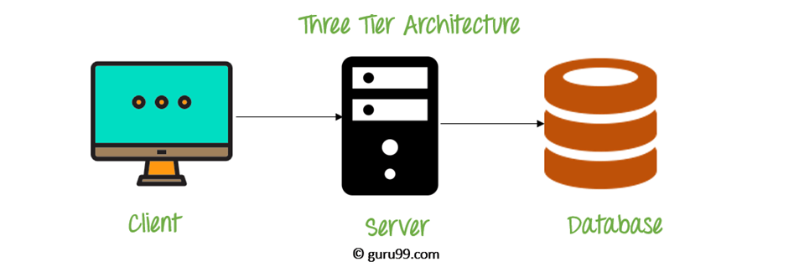

**The goal of Three Tier client-server architecture is:**

* To separate the user applications and physical database
* To support DBMS characteristics
* Program-data independence
* Supporting multiple views of the data

**Three Tier Architecture Example:**

Any large website on the internet

Data Models in DBMS

A Database model defines the logical design and structure of a database and defines how data will be stored, accessed and updated in a database management system.

While the **Relational Model** is the most widely used database model, there are other models too:

* Hierarchical Model
* Network Model
* [Entity-relationship Model](https://www.studytonight.com/dbms/er-model-concepts.php)
* [Relational Model](https://www.studytonight.com/dbms/rdbms-concept.php)

## Hierarchical Model

This database model organises data into a tree-like-structure, with a single root, to which all the other data is linked. The heirarchy starts from the **Root** data, and expands like a tree, adding child nodes to the parent nodes.

In this model, a child node will only have a single parent node.

This model efficiently describes many real-world relationships like index of a book, recipes etc.

In hierarchical model, data is organised into tree-like structure with one one-to-many relationship between two different types of data, for example, one department can have many courses, many professors and of course many students.

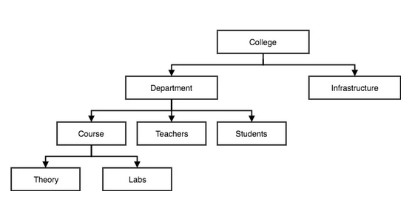

## Network Model

This is an extension of the Hierarchical model. In this model data is organised more like a graph, and are allowed to have more than one parent node.

In this database model data is more related as more relationships are established in this database model. Also, as the data is more related, hence accessing the data is also easier and fast. This database model was used to map many-to-many data relationships.

This was the most widely used database model, before Relational Model was introduced.

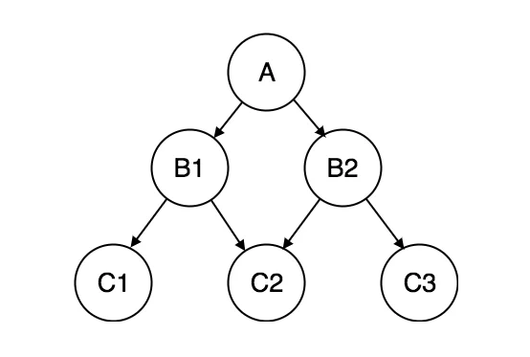

## Entity-relationship Model

In this database model, relationships are created by dividing object of interest into entity and its characteristics into attributes.

Different entities are related using relationships.

E-R Models are defined to represent the relationships into pictorial form to make it easier for different stakeholders to understand.

This model is good to design a database, which can then be turned into tables in relational model (explained below).

Let's take an example, If we have to design a School Database, then Student will be an entity with attributes name, age, address etc. As Address is generally complex, it can be another entity with attributes street name, pincode, city etc, and there will be a relationship between them.

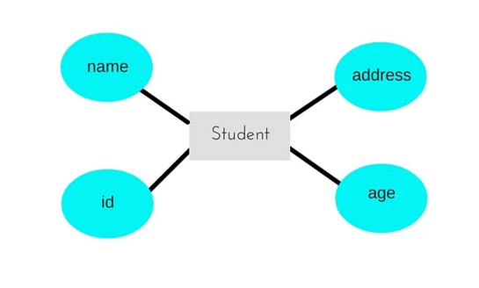

## Relational Model

In this model, data is organised in **two-dimensional tables** and the relationship is maintained by storing a common field.

This model was introduced by E.F Codd in 1970, and since then it has been the most widely used database model. Infact, we can say the only database model used around the world.

The basic structure of data in the relational model is tables. All the information related to a particular type is stored in rows of that table.

Hence, tables are also known as relations in relational model.

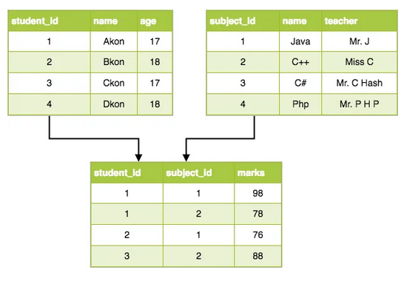

# Data model Schema and Instance

* The data which is stored in the database at a particular moment of time is called an instance of the database.
* The overall design of a database is called schema.
* A database schema is the skeleton structure of the database. It represents the logical view of the entire database.
* A schema contains schema objects like table, foreign key, primary key, views, columns, data types, stored procedure, etc.
* A database schema can be represented by using the visual diagram. That diagram shows the database objects and relationship with each other.
* A database schema is designed by the database designers to help programmers whose software will interact with the database. The process of database creation is called data modelling.

A schema diagram can display only some aspects of a schema like the name of record type, data type, and constraints. Other aspects can't be specified through the schema diagram. For example, the given figure neither show the data type of each data item nor the relationship among various files.

In the database, actual data changes quite frequently. For example, in the given figure, the database changes whenever we add a new grade or add a student. The data at a particular moment of time is called the instance of the database.

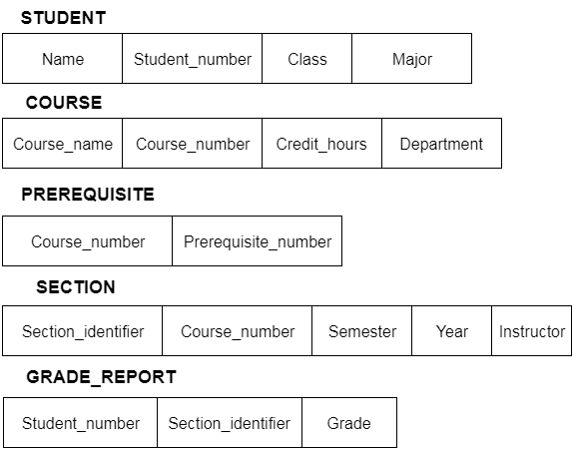

Database Language

* A DBMS has appropriate languages and interfaces to express database queries and updates.
* Database languages can be used to read, store and update the data in the database.

## Types of Database Language

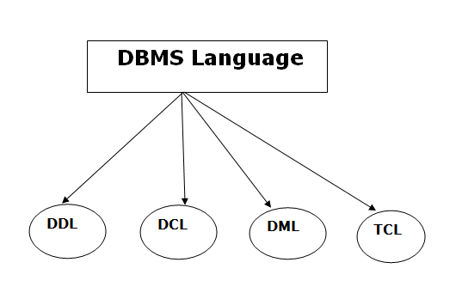

1. Data Definition Language

* **DDL** stands for **D**ata **D**efinition **L**anguage. It is used to define database structure or pattern.
* It is used to create schema, tables, indexes, constraints, etc. in the database.
* Using the DDL statements, you can create the skeleton of the database.
* Data definition language is used to store the information of metadata like the number of tables and schemas, their names, indexes, columns in each table, constraints, etc.

Here are some tasks that come under DDL:

* **Create:** It is used to create objects in the database.
* **Alter:** It is used to alter the structure of the database.
* **Drop:** It is used to delete objects from the database.
* **Truncate:** It is used to remove all records from a table.
* **Rename:** It is used to rename an object.
* **Comment:** It is used to comment on the data dictionary.

These commands are used to update the database schema that's why they come under Data definition language.

2. Data Manipulation Language

**DML** stands for **D**ata **M**anipulation **L**anguage. It is used for accessing and manipulating data in a database. It handles user requests.

Here are some tasks that come under DML:

* **Select:** It is used to retrieve data from a database.
* **Insert:** It is used to insert data into a table.
* **Update:** It is used to update existing data within a table.
* **Delete:** It is used to delete all records from a table.
* **Merge:** It performs UPSERT operation, i.e., insert or update operations.
* **Call:** It is used to call a structured query language or a Java subprogram.
* **Explain Plan:** It has the parameter of explaining data.
* **Lock Table:** It controls concurrency.

3. Data Control Language

* **DCL** stands for **D**ata **C**ontrol **L**anguage. It is used to retrieve the stored or saved data.
* The DCL execution is transactional. It also has rollback parameters. (But in Oracle database, the execution of data control language does not have the feature of rolling back.)

Here are some tasks that come under DCL:

* **Grant:** It is used to give user access privileges to a database.
* **Revoke:** It is used to take back permissions from the user.

There are the following operations which have the authorization of Revoke:

**CONNECT, INSERT, USAGE, EXECUTE, DELETE, UPDATE** and **SELECT.**

4. Transaction Control Language

**TCL** is used to run the changes made by the DML statement. TCL can be grouped into a logical transaction.

Here are some tasks that come under TCL:

* **Commit:** It is used to save the transaction on the database.
* **Rollback:** It is used to restore the database to original since the last Commit.

ACID Properties in DBMS

DBMS is the management of data that should remain integrated when any changes are done in it. It is because if the integrity of the data is affected, whole data will get disturbed and corrupted. Therefore, to maintain the integrity of the data, there are four properties described in the database management system, which are known as the **ACID** properties. The ACID properties are meant for the transaction that goes through a different group of tasks, and there we come to see the role of the ACID properties.

In this section, we will learn and understand about the ACID properties. We will learn what these properties stand for and what does each property is used for. We will also understand the ACID properties with the help of some examples.

ACID Properties:

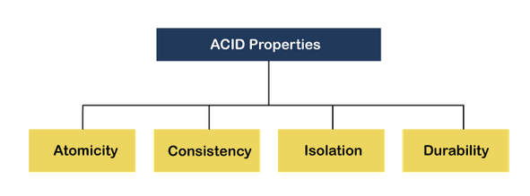

**1) Atomicity:**

The term atomicity defines that the data remains atomic. It means if any operation is performed on the data, either it should be performed or executed completely or should not be executed at all. It further means that the operation should not break in between or execute partially. In the case of executing operations on the transaction, the operation should be completely executed and not partially.

**Example:** If Remo has account A having $30 in his account from which he wishes to send $10 to Sheero's account, which is B. In account B, a sum of $ 100 is already present. When $10 will be transferred to account B, the sum will become $110. Now, there will be two operations that will take place. One is the amount of $10 that Remo wants to transfer will be debited from his account A, and the same amount will get credited to account B, i.e., into Sheero's account. Now, what happens - the first operation of debit executes successfully, but the credit operation, however, fails. Thus, in Remo's account A, the value becomes $20, and to that of Sheero's account, it remains $100 as it was previously present.

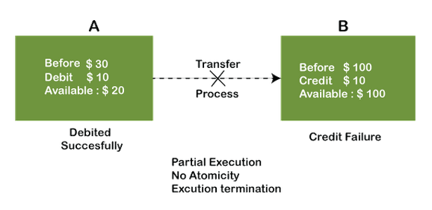

In the above diagram, it can be seen that after crediting $10, the amount is still $100 in account B. So, it is not an atomic transaction.

The below image shows that both debit and credit operations are done successfully. Thus, the transaction is atomic.

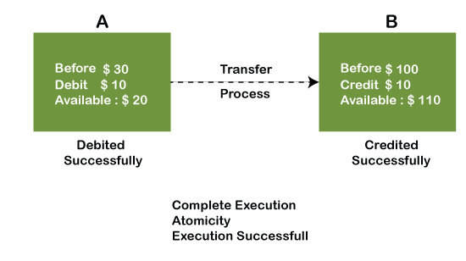

Thus, when the amount loses atomicity, then in the bank systems, this becomes a huge issue, and so the **atomicity is the main focus in the bank systems**.

**2) Consistency:**

The word **Consistency** means that the value should remain preserved always. In [DBMS the integrity of the data should be maintained, which means if a change in the database is made, it should remain preserved always. In the case of transactions, the integrity of the data is very essential so that the database remains consistent before and after the transaction. The data should always be correct.](https://www.javatpoint.com/dbms-tutorial)

**Example:**

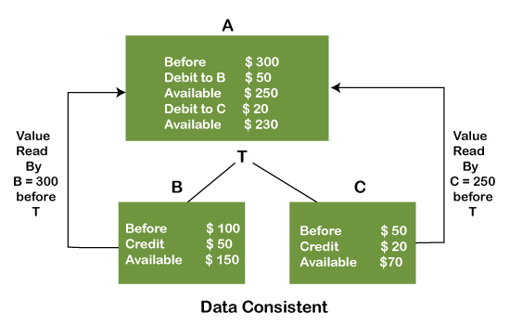

In the above figure, there are three accounts, A, B, and C, where A is making a transaction T one by one to both B & C. There are two operations that take place, i.e., Debit and Credit. Account A firstly debits $50 to account B, and the amount in account A is read $300 by B before the transaction. After the successful transaction T, the available amount in B becomes $150. Now, A debits $20 to account C, and that time, the value read by C is $250 (that is correct as a debit of $50 has been successfully done to B). The debit and credit operation from account A to C has been done successfully. We can see that the transaction is done successfully, and the value is also read correctly. Thus, the data is consistent. In case the value read by B and C is $300, which means that data is inconsistent because when the debit operation executes, it will not be consistent.

**3) Isolation:**

The term 'isolation' means separation. In DBMS, Isolation is the property of a database where no data should affect the other one and may occur concurrently. In short, the operation on one database should begin when the operation on the first database gets complete. It means if two operations are being performed on two different databases, they may not affect the value of one another. In the case of transactions, when two or more transactions occur simultaneously, the consistency should remain maintained. Any changes that occur in any particular transaction will not be seen by other transactions until the change is not committed in the memory.

**Example:** If two operations are concurrently running on two different accounts, then the value of both accounts should not get affected. The value should remain persistent. As you can see in the below diagram, account A is making T1 and T2 transactions to account B and C, but both are executing independently without affecting each other. It is known as Isolation.

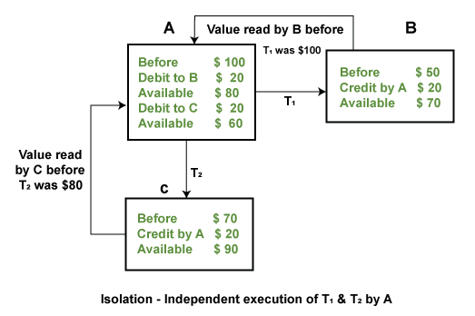

**4) Durability:**

Durability ensures the permanency of something. In DBMS, the term durability ensures that the data after the successful execution of the operation becomes permanent in the database. The durability of the data should be so perfect that even if the system fails or leads to a crash, the database still survives. However, if gets lost, it becomes the responsibility of the recovery manager for ensuring the durability of the database. For committing the values, the COMMIT command must be used every time we make changes.

Therefore, the ACID property of DBMS plays a vital role in maintaining the consistency and availability of data in the database.

Thus, it was a precise introduction of ACID properties in DBMS. We have discussed these properties in the transaction section also.

Relational data Model

Relational Model Concept

Relational model can represent as a table with columns and rows. Each row is known as a tuple. Each table of the column has a name or attribute.

**Domain:** It contains a set of atomic values that an attribute can take.

**Attribute:** It contains the name of a column in a particular table. Each attribute Ai must have a domain, dom(Ai)

**Relational Instance:** In the relational database system, the relational instance is represented by a finite set of tuples. Relation instances do not have duplicate tuples.

**Relational schema:** A relational schema contains the name of the relation and name of all columns or attributes.

**Relational key:** In the relational key, each row has one or more attributes. It can identify the row in the relation uniquely.

**Example: STUDENT Relation**

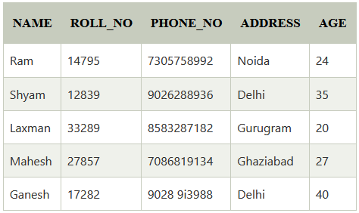

* In the given table, NAME, ROLL_NO, PHONE_NO, ADDRESS, and AGE are the attributes.
* The instance of schema STUDENT has 5 tuples.
* t3 = <Laxman, 33289, 8583287182, Gurugram, 20>

## **Properties of Relations**

* Name of the relation is distinct from all other relations.
* Each relation cell contains exactly one atomic (single) value
* Each attribute contains a distinct name
* Attribute domain has no significance
* tuple has no duplicate value
* Order of tuple can have a different sequence

Join Operations:

A Join operation combines related tuples from different relations, if and only if a given join condition is satisfied.

**Example:**

**Employee Table**

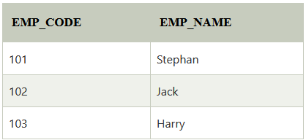

**Salary Table**

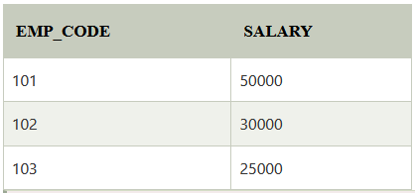

**Result Table**

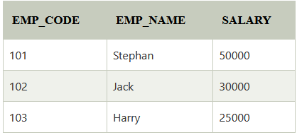

**Types of Join Operations:**

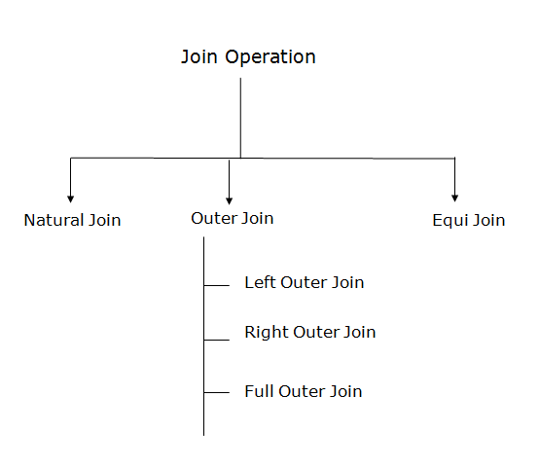

* 1. **Natural Join:**
* A natural join is the set of tuples of all combinations in R and S that are equal on their common attribute names.

**Example:** Let's use the above EMPLOYEE table and SALARY table:

**Output:**

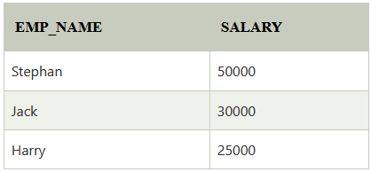

**2) Outer Join:**

* The outer join operation is an extension of the join operation. It is used to deal with missing information.

**Example:**

**Employee**

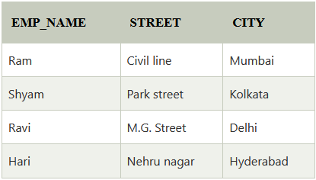

**Fact_Workers**

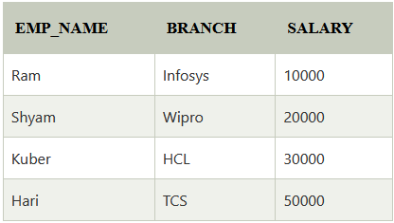

**Output**

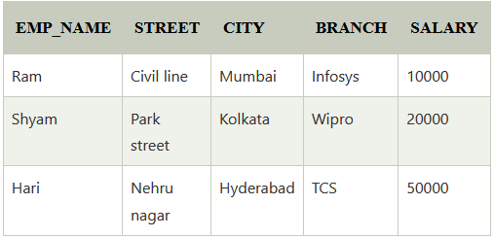

An outer join is basically of three types:

1. Left outer join
2. Right outer join
3. Full outer join

### A. Left outer join:

* Left outer join contains the set of tuples of all combinations in R and S that are equal on their common attribute names.
* In the left outer join, tuples in R have no matching tuples in S.

**Example:** Using the above EMPLOYEE table and FACT_WORKERS table

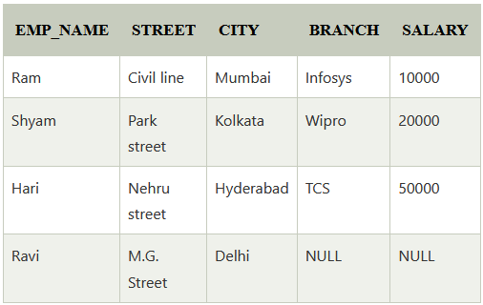

**B. Right outer join:**

* Right outer join contains the set of tuples of all combinations in R and S that are equal on their common attribute names.
* In right outer join, tuples in S have no matching tuples in R.

**Example:** Using the above EMPLOYEE table and FACT_WORKERS Relation

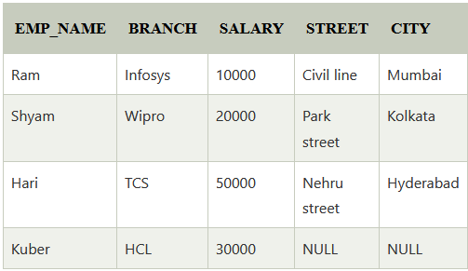

**C. Full outer join:**

* Full outer join is like a left or right join except that it contains all rows from both tables.
* In full outer join, tuples in R that have no matching tuples in S and tuples in S that have no matching tuples in R in their common attribute name.

**Example:** Using the above EMPLOYEE table and FACT_WORKERS table.

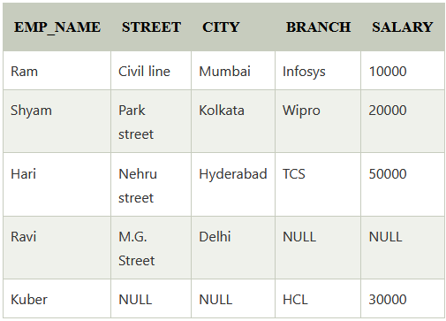

**3) Equi Join:**

It is also known as an inner join. It is the most common join. It is based on matched data as per the equality condition. The equi join uses the comparison operator (=).

**Example:**

**CUSTOMER RELATION**

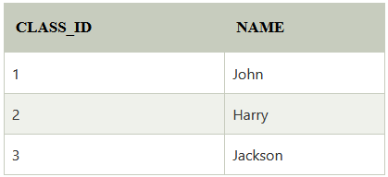

**PRODUCT**

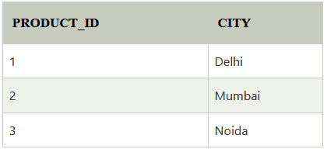

**OUTPUT**

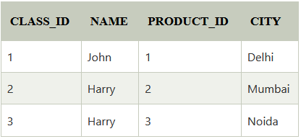

Integrity Constraints

* Integrity constraints are a set of rules. It is used to maintain the quality of information.
* Integrity constraints ensure that the data insertion, updating, and other processes have to be performed in such a way that data integrity is not affected.
* Thus, integrity constraint is used to guard against accidental damage to the database.

**Types of Integrity Constraint:**

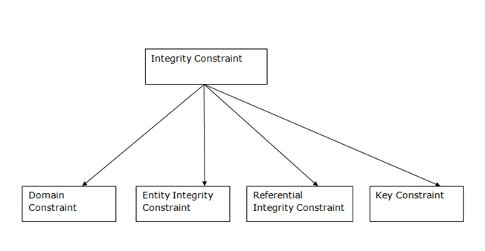

* 1. **Domain Constraints**
* Domain constraints can be defined as the definition of a valid set of values for an attribute.
* The data type of domain includes string, character, integer, time, date, currency, etc. The value of the attribute must be available in the corresponding domain.

**Example:**

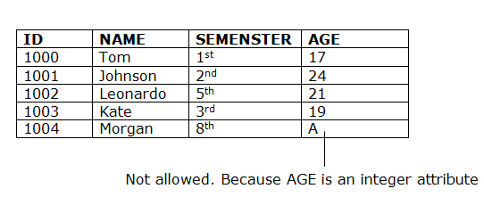

**2) Entity integrity Constraints**

* The entity integrity constraint states that primary key value can't be null.
* This is because the primary key value is used to identify individual rows in relation and if the primary key has a null value, then we can't identify those rows.
* A table can contain a null value other than the primary key field.

**Example:**

**EMPLOYEE**

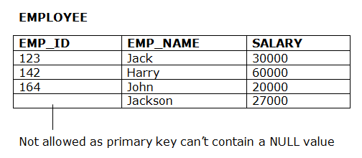

**3) Referential Integrity Constraints**

* A referential integrity constraint is specified between two tables.
* In the Referential integrity constraints, if a foreign key in Table 1 refers to the Primary Key of Table 2, then every value of the Foreign Key in Table 1 must be null or be available in Table 2.

**Example:**

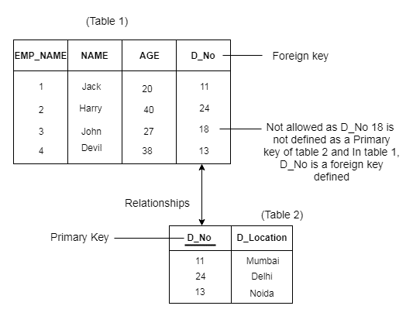

**4) Key Constraints**

* Keys are the entity set that is used to identify an entity within its entity set uniquely.
* An entity set can have multiple keys, but out of which one key will be the primary key. A primary key can contain a unique and null value in the relational table.

**Example:**

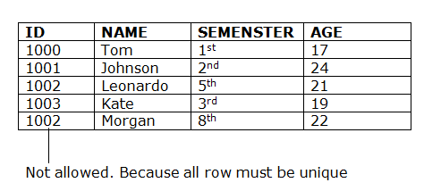

Normalization

DBMS Normalization

* Normalization is the process of organizing the data in the database.
* Normalization is used to minimize the redundancy from a relation or set of relations. It is also used to eliminate the undesirable characteristics like Insertion, Update and Deletion Anomalies.
* Normalization divides the larger table into the smaller table and links them using relationship.
* The normal form is used to reduce redundancy from the database table.

**Types of Normal Forms**

There are the four types of normal forms:

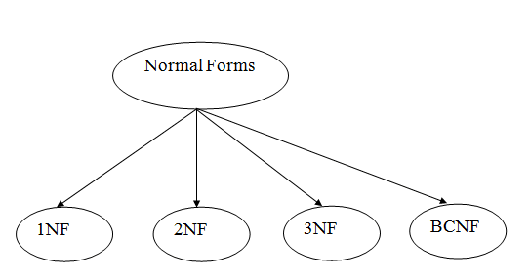

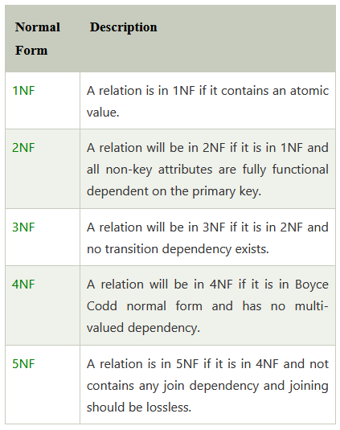

1. **First Normal Form:**

* A relation will be 1NF if it contains an atomic value.
* It states that an attribute of a table cannot hold multiple values. It must hold only single-valued attribute. Means per row must contain only one value in each column.
* First normal form disallows the multi-valued attribute, composite attribute, and their combinations.

**Example:** Relation EMPLOYEE is not in 1NF because of multi-valued attribute EMP_PHONE.

**EMPLOYEE Table:**

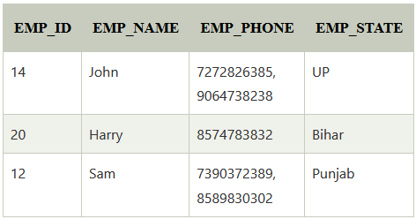

In the above table in column EMP_PHONE there is multiple values in one row that’s why it obey the 1NF.

Let’s convert the above table into 1NF forms:

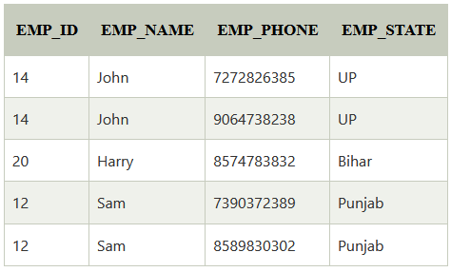

As you see we remove the extra phone numbers in EMP_PHONE column.

**2) Second Normal Form**

* In the 2NF, relational must be in 1NF.
* In the second normal form, all non-key attributes are fully functional dependent on the primary key.

**Example:** Let's assume, a school can store the data of teachers and the subjects they teach. In a school, a teacher can teach more than one subject.

**TEACHER Table**

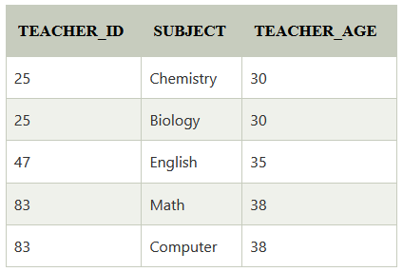

In the given table, non-prime attribute TEACHER_AGE is dependent on TEACHER_ID which is a proper subset of a candidate key. That's why it violates the rule for 2NF.

To convert the given table into 2NF, we decompose it into two tables:

**TEACHER_DETAIL table:**

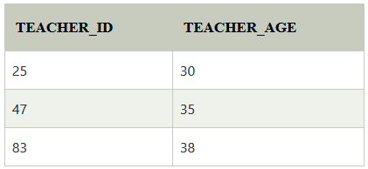

**TEACHER_SUBJECT table:**

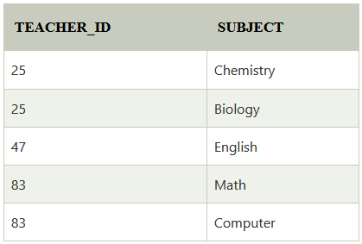

**3) Third Normal Form (3NF)**

* A relation will be in 3NF if it is in 2NF and not contain any transitive partial dependency.
* 3NF is used to reduce the data duplication. It is also used to achieve the data integrity.
* If there is no transitive dependency for non-prime attributes, then the relation must be in third normal form.

A relation is in third normal form if it holds atleast one of the following conditions for every non-trivial function dependency X → Y.

1. X is a super key.
2. Y is a prime attribute, i.e., each element of Y is part of some candidate key.

**Example:**

**EMPLOYEE_DETAIL table:**

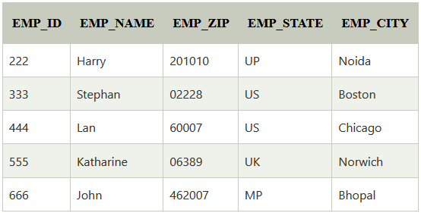

**Candidate key:** {EMP_ID}

**Non-prime attributes:** In the given table, all attributes except EMP_ID are non-prime.

Here, EMP_STATE & EMP_CITY dependent on EMP_ZIP and EMP_ZIP dependent on EMP_ID. The non-prime attributes (EMP_STATE, EMP_CITY) transitively dependent on super key(EMP_ID). It violates the rule of third normal form.

That's why we need to move the EMP_CITY and EMP_STATE to the new <EMPLOYEE_ZIP> table, with EMP_ZIP as a Primary key.

**EMPLOYEE table:**

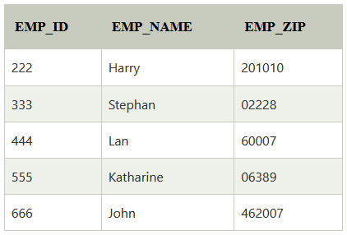

**EMPLOYEE_ZIP table:**

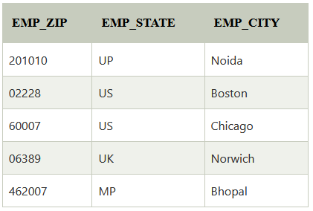

Transaction

Transactions in DBMS:

* Transactions are a set of operations used to perform a logical set of work. It contains a group of tasks.
* A transaction is an action or series of actions. It is performed by a single user to perform operations for accessing the contents of the database.
* All types of databases access operation which are held between the beginning and end transaction statements are considered as a single logical transaction in DBMS. During the transaction the database is inconsistent. Only once the database is committed the state is changed from one consistent state to another.
* One of the major uses of DBMS is to protect the user’s data from system failures. It is done by ensuring that all the data is restored to a consistent state when the computer is restarted after a crash. The transaction is any one execution of the user program in a DBMS. Executing the same program multiple times will generate multiple transactions.

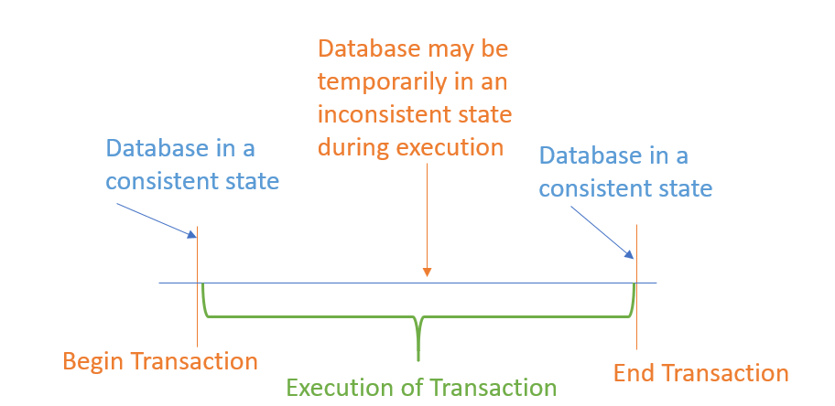

## Operations of Transaction:

Following are the main operations of transaction:

**Read(X):** Read operation is used to read the value of X from the database and stores it in a buffer in main memory.

**Write(X):** Write operation is used to write the value back to the database from the buffer.

Let's take an example to debit transaction from an account which consists of following operations:

Let's assume the value of X before starting of the transaction is 4000.

* The first operation reads X's value from database and stores it in a buffer.
* The second operation will decrease the value of X by 500. So buffer will contain 3500.
* The third operation will write the buffer's value to the database. So X's final value will be 3500.

But it may be possible that because of the failure of hardware, software or power, etc. that transaction may fail before finished all the operations in the set.

**For example:** If in the above transaction, the debit transaction fails after executing operation 2 then X's value will remain 4000 in the database which is not acceptable by the bank.

To solve this problem, we have two important operations:

**Commit:** It is used to save the work done permanently.

**Rollback:** It is used to undo the work done.

Transaction Property

The transaction has the four properties. These are used to maintain consistency in a database, before and after the transaction.

## Property of Transaction

1. **A**tomicity
2. **C**onsistency
3. **I**solation
4. **D**urability

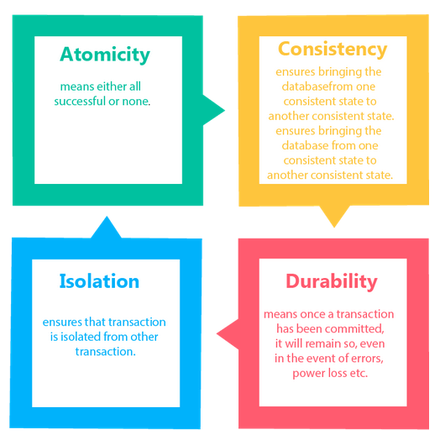

## Atomicity

* A transaction is a single unit of operation. You either it entirely or do not execute it at all. There cannot be partial execution.
* It states that all operations of the transaction take place at once if not, the transaction is aborted.
* There is no midway, i.e., the transaction cannot occur partially. Each transaction is treated as one unit and either run to completion or is not executed at all.

Atomicity involves the following two operations:

**Abort:** If a transaction aborts then all the changes made are not visible.

**Commit:** If a transaction commits then all the changes made are visible.

**Example:** Let's assume that following transaction T consisting of T1 and T2. A consists of Rs 600 and B consists of Rs 300. Transfer Rs 100 from account A to account B.

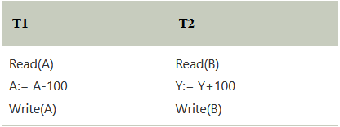

After completion of the transaction, A consists of Rs 500 and B consists of Rs 400.

If the transaction T fails after the completion of transaction T1 but before completion of transaction T2, then the amount will be deducted from A but not added to B. This shows the inconsistent database state. In order to ensure correctness of database state, the transaction must be executed in entirety.

## Consistency

* The integrity constraints are maintained so that the database is consistent before and after the transaction.
* The execution of a transaction will leave a database in either its prior stable state or a new stable state.
* The consistent property of database states that every transaction sees a consistent database instance.
* The transaction is used to transform the database from one consistent state to another consistent state.

**For example:** The total amount must be maintained before or after the transaction.

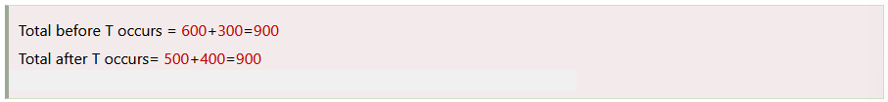

Therefore, the database is consistent. In the case when T1 is completed but T2 fails, then inconsistency will occur.

## Isolation

* It shows that the data which is used at the time of execution of a transaction cannot be used by the second transaction until the first one is completed.
* In isolation, if the transaction T1 is being executed and using the data item X, then that data item can't be accessed by any other transaction T2 until the transaction T1 ends.
* The concurrency control subsystem of the DBMS enforced the isolation property.

## Durability

* The durability property is used to indicate the performance of the database's consistent state. It states that the transaction made the permanent changes.
* They cannot be lost by the erroneous operation of a faulty transaction or by the system failure. When a transaction is completed, then the database reaches a state known as the consistent state. That consistent state cannot be lost, even in the event of a system's failure.
* The recovery subsystem of the DBMS has the responsibility of Durability property.

States of Transaction

In a database, the transaction can be in one of the following states –

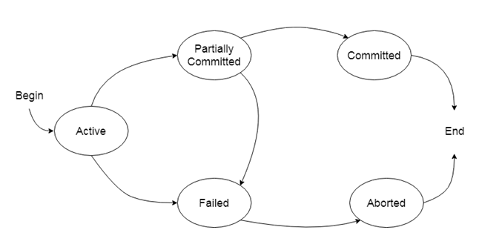

### Active state

* The active state is the first state of every transaction. In this state, the transaction is being executed.
* For example: Insertion or deletion or updating a record is done here. But all the records are still not saved to the database.

### Partially committed

* In the partially committed state, a transaction executes its final operation, but the data is still not saved to the database.
* In the total mark calculation example, a final display of the total marks step is executed in this state.

### Committed

* A transaction is said to be in a committed state if it executes all its operations successfully. In this state, all the effects are now permanently saved on the database system.

### Failed state

* If any of the checks made by the database recovery system fails, then the transaction is said to be in the failed state.
* In the example of total mark calculation, if the database is not able to fire a query to fetch the marks, then the transaction will fail to execute.

### Aborted

* If any of the checks fail and the transaction has reached a failed state then the database recovery system will make sure that the database is in its previous consistent state. If not then it will abort or roll back the transaction to bring the database into a consistent state.
* If the transaction fails in the middle of the transaction then before executing the transaction, all the executed transactions are rolled back to its consistent state.
* After aborting the transaction, the database recovery module will select one of the two operations:
  1. Re-start the transaction
  2. Kill the transaction

What is a Schedule?

A Schedule is a process creating a single group of the multiple parallel transactions and executing them one by one. It should preserve the order in which the instructions appear in each transaction. If two transactions are executed at the same time, the result of one transaction may affect the output of other.

In a nutshell, A series of operation from one transaction to another transaction is known as schedule

**Example**

*Initial Product Quantity is 10*

*Transaction 1: Update Product Quantity to 50*

*Transaction 2: Read Product Quantity*

If Transaction 2 is executed before Transaction 1, outdated information about the product quantity will be read. Hence, schedules are required.

Parallel execution in a database is inevitable. But, Parallel execution is permitted when there is an equivalence relation amongst the simultaneously executing transactions.

This equivalence is of 3 Types.

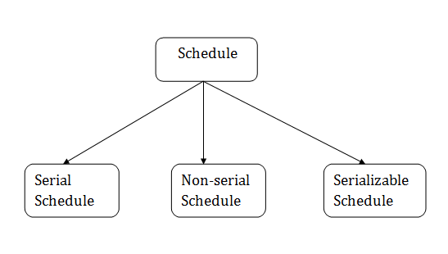

## 1. Serial Schedule

The serial schedule is a type of schedule where one transaction is executed completely before starting another transaction. In the serial schedule, when the first transaction completes its cycle, then the next transaction is executed.

**For example:** Suppose there are two transactions T1 and T2 which have some operations. If it has no interleaving of operations, then there are the following two possible outcomes:

1. Execute all the operations of T1 which was followed by all the operations of T2.
2. Execute all the operations of T2 which was followed by all the operations of T1.

* In the given (a) figure, Schedule A shows the serial schedule where T1 followed by T2.
* In the given (b) figure, Schedule B shows the serial schedule where T2 followed by T1.

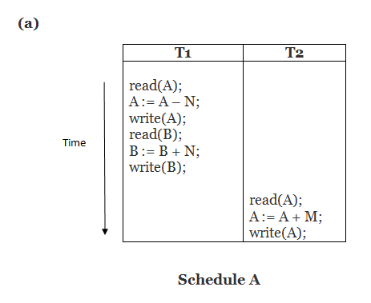

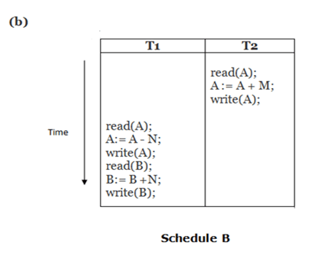

## 2. Non-serial Schedule

* If interleaving of operations is allowed, then there will be non-serial schedule.
* It contains many possible orders in which the system can execute the individual operations of the transactions.
* In the given figure (c) and (d), Schedule C and Schedule D are the non-serial schedules. It has interleaving of operations.

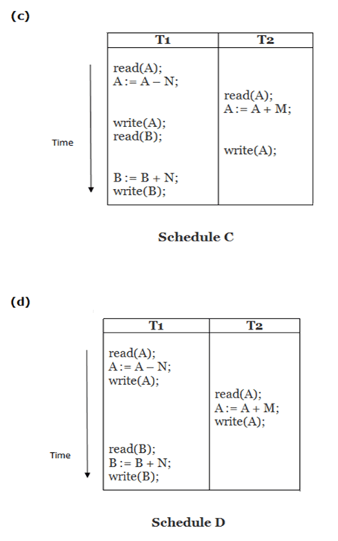

## 3. Serializable schedule

* The serializability of schedules is used to find non-serial schedules that allow the transaction to execute concurrently without interfering with one another.
* It identifies which schedules are correct when executions of the transaction have interleaving of their operations.
* A non-serial schedule will be serializable if its result is equal to the result of its transactions executed serially.

**Here,**

Schedule A and Schedule B are serial schedule.

Schedule C and Schedule D are Non-serial schedule.

### What is Serializability?

Serializability is the process of search for a concurrent schedule who output is equal to a serial schedule where transaction are execute one after the other. Depending on the type of schedules, there are two types of serializability:

* Conflict
* View

Structured Query Language

(SQL)

Suppose we have a database and if we want to work with database. We need database management system. But with data management system, we want to create, store, modify data, how can we do this? To talk with database we need to learn language that understand the database. If you want to work with database you need to learn SQL language. Most of the actions you need to perform on a database are done with SQL statement.

SQL language specifically designed for working with Database to…

* Create
* Manipulate
* Share/Access

Why to learn SQL:

SQL is Structured Query Language, which is a computer language for storing, manipulating and retrieving data stored in a relational database.

SQL is the standard language for Relational Database System. All the Relational Database Management System (RDMS) like MYSQL, MS Access, Oracle, Sybase, Informix, Postgres and SQL Server use SQL as their standard database language.

SQL is widely popular because if offers the following advantages:

* Allows users to communicate. i.e access and manipulate the database.
* Allows users to retrieve data from a database.
* Allows users to create, update, modify and delete the database.

SQL is a language for defining the structure of a database.

SQL is useful for a lot of things!

* MySQL
* PostGreSQL
* Oracle Databases
* Microsoft Access
* Amazon’s Redshift
* Looker
* MemSQL
* Periscope Data

What can SQL do?

* SQL can execute queries against a database
* SQL can retrieve data from a database
* SQL can insert records in a database
* SQL can delete records from a database
* SQL can create new databases
* SQL can create new tables in a database
* SQL can create views in a database
* SQL can set permissions on tables, procedures, and views

Applications of SQL

Data As mentioned before, SQL is one of the most widely used query language over the databases. I’m going to list few of them here:

* Allows users to access data in the relational database management systems.
* Allows users describe the data.
* Allows users to define the data in a database and manipulate that data.
* Allows to embed within other languages using SQL modules, libraries and pre-compilers.
* Allows users to create and drop databases and tables.
* Allows users to create view, stored procedure, functions in a database.
* Allows users to set permissions on tables, procedures and views.

SQL Terms:

* Data

Data is defined as facts or figures, or information that’s stored in or used by a computer.

* Entity

Something of interest to the database user community. Examples include customers, parts, geographic, location, etc

* Column

An individual piece of data stored in a table.

* Row

A set of columns that together completely describe an entity or some action on an entity. Also called a record.

* Table

A set of rows, held either in memory (nonpersistent) or on permanent storage(persistent).

* Result Set

Another name for a nonpersistent table, generally the result of an SQL query.

* Database

A database is organized collection of data/information so that it can be easily accessed, managed and updated.

Data science, business intelligence, or some other facet of data analysis, you will likely need to know SQL, along with other languages/platforms such as Python and R. Data is everywhere, in huge quantities, and arriving at a rapid pace, and people who can extract meaningful information from all this data are in big demand.

# SQL Query Execution Order:

SQL queries are used to access a set of records present in our database tables. SQL queries are made up of one or more clauses. A particular order must be followed to execute these clauses to obtain correct results. This order of execution is known as SQL query execution order.

SQL query execution order means optimizing our search results from the database or where the query clauses are evaluated according to the requirements.

Like how we plan something step by step and reach the final result, similarly, we use clauses in a particular order known as the SQL query execution order. Here is the table that shows the order in which the clauses are used.

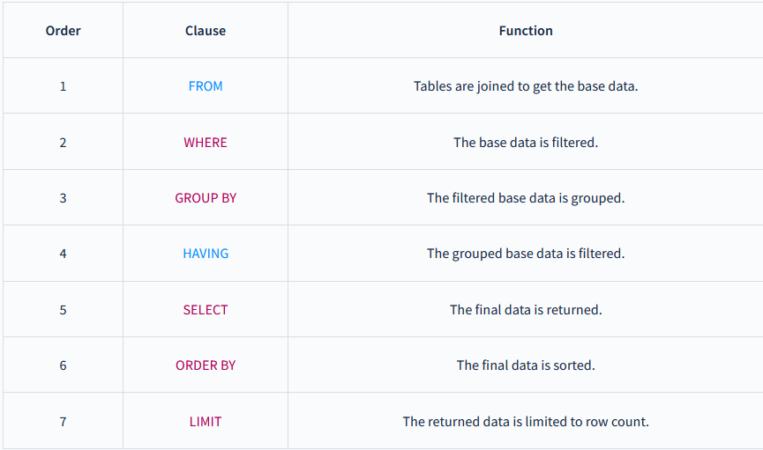

Part - 2

--------------------SQL Tutorial-------------------

SQL is followed by a unique set of rules and guidelines called Syntax. This tutorial gives you a quick start with SQL by listing all the basic SQL Syntax.

All the SQL statements start with any of the keywords like SELECT, INSERT, UPDATE, DELETE, ALTER, DROP, CREATE, USE, SHOW.

Keep in mind that…

SQ keywords are NOT case sensitive: select is the same as SELECT.

Semicolon after SQL Statements?

Some database systems require a semicolon at the end of each SQL statement.

Semicolon is the standard way to separate each SQL statement in database systems that allow more than one SQL statement to be executed in the same call to the server.

SQL From

The FROM clause in SQL is used to tell the compiler **from** which table(s) the data needs to be fetched when an [SQL query](https://www.scaler.com/topics/sql/sql-query-execution-order/) is made.

## Syntax

The syntax for a **single table** in FROM clause:

SELECT * FROM <table_name> WHERE <conditions>

The syntax for using **multiple tables** in FROM clause with JOIN conditions:

SELECT * FROM <table_name1>, <table_name2> WHERE <conditions_relating_the_two_tables>

SQL Select

The SELECT statement is used to select data from a database. It returns the data in the form of a result table. These result tables are called result-sets.

The data returned is stored in a result table, called the result-set.

SELECT Syntax

SELECT column1, column2, ...columnN  
FROM table_name;

Here, column1, column2,… are the field names of the table you want to select data from. If you want to select all the fields available in the table, use the following syntax:

SELECT * FROM table_name;

SQL Select Distinct

The SQL SELECT DISTINCT Statement

The SELECT DISTINCT statement is used to eliminate all the duplicate records and return only distinct (different) values.

Inside a table, a column often contains many duplicate values; and sometimes you only want to list the different (distinct) values.

SELECT DISTINCT Syntax

SELECT DISTINCT column1, column2, ...columnN  
FROM table_name;

DISTINCT with COUNT

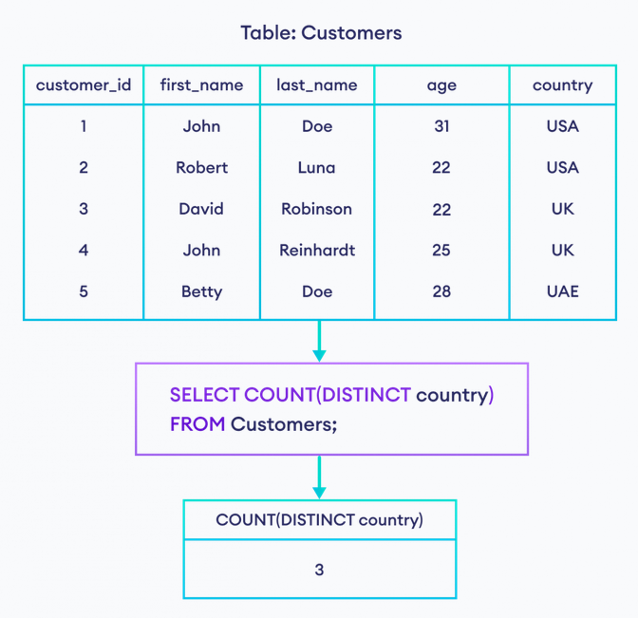

SQL Select as Alias

## SQL AS Alias

The **AS** keyword is used to give columns or tables a temporary name that can be used to identify that column or table later.

SELECT first_name AS name

FROM Customers;

Here, the SQL command selects the first_name of Customers. However, its column name will be name instead of first_name in the result set.

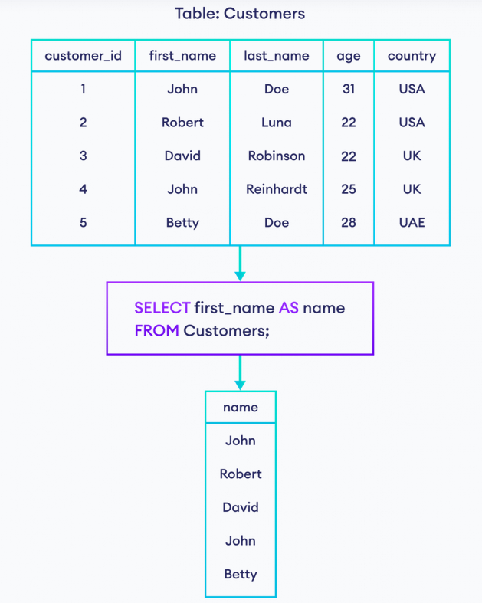

## SQL AS With More Than One Column

We can also use aliases with more than one column. For example,

SELECT customer_id AS cid, first_name AS name

FROM Customers;

Here, the SQL command selects customer_id as cid and first_name as name.

## SQL AS With Expression

We can combine data from multiple columns and represent data in a single column using the CONCAT() function. For example,



Here, the SQL command selects first_name and last_name. And, the name of the column will be full_name in the result set.

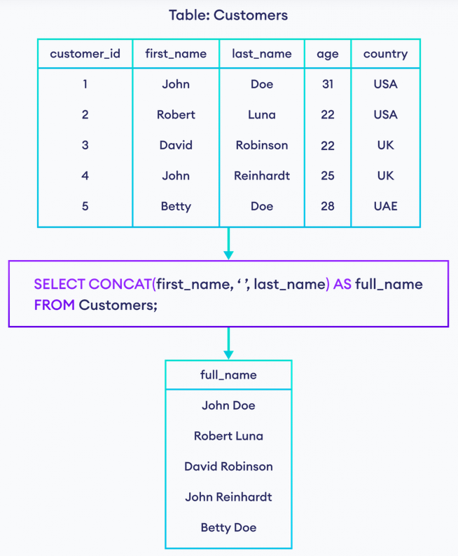

SQL AS With Functions

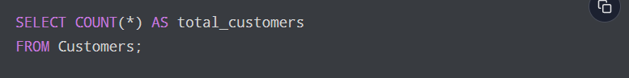

SQL AS With Table Name

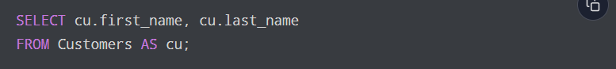

SQL AS With JOIN

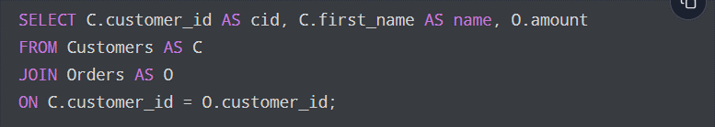

SQL Operators

What is an Operator in SQL?

An operator is a reserved word or a character used primarily in an SQL statement’s WHERE clause to perform operations, such as comparisons and arithmetic operations. These Operators are used to specify conditions in an SQL statement and to serve as conjunctions for multiple conditions in a statement.

* Arithmetic operators
* Comparison operators
* Logical operators
* Operators used to negate conditions

SQL Arithmetic Operators

Assume ‘variable a’ holds 10 and ‘variable b’ holds 20, then-

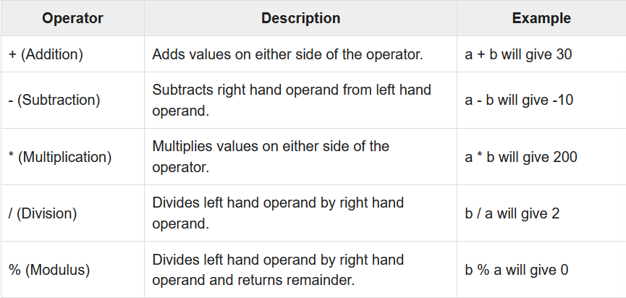

SQL Comparison Operators:

Assume variable ‘a’ holds 10 and variable ‘b’ holds 20, then-

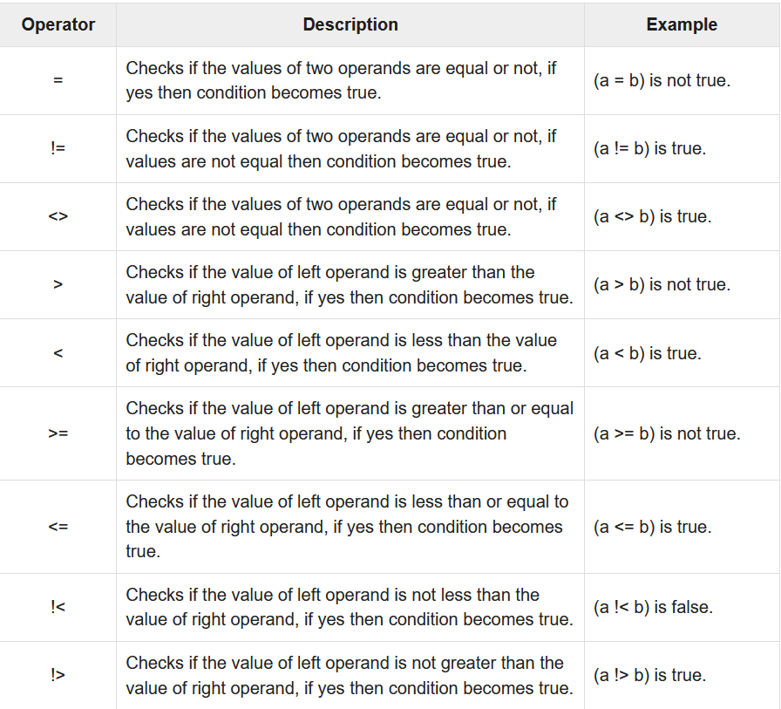

SQL Logical Operators

Here is a list of all the logical operators available in SQL

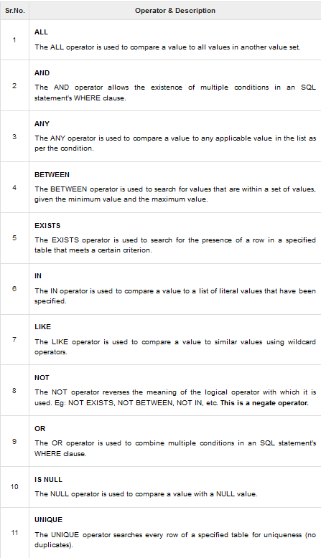

SQL Where Clause

The WHERE clause is used to filter records.

It is used to extract only those records that fulfill a specified condition.

WHERE Syntax

SELECT column1, column2, ...columnN  
FROM table_name  
WHERE condition;

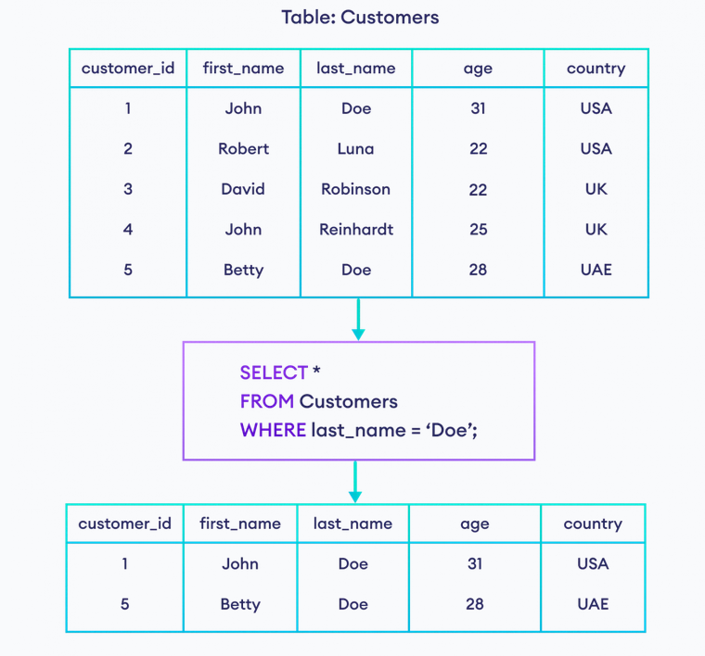

**NOTE:** The WHERE clause is not only used in SELECT statement, it is also used in UPDATE, DELETE, etc!

In SQL, we must enclose textual data inside either single or double quotations like ‘Doe’ in our example.

SQL And, Or and Not

The SQL AND, OR and NOT Operators

The WHERE clause can be combined with AND, OR and NOT operators.

The AND and OR operators are used to filter records. They are used to combine multiple conditions to narrow data in an SQL statement. These two operators are called as the conjunctive operators.

These operators provide a means to make multiple comparisons with different operators in the same SQL statement.

* The AND operator displays a record if all the conditions separated by AND are TRUE.
* The OR operator displays a record if any of the conditions separated by OR is TRUE.

The NOT operator displays a record if the condition’s is NOT TRUE.

**AND Syntax**

SELECT column1, column2, ...  
FROM table_name  
WHERE condition1 AND condition2 AND condition3 ...;

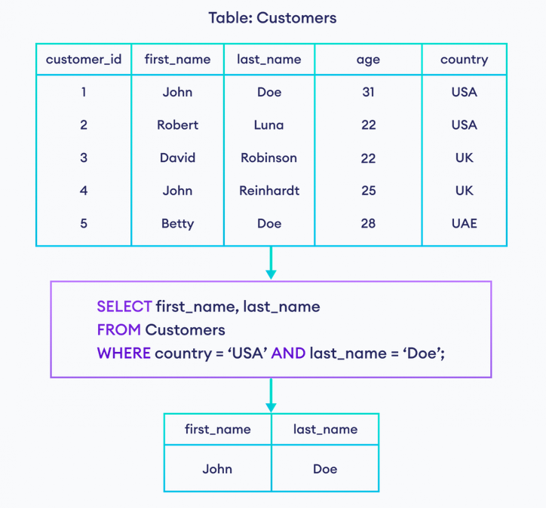

**OR Syntax**

SELECT column1, column2, ...  
FROM table_name  
WHERE condition1 OR condition2 OR condition3 ...;

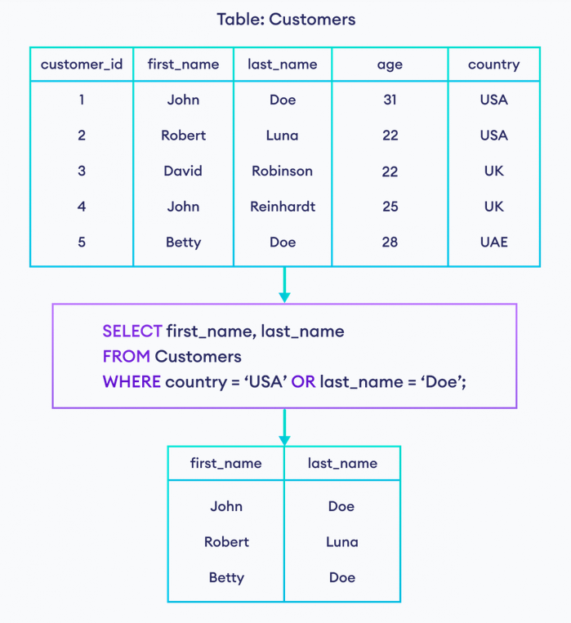

**NOT Syntax**

SELECT column1, column2, ...  
FROM table_name  
WHERE NOT condition;

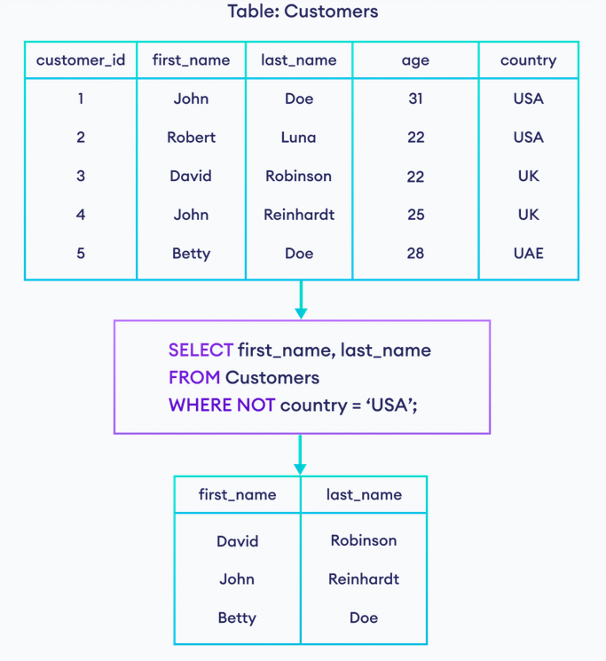

Combining Multiple Operators

It is also possible to combine multiple AND, OR and NOT operators in an SQL statement. For example,

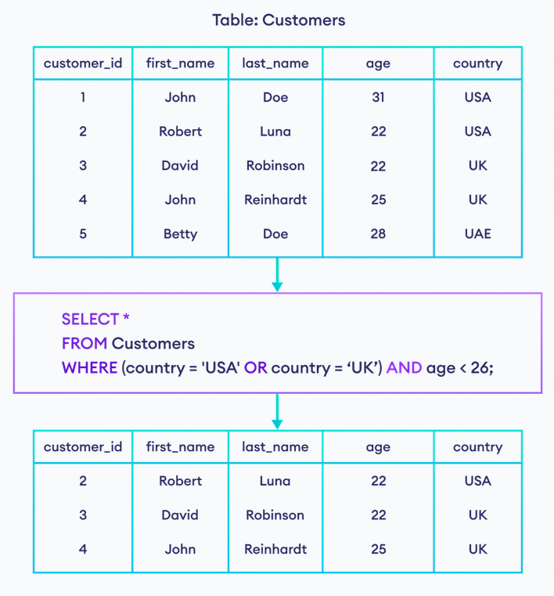

SQL Order By

The ORDER BY keyword is used to sort the result-set in ascending or descending order.

The ORDER BY keyword sorts the records in ascending order by default. To sort the records in descending order, use the DESC keyword.

ORDER BY Syntax

SELECT column1, column2, ...  
FROM table_name  
ORDER BY column1, column2, ... ASC|DESC;

ORDER BY Several Columns

SELECT * FROM Customers  
ORDER BY Column_1,Column_2;

This means that it orders by Column_1, but if some rows have the same records, it orders them by Column_2.

SQL Select Random

The SQL SELECT RANDOM() function returns the random row. It can be used in online exam to display the random questions.

There are a lot of ways to select a random record or row from a database table. Each database server needs different SQL syntax.

**MY SQL:**

SELECT Column_name FROM table_name  
ORDER BY RAND()

LIMIT 1

**Microsoft SQL server:**

SELECT TOP 1 FROM table_name  
ORDER BY NEW ID()

**ORACLE:**

SELECT Column_name

(SELECT Column_name FROM table_name

ORDER BY dbms_random.value)

WHERE rownum = 1

**PostgreSQL:**

SELECT Column_name FROM table_name  
ORDER BY RAND()

LIMIT 1

SQL Insert Into

The SQL INSERT INTO Statement

The INSERT INTO statement is used to insert new records to a table in the database.

INSERT INTO Syntax

It is possible to write the INSERT INTO statement in two ways:

1.Specify both the column names and the values to be inserted:

INSERT INTO table_name (column1, column2, column3, ...)  
VALUES (value1, value2, value3, ...);

2. If you are adding values for all the columns of the table, you do not need to specify the column names in the SQL query, However, make sure the order of the values is in the same order as the columns in the table. Here, the INSERT INTO syntax would be as follows:

INSERT INTO table_name  
VALUES (value1, value2, value3, ...);

Example:

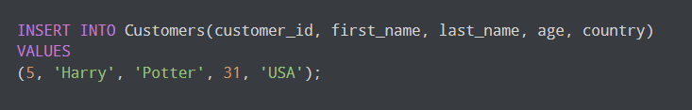

Here, the SQL command inserts a new row in the Customers table with the given values.

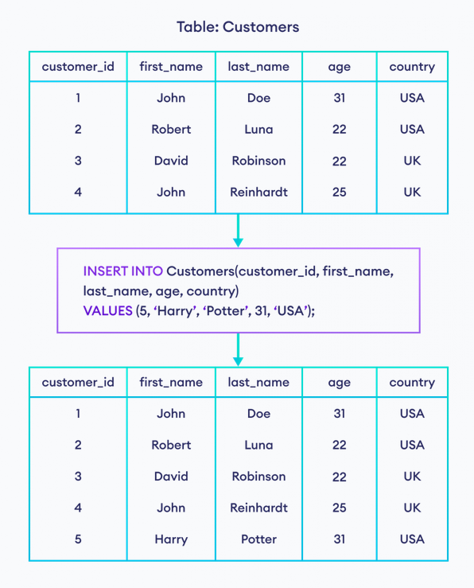

## Insert Row Providing Value Explicitly

It's possible to provide default values to a column (for example, auto incrementing a column). In a database table, the **ID** field is usually unique auto incremented.

In such cases, we can omit the value for that column during row insertion. For example,

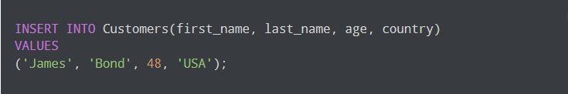

Here, the SQL command automatically sets the new customer_id for the new row and inserts it in a table.

## Insert Multiple Rows at Once in SQL

It's also possible to insert multiple rows to a database table at once. For example,

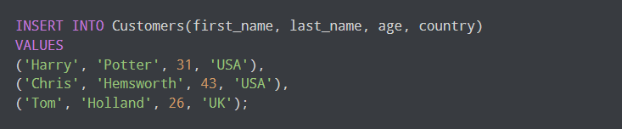

Here, the SQL command inserts three rows to the Customers table.

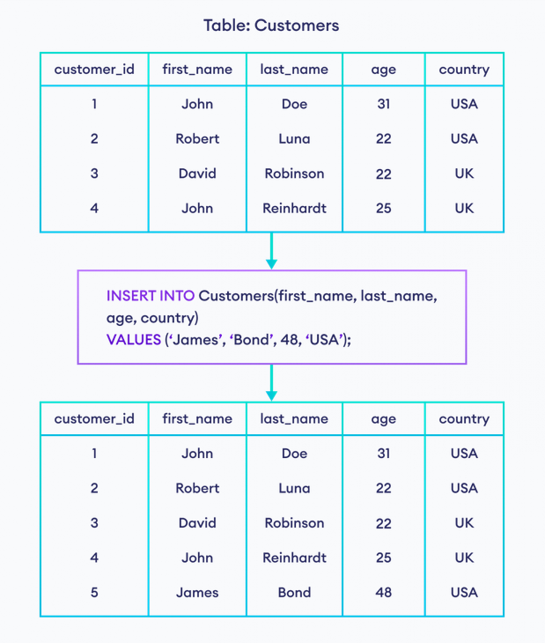

SQL Null/Not Null

What is a NULL Value?

A field with a NULL value is a field with no value.

If a field in a table is optional, it is possible to insert a new record or update a record without adding a value to this field. Then, the field will be saved with a NULL value.

**NOTE:** A NULL value is different from a zero value or a field that contains spaces. A field with a NULL value is one that has been left blank during record creation!

How to test for NULL Values?

It is not possible to test for NULL values with comparison operators, such as =, <, or <>.

We will have to use the IS NULL and IS NOT NULL operators instead.

IS NULL Syntax

SELECT column_namesFROM table_name  
WHERE column_name IS NULL;

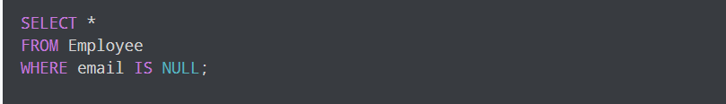

Here, the SQL command selects employees who do not have email.

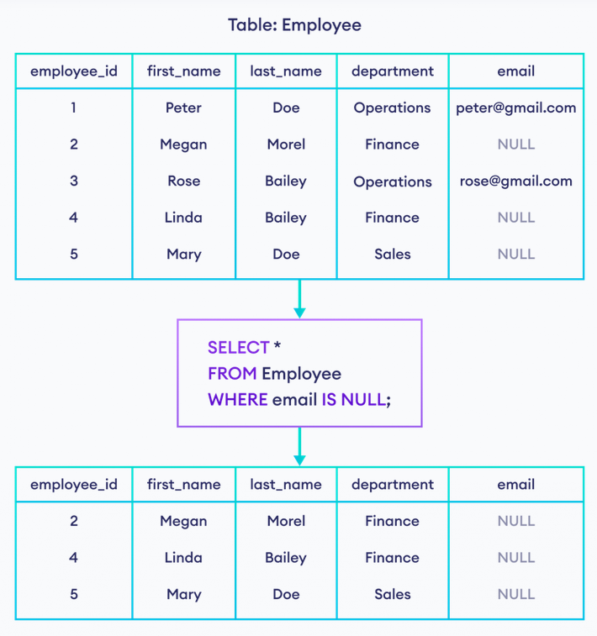

IS NOT NULL Syntax

In SQL, IS NOT NULL condition is used to select rows if the specified field is NOT NULL. For example,

SELECT column_namesFROM table_name  
WHERE column_name IS NOT NULL;

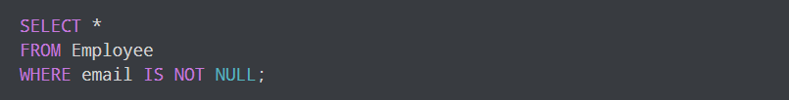

Here, the SQL command selects employees who have emails.

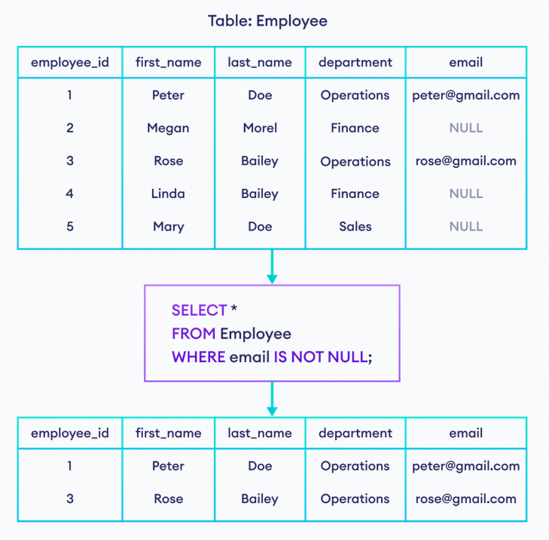

## **IS NULL With COUNT():**

We can use the [COUNT()](https://programiz.com/sql/count) function with IS NULL to count the number of rows with an empty field. For example,

 Here, the SQL command returns the total number of employees that do not have email.

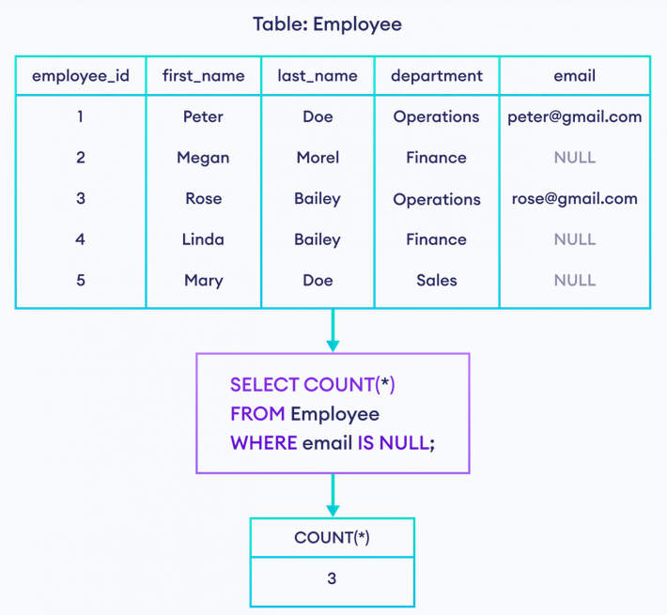

Similarly, we can use the COUNT() function with IS NOT NULL to count the number of non-empty fields.

SQL Update

The SQL UPDATE Statement

The UPDATE statement is used to modify the existing records in a table. You can use the WHERE clause with the UPDATE query to update the selected rows, otherwise all the rows would be affected.

UPDATE Syntax

UPDATE table_name  
SET column1 = value1, column2 = value2, ...  
WHERE condition;

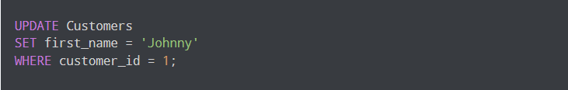

Here, the SQL command changes the value of the first_name column will be **Johnny** if customer_id is equal to **1**.

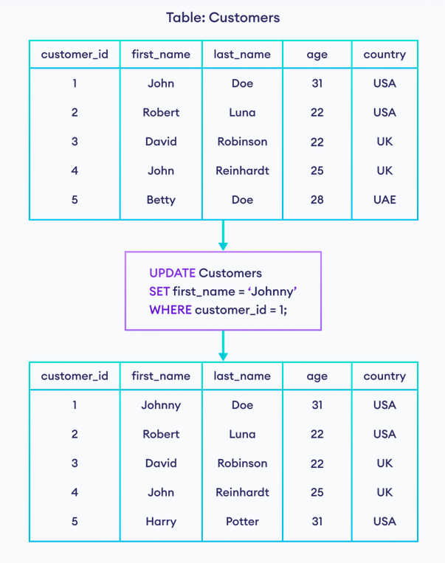

**NOTE**: Be careful when updating records in a table! Notice the WHERE clause in the UPDATE statement. The WHERE clause specifies which records that should be updated. If you omit the WHERE clause, all records in the table will be updated!

## Update Multiple Values in a Row

We can also update multiple values in a row at once. For example,

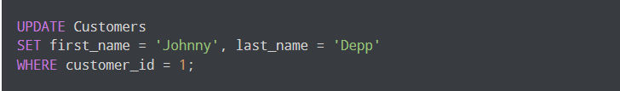

Here, the SQL command changes the value of the first_name column to **Johnny** and last_name to **Depp** if customer_id is equal to **1**.

SQL Delete

The SQL DELETE Statement

The DELETE statement is used to delete existing records in a table.

You can use the WHERE clause with a DELETE query to delete the selected rows, otherwise all the records would be deleted.

DELETE Syntax

DELETE FROM table_name WHERE condition;



Here, the SQL command will delete a row from the Customers table where customer_id is **5**.

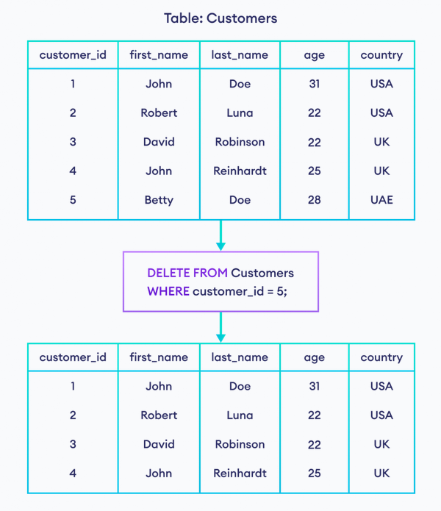

**NOTE**: Be careful when deleting records in a table! Notice the WHERE clause in the DELETE statement. The WHERE clause specifies which records should be deleted. If you omit the WHERE clause, all records in the table will be deleted!

SQL Top, Limit

The SQL TOP Clause

The TOP clause is used to fetch a TOP N number or X percent records from a table.

The TOP clause is useful on large tables with thousands of records. Returning a large number of records can impact performance.

LIMIT Syntax

SELECT column_name(s)  
FROM table_nameWHERE condition  
TOP number;

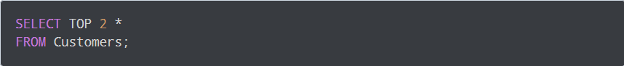

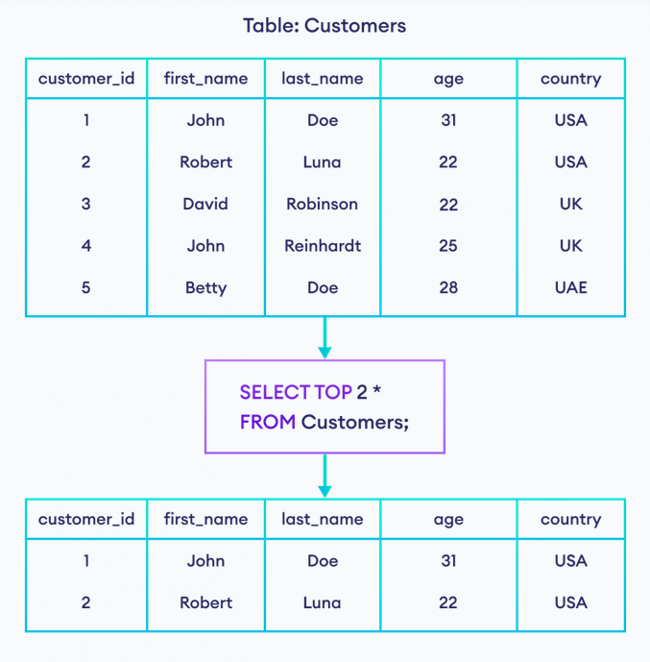

SQL Min() and Max() functions

The SQL MIN() and MAX() Functions

The MIN() function returns the smallest value of the selected column.

The MAX() function returns the largest value of the selected column.

**MIN() Syntax**

SELECT MIN(column_name)  
FROM table_name  
WHERE condition;



Here, the SQL command returns the smallest value from the age column.

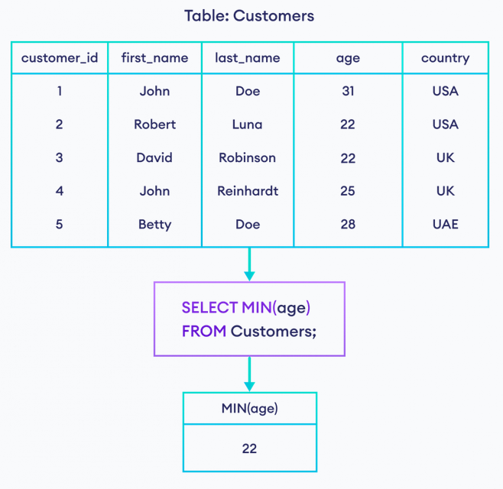

**MAX() Syntax**

SELECT MAX(column_name)  
FROM table_name  
WHERE condition;



Here, the SQL command returns the largest value from the age column.

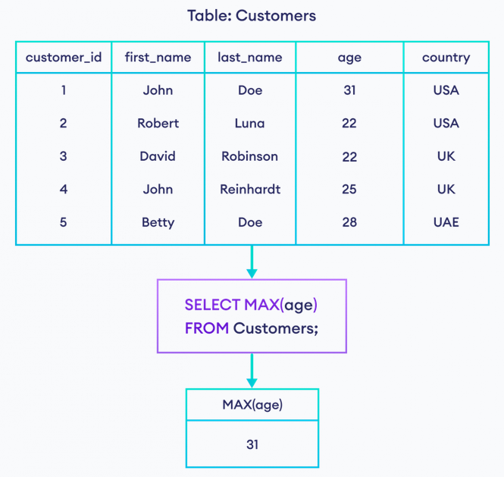

## **Aliases with MAX() and MIN()**

In the above examples, the field name in the result set is MIN(age) and MAX(age).

It is also possible to give custom names to these fields using the AS keyword. For example,



Here, the field name MAX(age) is replaced with max_age in the result set.

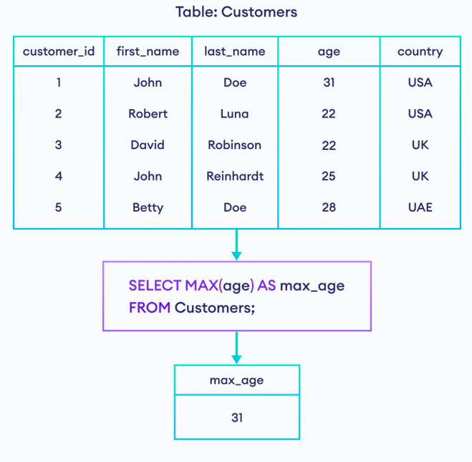

## **MAX() and MIN() with Strings**

The MAX() and MIN() functions also work with other data types such as text, not just numbers. For example,



Here, the SQL command selects the minimum value of first_name based on the dictionary order.

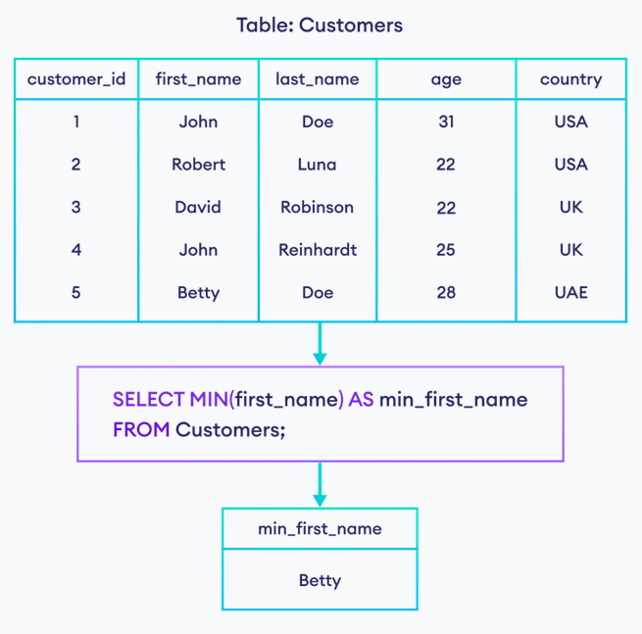

SQL Count(), Avg() and Sum() Functions

The SQL COUNT(), AVG() and SUM() Functions

COUNT() Syntax:

The COUNT() function returns the number of rows that matches a specified criterion.

SELECT COUNT(column_name)  
FROM table_name  
WHERE condition;

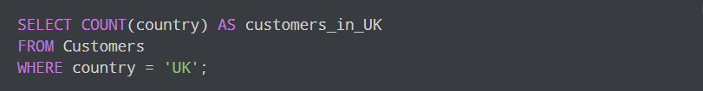

Here, the SQL command returns the count of customers whose country is **UK**.

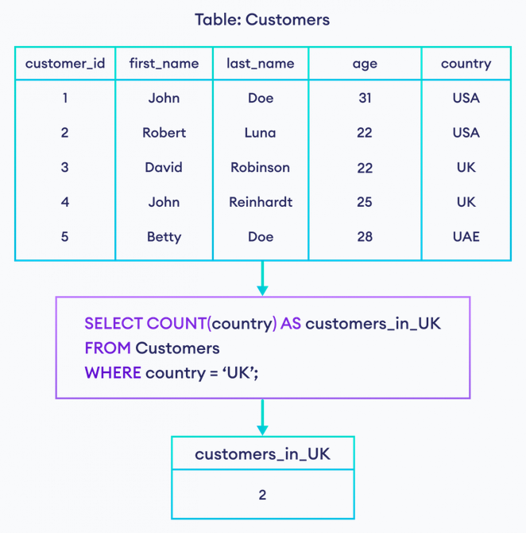

## **COUNT() With HAVING Clause:**

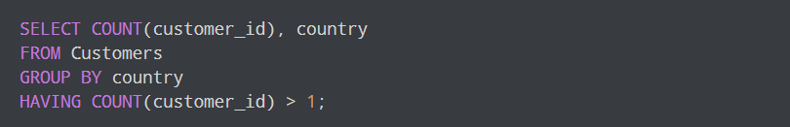

AVG() Syntax

The AVG() function returns the average value of a numeric column.

SELECT AVG(column_name)  
FROM table_name  
WHERE condition;



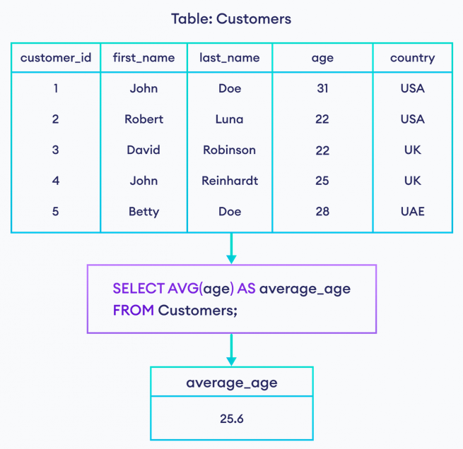

SUM() Syntax

The SUM() function returns the total sum of a numeric column.

SELECT SUM(column_name)  
FROM table_name  
WHERE condition;



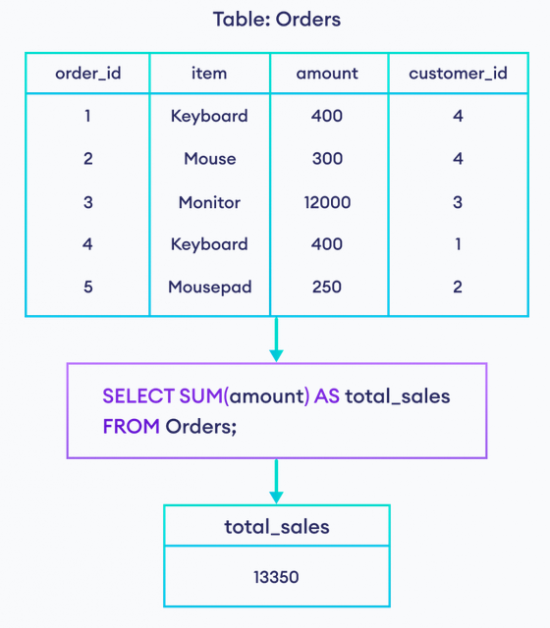

SQL Like

The SQL LIKE Operator

The LIKE operator is used in a WHERE clause to search for a specified pattern in a column.

There are two wildcards often used in conjunction with the LIKE operator:

* The percent sign (%) represents zero, one, or multiple characters.
* The underscore sign (_) represents one, single character.

The percent sign and underscore can also be used in combinations!

**LIKE Syntax**

SELECT column1, column2, ...  
FROM table_name  
WHERE columnN LIKE pattern;

Example:

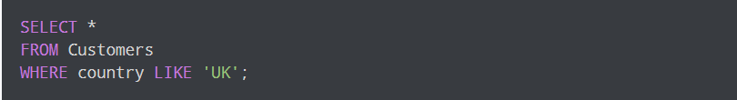

Here, the SQL command selects customers whose country is **UK**.

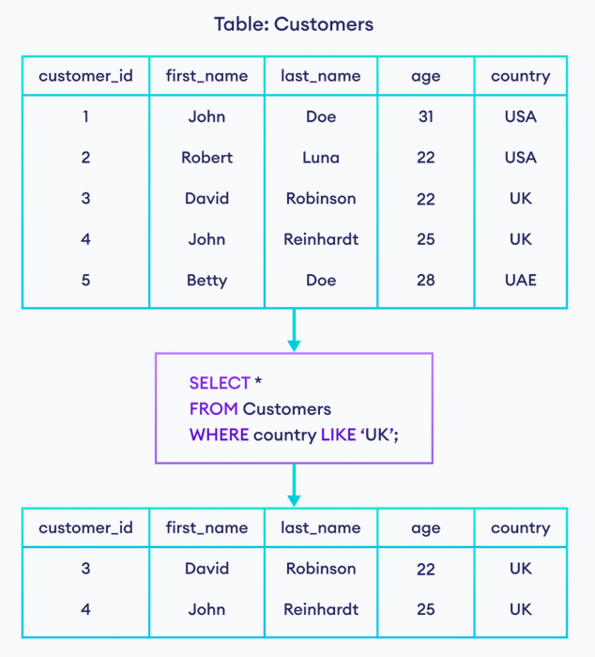

Tip: You can also combine any number of conditions using AND or OR operators.

Here are some examples showing different LIKE operators with ‘%’ and ‘_’ wildcards:

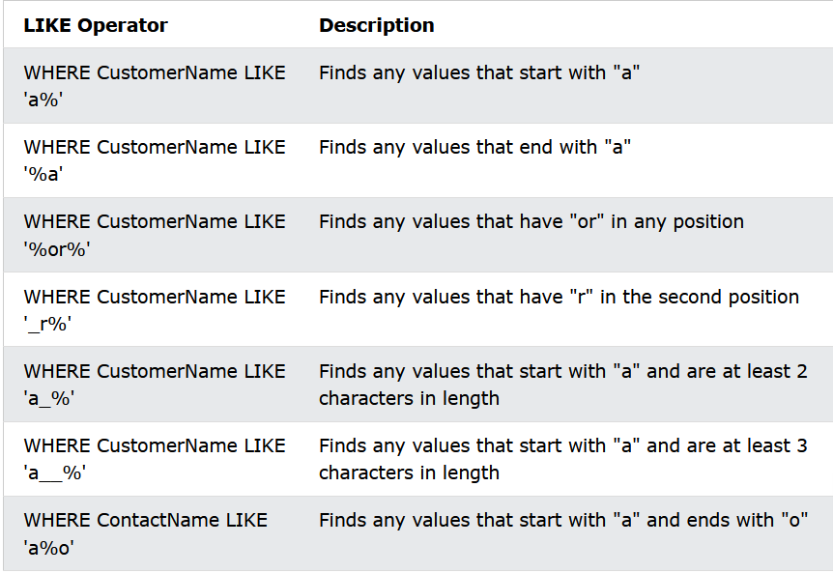

SQL Wildcards

A wildcard character is used to substitute one or more characters in a string.

Wildcard characters are used with the LIKE operator. The LIKE operator is used in a WHERE clause to search for a specified pattern in a column.

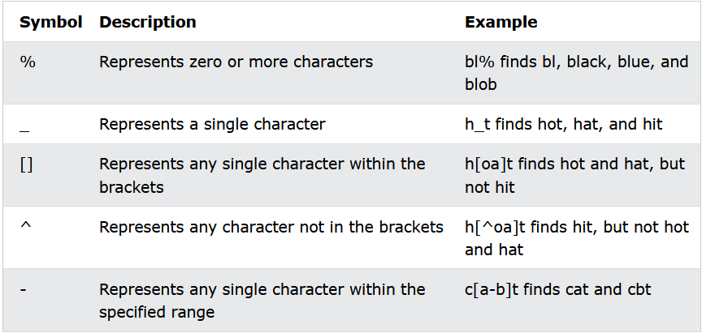

Example:

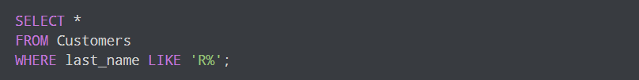

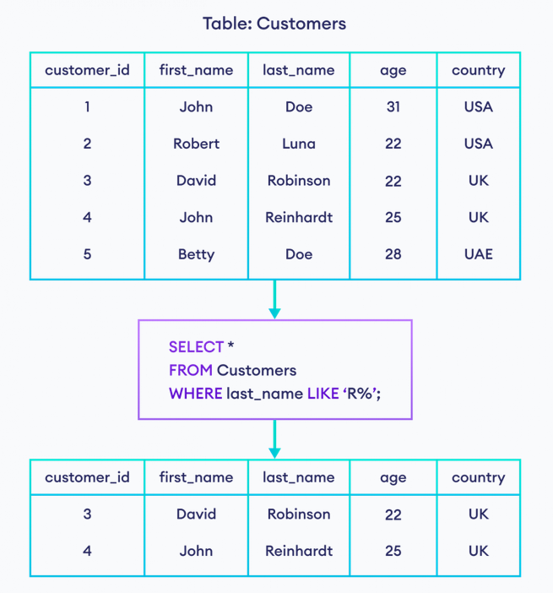

## **SQL NOT LIKE Operator:**

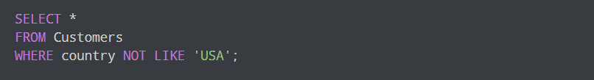

## **SQL LIKE With Multiple Values**

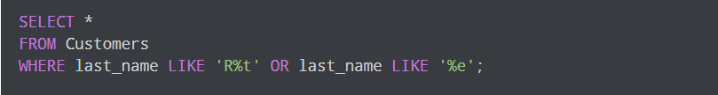

SQL In

The SQL IN operator

The IN operator allows you to specify multiple values in a WHERE clause.

The IN operator is a shorthand for multiple OR conditions.

**IN Syntax**

SELECT column_name(s)  
FROM table_name  
WHERE column_name IN (value1, value2, ...);

**OR:**

SELECT column_name(s)  
FROM table_name  
WHERE column_name IN (*SELECT* STATEMENT);

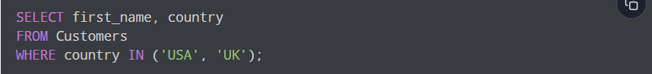

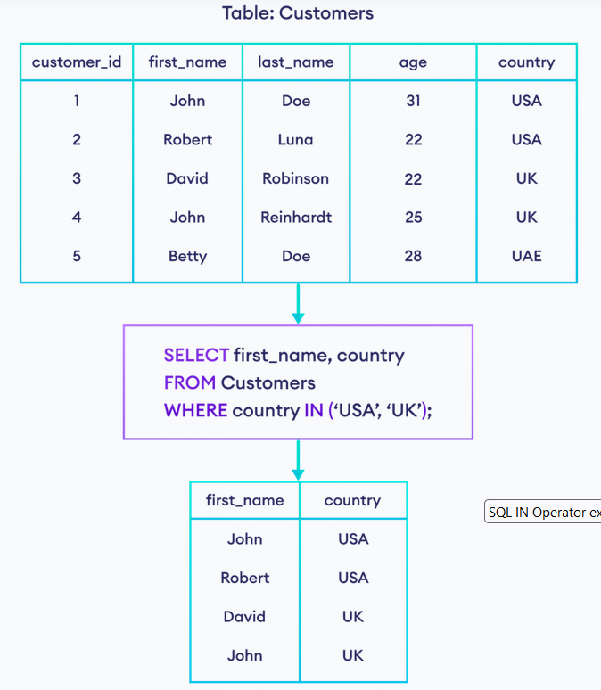

## **SQL IN Operator with Columns:**

The IN operator can also be used to select rows in which a certain value exists in the given field. Let's see an example to clarify it.

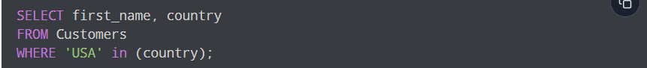

## **SQL NOT IN Operator:**

The NOT IN operator returns is used to exclude the rows that match values in the list. It returns all the rows except the excluded rows. For example,

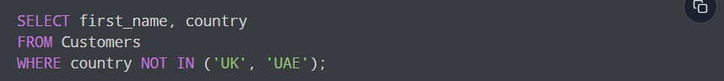

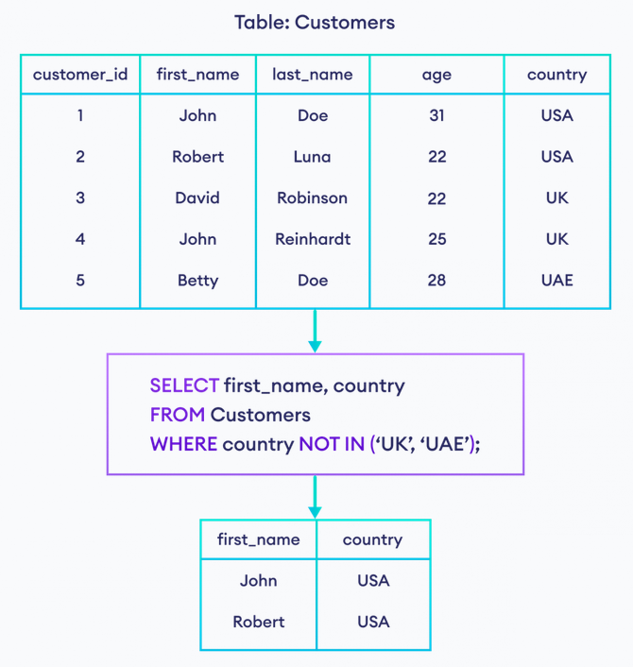

SQL Between

The SQL BETWEEN Operator

The BETWEEN operator selects values within a given range. The values can be numbers, text, or dates.

The BETWEEN operator is inclusive: begin and end values are included.

**BETWEEN Syntax**

SELECT *column_name(s)*  
FROM *table_name*  
WHERE *column_name* BETWEEN *value1* AND *value2;*

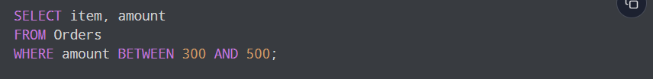

Here, the SQL command selects all orders that have amounts between **300** and **500** including **300** and **500**.

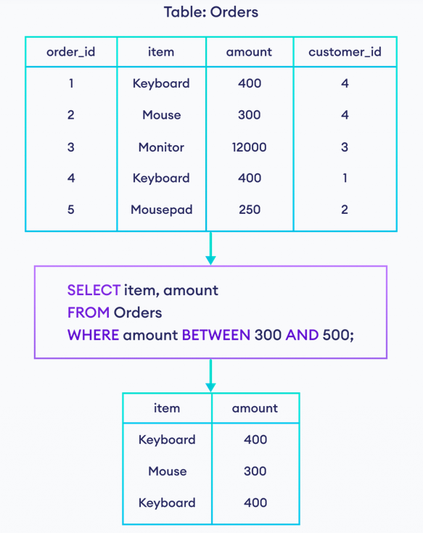

## **SQL NOT BETWEEN Operator:**

The NOT BETWEEN operator is used to exclude the rows that match values in the range. It returns all the rows except the excluded rows. For example,

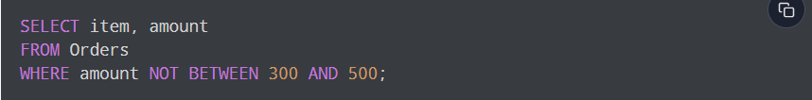

## **SQL BETWEEN OPERATOR With Texts**

The BETWEEN operator also works with texts. For example,

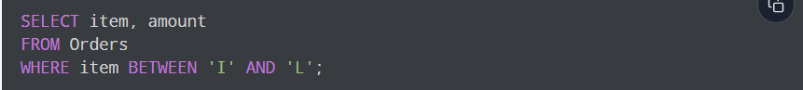

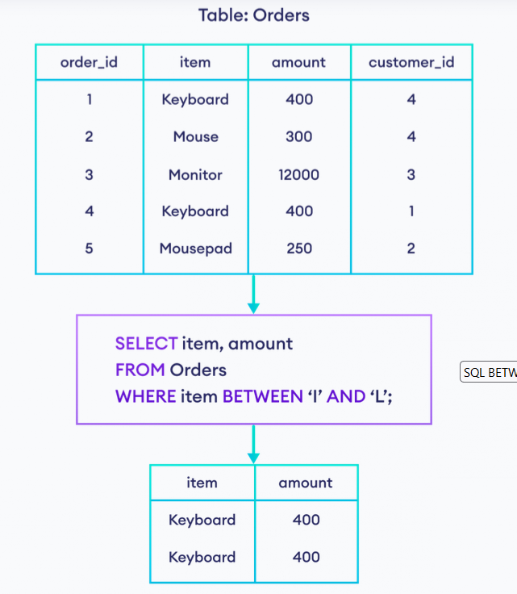

If we need to include all the words that start with **L** as well, we can use ~ like this.

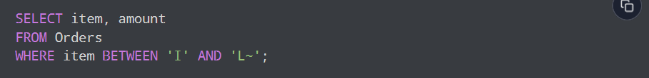

SQL Aliases

SQL aliases are used to give a table, or a column in a table, a temporary name.

Aliases are often used to make column names more readable.

An alias only exists for the duration of that query.

An alias is created with the AS keyword.

**Alias Column Syntax**

SELECT column_name AS alias_name  
FROM table_name;

**Alias Table Syntax**

SELECT column_name(s)  
FROM table_name AS alias_name;

Aliases can be useful when:

* There are more than one table involved in a query.
* Functions are used in the query.
* Column names are big or not very readable.
* Two or more columns are combined together.

SQL Join

A JOIN clause is used to combine rows from two or more tables, based on a related column between them.

Example:

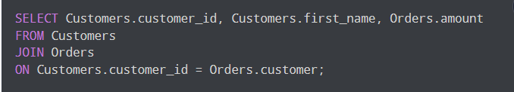

Here's how this code works:

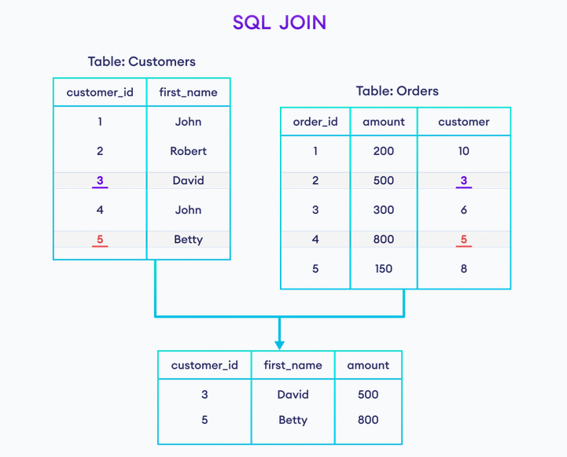

Here, the SQL command selects **customer_id** and **first_name** columns (from the **Customers** table) and the **amount** column (from the **Orders** table).

And, the result set will contain those rows where there is a match between **customer_id** (of the **Customers** table) and **customer** (of the **Orders** table).

There are Four types of SQL Joins:

* (INNER) JOIN: Returns records that have matching values in both tables.
* LEFT (OUTER) JOIN: Returns all records from the left table, and the matched records from the right table.
* RIGHT (OUTER) JOIN: Returns all records from the right table, and the matched records from the left table.
* FULL (OUTER) JOIN: Returns all records when there is a match in either left or right table.

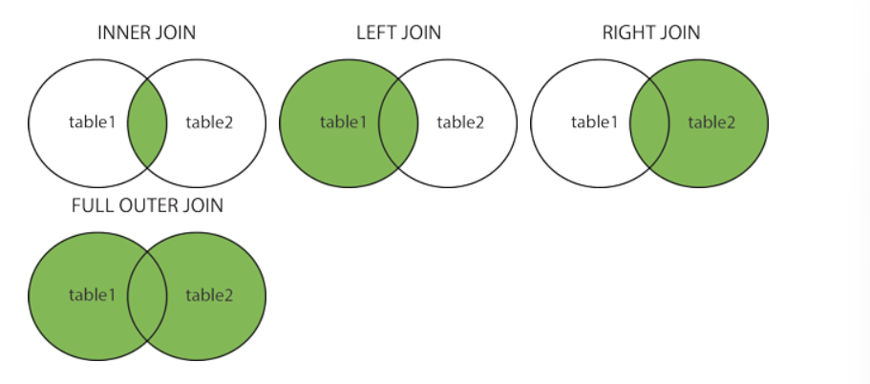

## SQL JOIN and Aliases

We can use [AS aliases](https://www.programiz.com/sql/select-as-alias) with table names to make our snippet short and clean. For example,

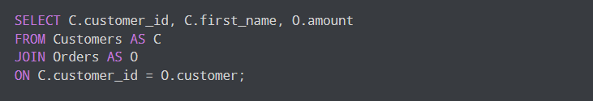

Also, we can change the column names temporarily using AS aliases. For example,

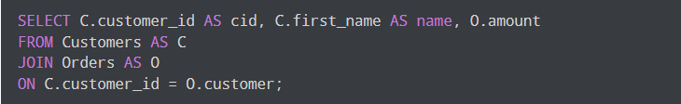

SQL Inner Join:

SQL INNER JOIN Keyword

The INNER JOIN keyword selects records that have matching values in both tables.

**INNER JOIN Syntax**

SELECT column_name(s)  
FROM table1  
INNER JOIN table2ON table1.column_name = table2.column_name;

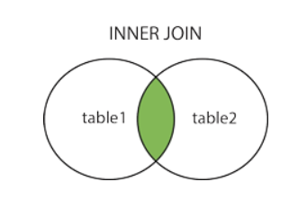

Example:

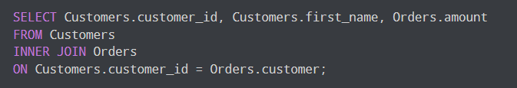

Here's how this code works:

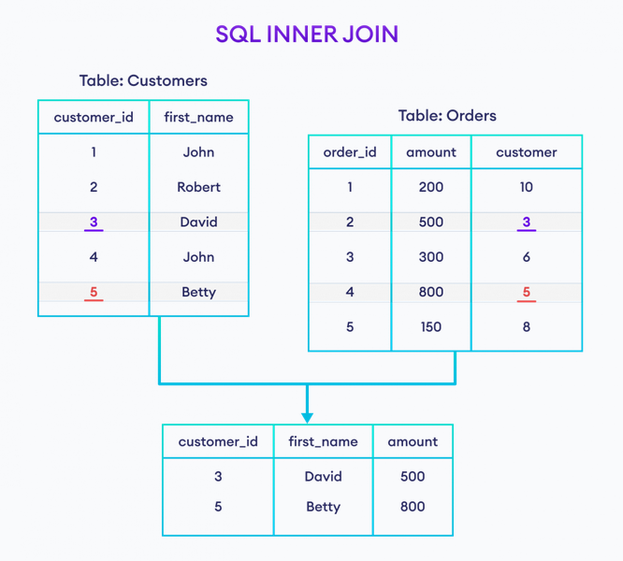

Here, the SQL command selects **customer_id** and **first_name** columns (from the **Customers** table) and the **amount** column (from the **Orders** table).

And, the result set will contain those rows where there is a match between **customer_id** (of the **Customers** table) and **customer** (of the **Orders** table).

## **INNER JOIN With WHERE Clause:**

Here's an example of the INNER JOIN with the [WHERE clause](https://www.programiz.com/sql/select#sql-where):

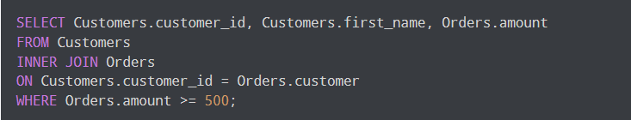

Here, the SQL command joins two tables and selects rows where the amount is **greater than or equal to 500**.

## **SQL INNER JOIN With AS Alias:**

We can use [AS aliases](https://www.programiz.com/sql/select-as-alias) inside INNER JOIN to make our snippet short and clean. For example,

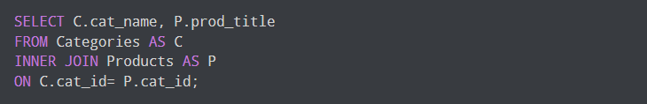

Here, the SQL command selects common rows between Category and Products table.

## **SQL INNER JOIN With Three Tables:**

We can also join more than two tables using the INNER JOIN. For example,

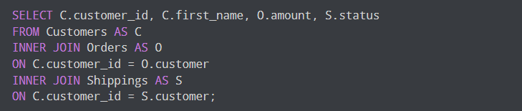

Here, the SQL command

* joins **Customers** and **Orders** table based on *customer_id*
* and joins **Customers** and **Status** table based on *customer_id*

The command returns those rows where there is a match between column values in both join conditions.

SQL Left Join:

SQL LEFT JOIN Keyword

The LEFT JOIN keyword returns all records from the left table (Table_1), and the matching records from the right table (Table_2). The result is 0 records from the right side, if there is no match.

**LEFT JOIN Syntax**

SELECT column_name(s)  
FROM table1  
LEFT JOIN table2ON table1.column_name = table2.column_name;

NOTE: In some database LEFT JOIN is called LEFT OUTER JOIN.

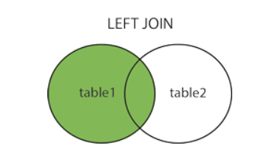

Example:

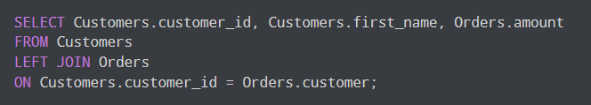

Here's how this code works:

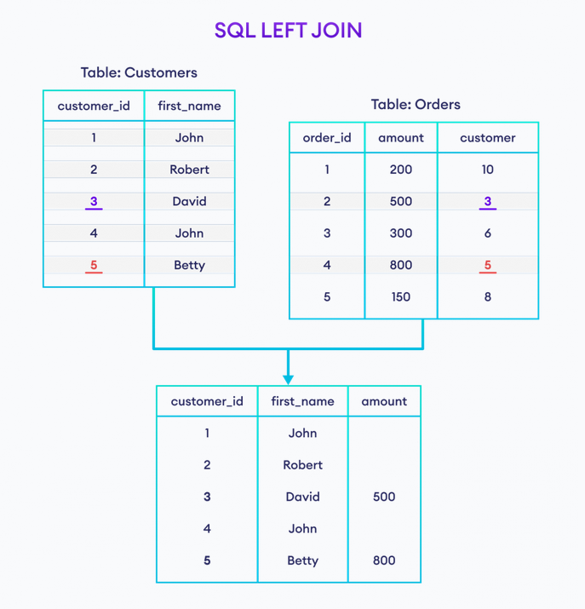

Here, the SQL command selects **customer_id** and **first_name** columns (from the **Customers** table) and the **amount** column (from the **Orders** table).

And, the result set will contain those rows where there is a match between **customer_id** (of the **Customers** table) and **customer** (of the **Orders** table) along with all the remaining rows from the **Customers** table.

## **LEFT JOIN With WHERE Clause**

The SQL command can have an optional [WHERE clause](https://www.programiz.com/sql/select#sql-where) with the LEFT JOIN statement. For example,

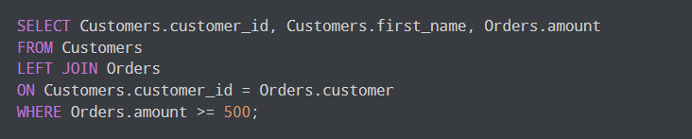

Here, the SQL command joins two tables and selects rows where the amount is **greater than or equal to 500**.

## **SQL LEFT JOIN With AS Alias:**

We can use [AS aliases](https://www.programiz.com/sql/select-as-alias) inside LEFT JOIN to make our snippet short and clean. For example,

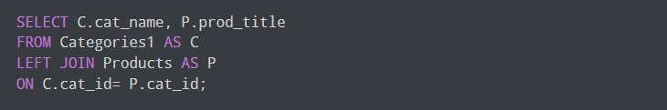

Here, the SQL command selects common rows between Category and Products table.

SQL Right Join Keyword

SQL RIGHT JOIN Keyword

The RIGHT JOIN keyword returns all records from the right table (Table_2), and the matching records from the left table (Table_1). The result is 0 records from the left side, if there is no match.

**RIGHT JOIN Syntax**

SELECT column_name(s)  
FROM table1  
RIGHT JOIN table2ON table1.column_name = table2.column_name;

NOTE: In some databases RIGHT JOIN is called RIGHT OUTER JOIN.

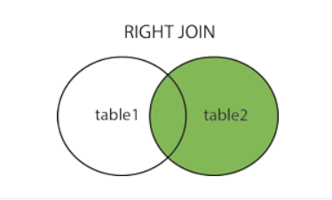

Example:

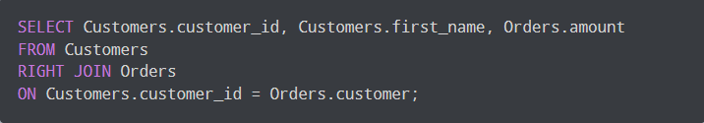

Here's how this code works:

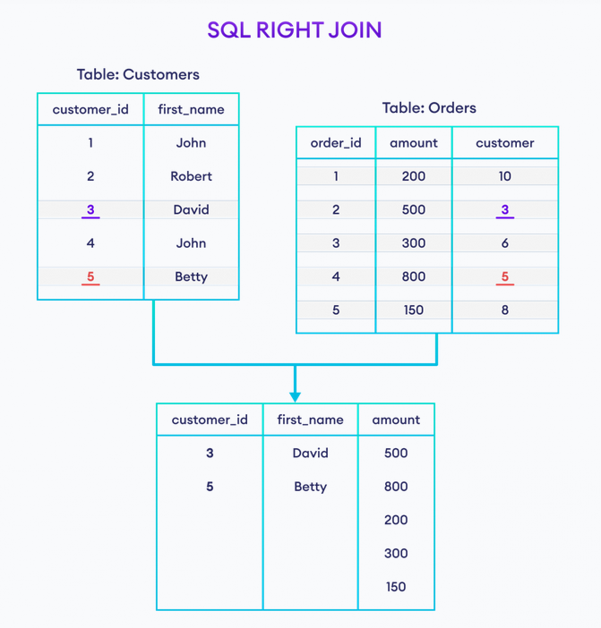

Here, the SQL command selects **customer_id** and **first_name** columns (from the **Customers** table) and the **amount** column (from the **Orders** table).

And, the result set will contain those rows where there is a match between **customer_id** (of the **Customers** table) and **customer** (of the **Orders** table) along with all the remaining rows from the **Orders** table.

## **RIGHT JOIN With WHERE Clause:**

The SQL command can have an optional [WHERE clause](https://www.programiz.com/sql/select#sql-where) with the RIGHT JOIN statement. For example,

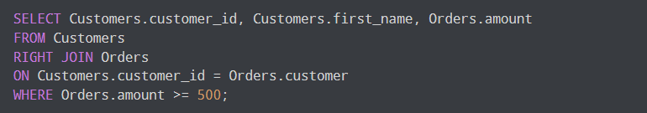

Here, the SQL command joins two tables and selects rows where the amount is **greater than or equal to 500**.

## **SQL RIGHT JOIN With AS Alias**

We can use [AS aliases](https://www.programiz.com/sql/select-as-alias) inside RIGHT JOIN to make our snippet short and clean. For example,

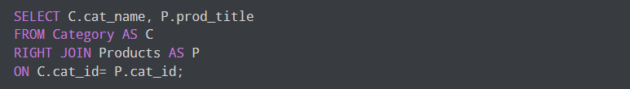

Here, the SQL command selects common rows between Category and Products table.

**RIGHT JOIN Vs RIGHT OUTER JOIN**

We can also use RIGHT OUTER JOIN instead of RIGHT JOIN. Basically, these two clauses are the same.

That means,

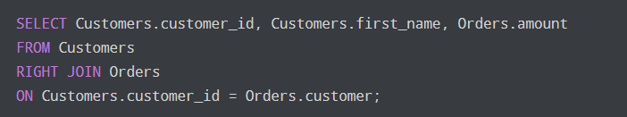

is similar to

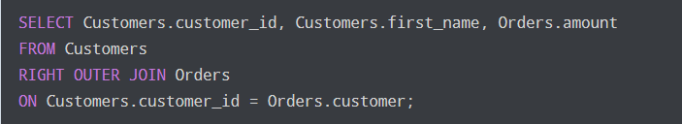

**RIGHT JOIN Vs INNER JOIN**

The RIGHT JOIN selects the common rows as well as all the remaining rows from the **right table**. Whereas the INNER JOIN selects only the common rows between two tables.

Let's take a look at example,

RIGHT JOIN

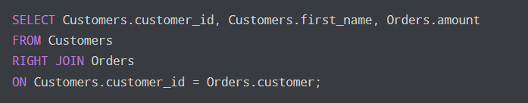

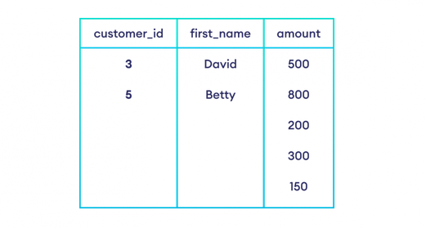

INNER JOIN

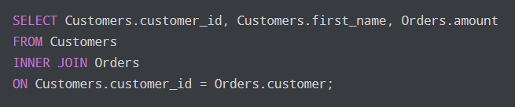

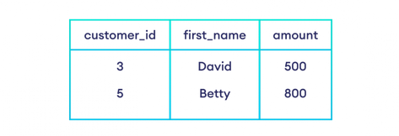

**RIGHT JOIN Vs LEFT JOIN:**

The RIGHT JOIN selects the common rows as well as all the remaining rows from the **right table**. Whereas, the LEFT JOIN selects the common rows as well as all the remaining rows from the **left table**.

Let's take a look at example,

RIGHT JOIN

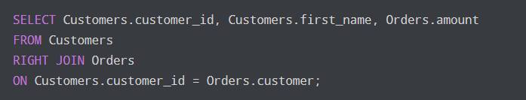

OUTPUT:

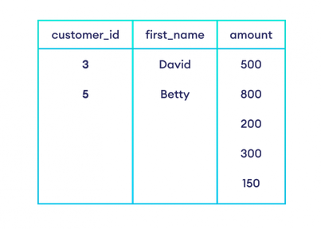

LEFT JOIN:

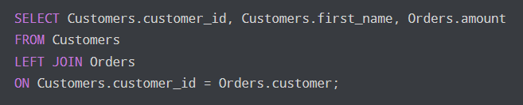

OUTPUT:

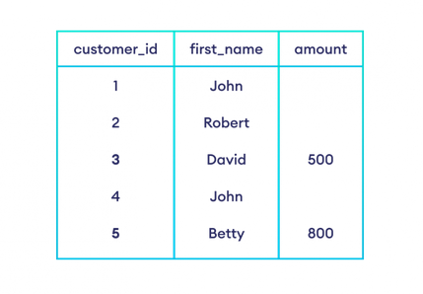

**RIGHT JOIN Vs FULL OUTER JOIN:**

The RIGHT JOIN selects the common rows as well as all the remaining rows from the **right table**. Whereas the FULL OUTER JOIN selects all the rows from both the tables.

Let's take a look at example,

RIGHT JOIN

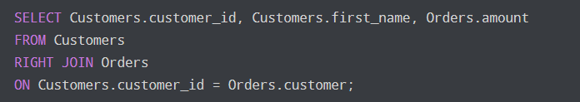

OUTPUT

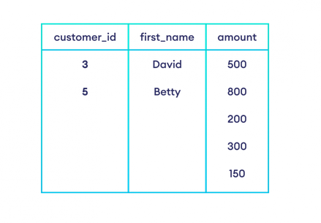

FULL OUTER JOIN

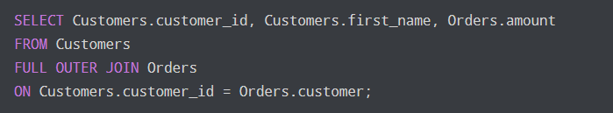

OUTPUT

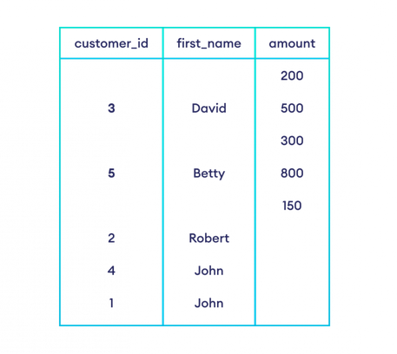

SQL Full Outer Join

SQL FULL OUTER JOIN Keyword

The FULL OUTER JOIN keyword returns all records when there is a match in left (Table_1) or right (Table_2) table records.

Tip: FULL OUTER JOIN and FULL JOIN are the same.

**SQL FULL OUTER JOIN Syntax**

SELECT column_name(s)  
FROM table1  
FULL OUTER JOIN table2ON table1.column_name = table2.column_nameWHERE condition;

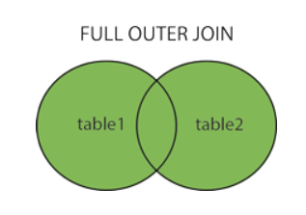

NOTE: FULL OUTER JOIN can potentially return very large result-sets!

Example:

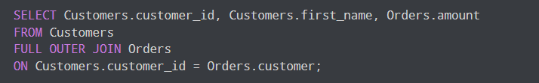

Here's how this code works:

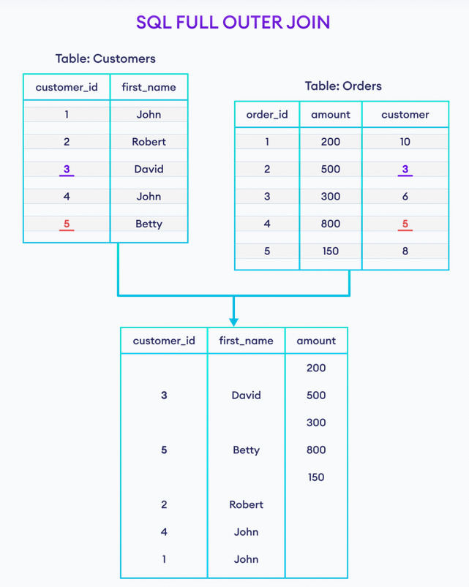

Here, the SQL command selects **customer_id** and **first_name** columns (from the **Customers** table) and the **amount** column (from the **Orders** table).

And, the result set will contain those rows where there is a match between **customer_id** (of the **Customers** table) and **customer** (of the **Orders** table) along with all the remaining rows from **both of the tables.**

## **FULL OUTER JOIN With WHERE Clause**

The SQL command can have an optional [WHERE clause](https://www.programiz.com/sql/select#sql-where) with the FULL OUTER JOIN statement. For example,

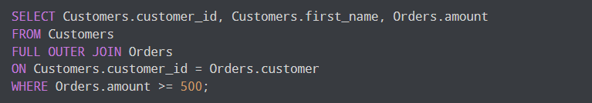

Here, the SQL command joins two tables and selects rows where the amount is **greater than or equal to 500**.

## **SQL FULL OUTER JOIN With AS Alias**

We can use [AS aliases](https://www.programiz.com/sql/select-as-alias) inside FULL OUTER JOIN to make our snippet short and clean. For example,

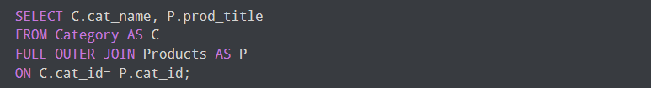

Here, the SQL command selects common rows between Category and Products table.

SQL Self Join

SQL SELF JOIN

A self join is a regular join, but the table is joined with itself.

**SELF Join Syntax**

SELECT column_name(s)  
FROM table1 T1, table1 T2  
WHERE condition;

T1 and T2 are different table aliases for the same table.

SQL Union

The SQL UNION Operator

A UNION operator is used to combine the result-set of two or more SELECT statements.

But there are some conditions:

* Every SELECT statement within UNION must have the same number of columns.
* The columns must also have similar data types.
* The columns in every SELECT statement must also be in the same order.

**UNION Syntax**

SELECT column_name(s) FROM table1  
UNION  
SELECT column_name(s) FROM table2;

**Example:**

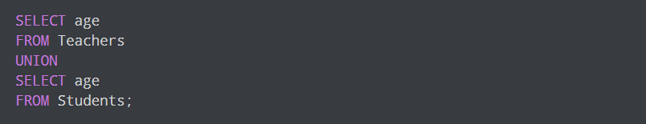

Here, the SQL command returns the age column from the Teachers table and the Students table, ignoring the duplicate rows.

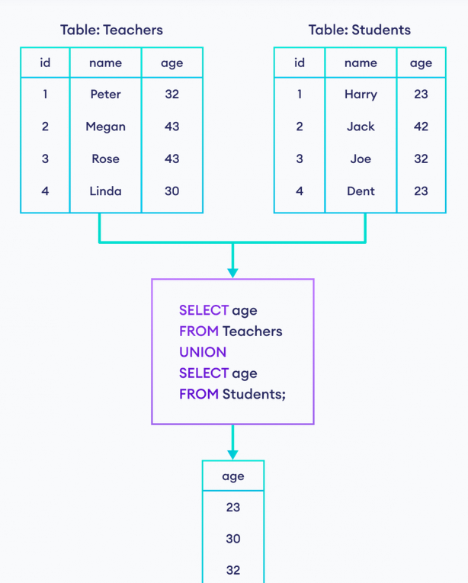



**UNION ALL Syntax**

The UNION operator selects only distinct values by default. To allow duplicate values, use UNION ALL:

SELECT column_name(s) FROM table1  
UNION ALL  
SELECT column_name(s) FROM table2;

­

Example:

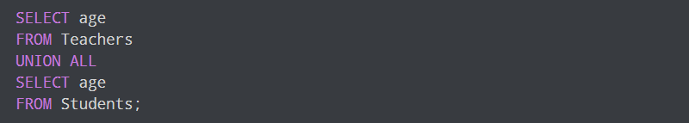

Here, the SQL command selects rows from both tables including duplicate rows.

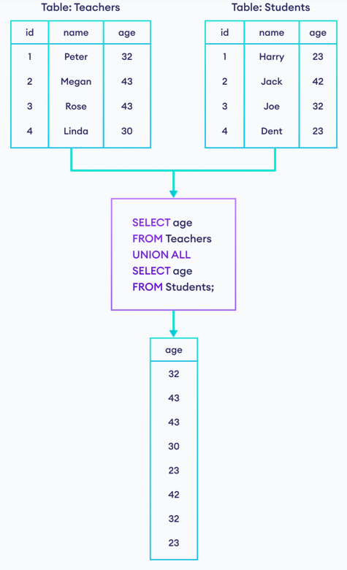

NOTE: The column names in the result-set are usually equal to the column names in the first SELECT statement.

**SQL UNION vs UNION ALL**

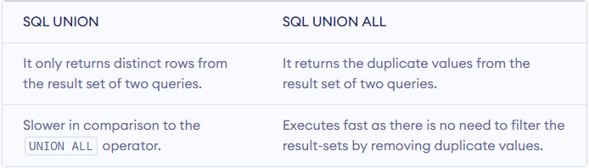

It is recommended to use UNION ALL when we know the result set will have unique values as it improves the performance.

**SQL UNION vs SQL JOIN**

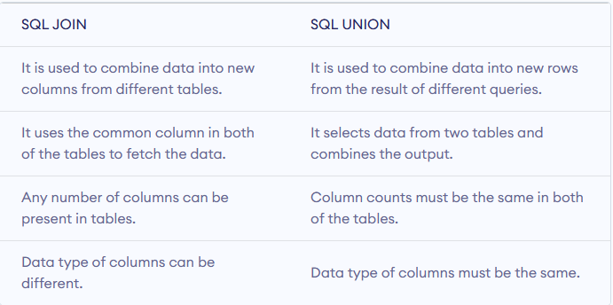

SQL Group By

The SQL GROUP BY Statement

When we work with a database table, we might come across conditions where we have to group the records based on their categories. So in that case, we use GROUP BY in SQL to group those records based on our needs. We can use the WHERE clause with [the ORDER BY clause](https://www.scaler.com/topics/sql/order-by-clause-in-sql/) to group data based on our needs.

## What is GROUP BY in SQL Query?

The GROUP BY statement groups rows that have the same values into summary rows, like “Find the number of customers in each country”.

The GROUP BY statement is often used with aggregate functions (COUNT() , MAX() , MIN() , SUM() , AVG() ) to group the result-set by one or more columns.

It's important to note that only the columns listed in the GROUP BY clause and aggregate functions can be included in the SELECT statement when using GROUP BY. Any other columns not included in the GROUP BY clause or an aggregate function will result in an error.

**GROUP BY Syntax**

SELECT column_name(s)  
FROM table_name  
WHERE condition  
GROUP BY column_name(s)ORDER BY column_name(s);

**Example**

Consider the CUSTOMERS table is having the following records-

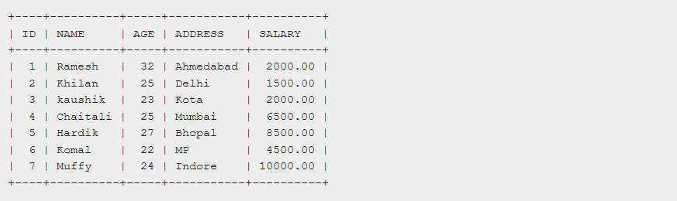

If you want to know the total amount of the salary on each customer, then the GROUP BY query would be as follows.

SELECT NAME, SUM(SALARY) FROM CUSTOMERS

GROUP BY NAME;

This would produce the following result-

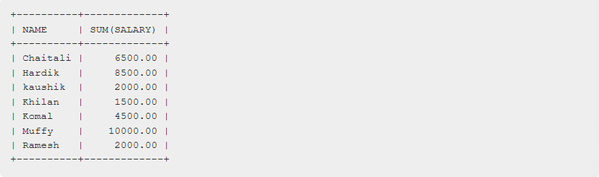

Now, let us look at a table where the CUSTOMERS table has the following records with duplicate names-

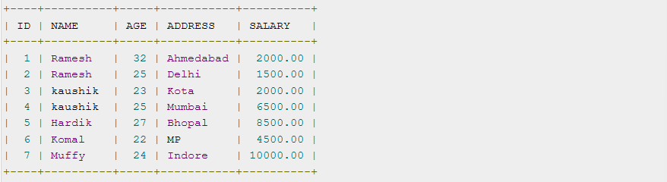

Now again, if you want to know the total amount of salary on each customer, then the GROUP BY query would be as follows-

SELECT NAME, SUM(SALARY) FROM CUSTOMERS

GROUP BY NAME;

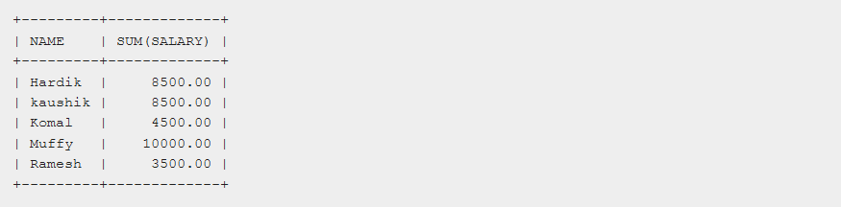

Another Example:

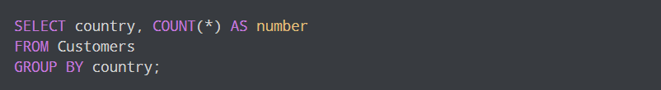

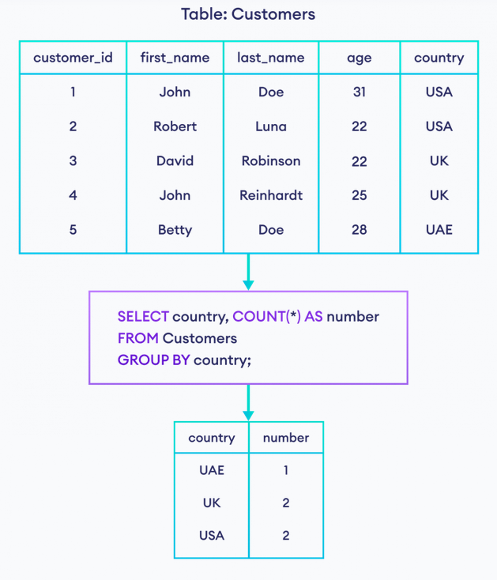

Example Two: Let's try to find the total amount for each customer who has placed an order.

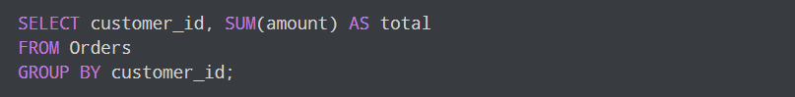

Here, the SQL command sums the amount after grouping rows with customer_id.

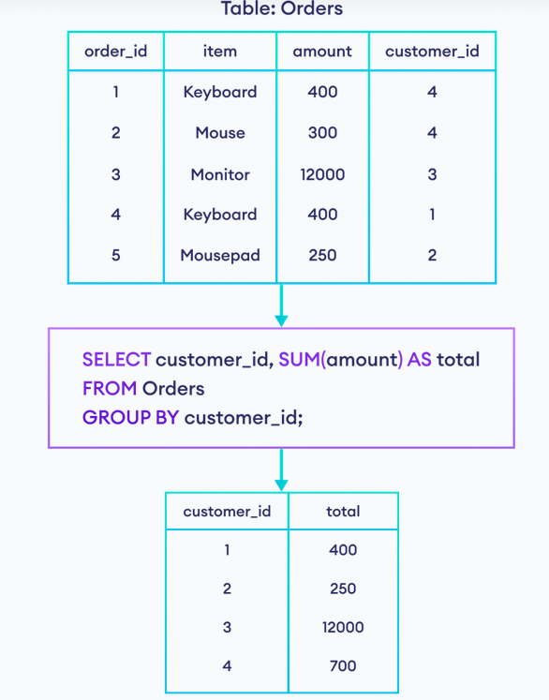

## **GROUP BY With Multiple Columns:**

GROUP BY can also be used to group rows based on multiple columns. For example,

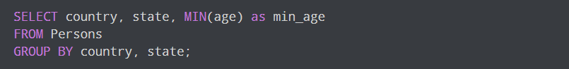

Here, the SQL command groups all persons with similar country and state, and gives the minimum age of each group.

SQL Having

The SQL HAVING Clause

The HAVING clause is added to SQL because the WHERE keyword cannot be used with aggregate functions.

**HAVING Syntax**

SELECT column_name(s)  
FROM table_name  
WHERE condition  
GROUP BY column_name(s)HAVING conditionORDER BY column_name(s);

Example:

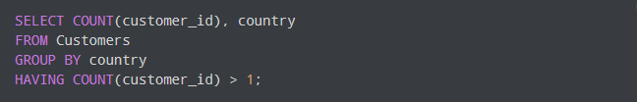

Here, the SQL command:

1. counts the number of rows by grouping them by *country*
2. returns the result set if their **count** is greater than **1**.

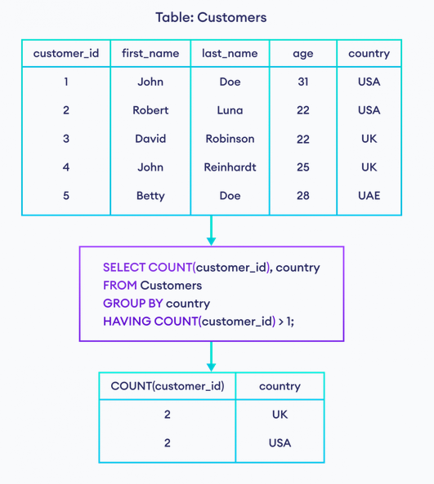

## **SQL HAVING Vs WHERE:**

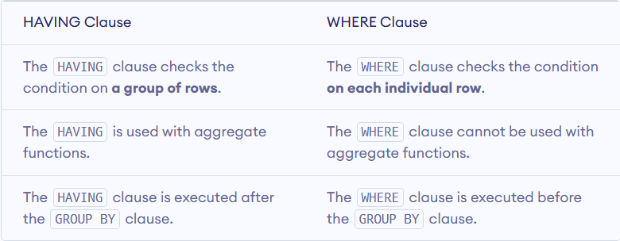

## Conclusion:

* We use GROUP BY in SQL to group those records based on our needs.
* The GROUP BY clause in SQL is typically used to organize similar types of data into groups. If multiple rows in a specific column have the same entries, it will group all the rows with the same entries.
* When we are grouping the Table using a single column, the output has all the rows with the same value as that particular column.
* When we are grouping the Table using multiple columns, the output has all the rows with the same value of both of those columns.
* We can use the HAVING clause to apply filter conditions for getting data for the final result set.

SQL Exists

The SQL EXISTS Operator

The EXISTS operator is used to test for the existence of any record in a subquery.

The EXISTS operator returns TRUE if the subquery returns one or more records.

**EXISTS Syntax**

SELECT EXISTS (s)  
FROM table_name

Above query will exits, if the `s` is present in the table or not. It seems like ‘LIKE’ operator, buT ‘EXISTS’ check for exact value.

It will return TRUE or FALSE.

SELECT column_name(s)  
FROM table_name  
WHERE EXISTS  
(SELECT column_name FROM table_name WHERE condition);

Example:

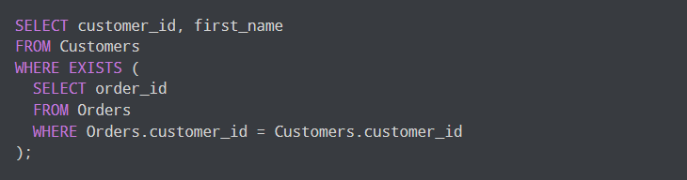

Here is how the SQL command works:

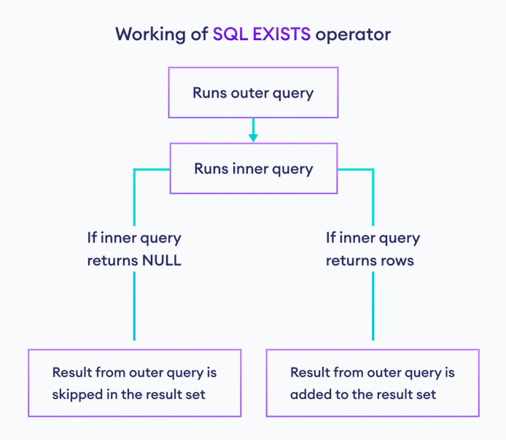

This process is repeated for each row of the outer query.

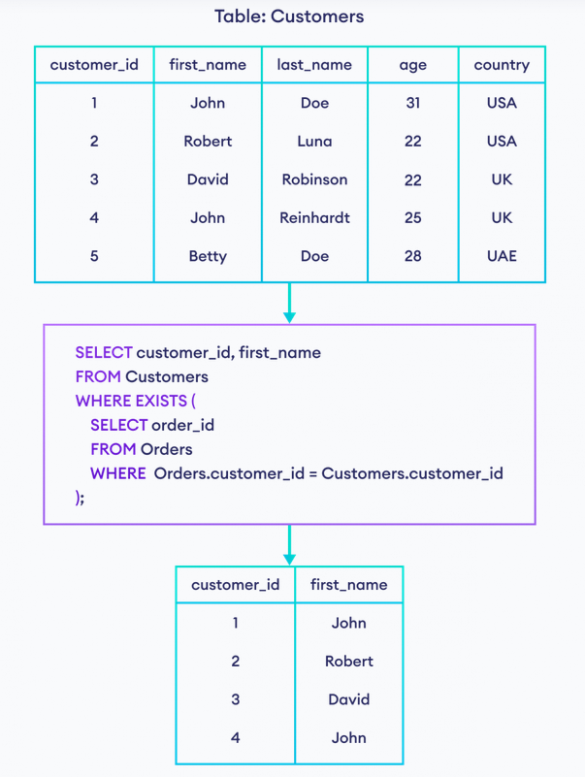

## SQL NOT EXISTS

We can also use the [NOT](https://www.programiz.com/sql/and-or-not) operator to inverse the working of the EXISTS clause. The SQL command executes if the [subquery](https://www.programiz.com/sql/subquery) returns an empty result-set. For example,

Example:

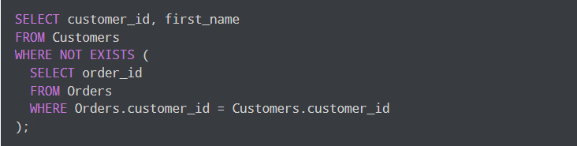

Here, the SQL command returns a row from the Customers table if the related row is not in the Orders table.

SQL Any and All operators

The SQL ANY and ALL Operators

The ANY and ALL operators allow you to perform a comparison between a single column value and a range of other values.

The SQL ANY Operator

The ANY operator:

* Returns a Boolean value as a result.
* Returns TRUE IF ANY of the subquery values meet the condition.

ANY means that the condition will be TRUE if the operation is true for any of the values in the range.

**ANY Syntax**

SELECT column_name(s)  
FROM table_name  
WHERE column_name operator ANY  
  (SELECT column_name  FROM table_name  WHERE condition);

**NOTE:** The operator must be a standard comparison operator (=,<>, !=, >, >=, <, or <=)

Example:

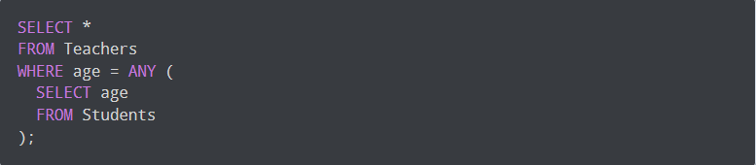

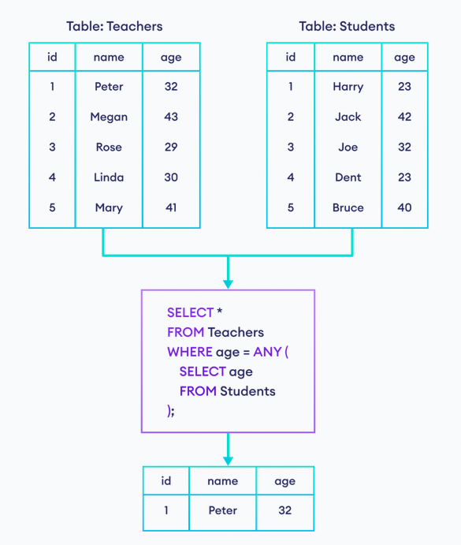

The SQL ALL Operator

The ALL operator:

* Returns a Boolean value as a result.
* Returns TRUE if ALL of the subquery values meet the condition.
* Is used with SELECT, WHERE and HAVING statements.

ALL means that the condition will be true only if the operation is true for all values in the range.

**ALL Syntax with SELECT**

SELECT ALL column_name(s)  
FROM table_name  
WHERE condition;

Example:

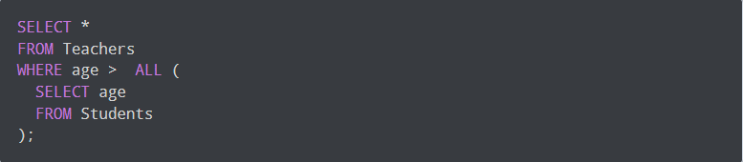

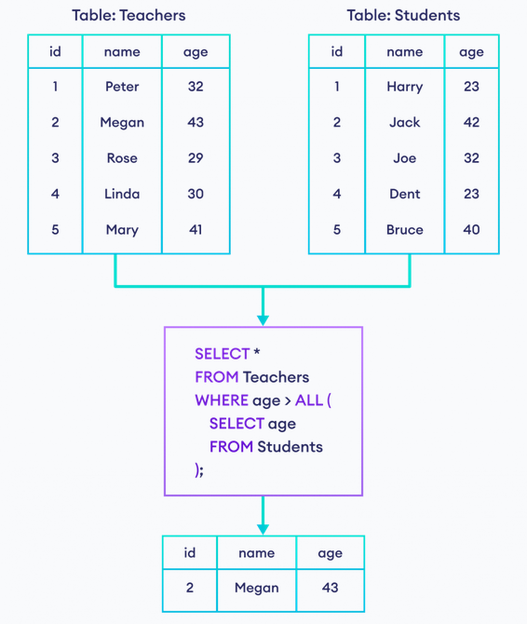

**ALL Syntax with WHERE or HAVING**

SELECT column_name(s)  
FROM table_name  
WHERE column_name operator ALL  
  (SELECT column_name  FROM table_name  WHERE condition);

SQL Select Into

The SELECT INTO statement copies data from one table into a new table.

**SELECT INTO Syntax**

Copy all columns into a new table:

SELECT *  
INTO newtable [IN externaldb]  
FROM oldtableWHERE condition;

Copy only some columns into a new table:

SELECT *column1*, *column2*, *column3*, ...  
INTO *newtable* [IN *externaldb*]  
FROM *oldtable*WHERE *condition;*

The new table will be created with the column-names and types as defined in the old table. You can create new column names using the AS clause.

SQL Insert Into Select

The SQL INSERT INTO SELECT Statement

The INSERT INTO SELECT statement copies data from one table and inserts it into another table.

The INSERT INTO SELECT statement requires that the data types in source and target tables match.

**Note**: The existing records in the target table are unaffected.

**INSERT INTO SELECT Syntax**

Copy all columns from one table to another table:

INSERT INTO table2  
SELECT * FROM table1WHERE condition;

Copy only some columns from one table into another table:

INSERT INTO table2 (column1, column2, column3, ...)  
SELECT column1, column2, column3, ...  
FROM table1  
WHERE condition;

SQL Case

The SQL CASE Statement

The CASE statement goes through conditions and returns a value when the first condition is met (Like an if-then-else statement). So, once a condition is true, it will stop reading and return the result. If no conditions are true, it returns the value in the ELSE clause.

If there is no ELSE part and no conditions are true, it returns NULL.

**CASE Syntax**

CASE  
    WHEN condition1 THEN result1  
    WHEN condition2 THEN result2  
    WHEN conditionN THEN resultN  
    ELSE result  
END;

Example:

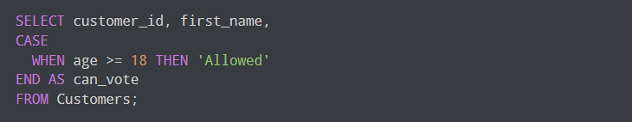

Here, the SQL command checks each row with the given case.

If *age* is greater than or equal to **18**, the result set contains

* columns with *customer_id* and *first_name* with their values
* **Allowed** is returned as a *can_vote* column.

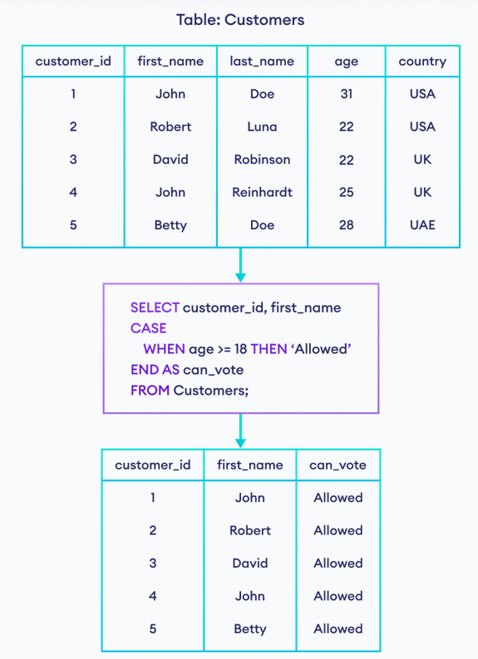

Example 2:

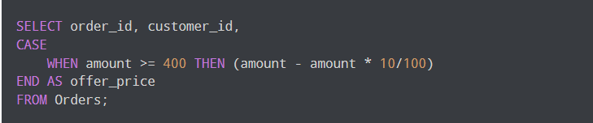

**Multiple Cases:**

It is also possible to stack multiple conditions inside the CASE clause.

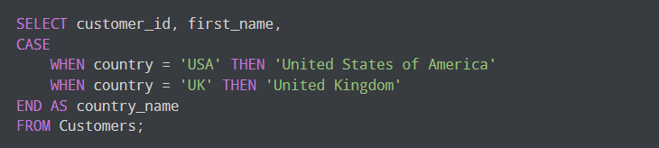

Here, the result set will contain a column named country_name along with customer_id and first_name columns.

The value of country_name will be **United States of America** if the country is equal to **USA**.

Similarly, the value of country_name will be **United Kingdom** if the country is equal to **UK**.

## **CASE With ELSE in SQL:**

A CASE statement can have an optional ELSE clause. The ELSE clause is executed if none of the conditions in the CASE statement is matched. For example,

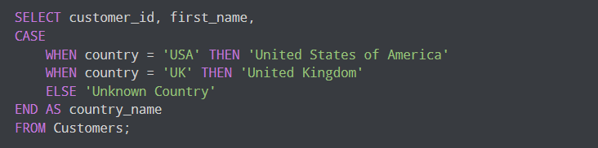

Here, the result set will contain a field named *country_name* along with *customer_id* and *first_name*.

The value of the *country_name* will be:

* **United States of America** if the *country* is **USA**
* **United Kingdom** if the *country* is **UK**
* **Unknown Country** if the *country* is neither **USA** nor **UK** (because of the ELSE clause).

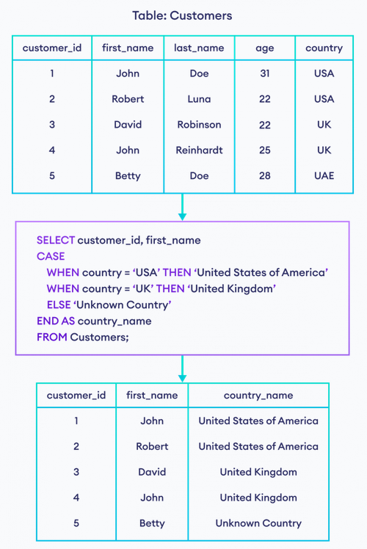

SQL Comments

SQL Comments

Comments are used to explain sections of SQL statements, or to prevent execution of SQL statements.

Single Line Comments

Single line comments start with --.

Any text between –- and the end of the line will be ignored (will not be executed).

The following example uses a single-line comment as an explanation:

--Select all:  
SELECT * FROM Customers;

The Following example uses a single-line comment to ignore the end of a line:

SELECT * FROM Customers -- WHERE City='Berlin';

The Following example uses a single-line comment to ignore a statement:

--SELECT * FROM Customers;  
SELECT * FROM Products;

Multi-line Comments

Multi-line comments start with /* and end with */.

Any text between /* and */ will be ignored.

The following example uses a multi-line comment as an explanation:

/*Select all the columns  
of all the records  
in the Customers table:*/  
SELECT * FROM Customers;

The following example uses a multi-line comment to ignore many statements:

/*SELECT * FROM Customers;  
SELECT * FROM Products;  
SELECT * FROM Orders;  
SELECT * FROM Categories;*/  
SELECT * FROM Suppliers;

To ignore just a part of a statement, also use the /* */ comment.

The following example uses a comment to ignore part of a line:

SELECT CustomerName, /*City,*/ Country FROM Customers;

SQL Sub-Queries

A **Subquery** or **Inner** **query** or a **Nested** **query** is a query within another SQL query and embedded within the WHERE clause.

A subquery is used to return data that will be used in the main query as a condition to further restrict the data to be retrieved.

A subquery is a query that is used within another SQL query embedded in the WHERE clause. Subqueries can be used with the SELECT, INSERT, UPDATE and DELETE statements along with the operators like =, <, >, <=, >=, IN, BETWEEN etc.

## Introduction to Subqueries in SQL

Subqueries also called a **nested query** or **inner query** is a query which is present inside another SQL query. In SQL, it is possible to place a SQL query inside another query. For example,

SELECT *

FROM Students

WHERE marks = (

SELECT max(marks)

FROM Students

);

**Let's take a look at subquery and outer query of the above given example.**

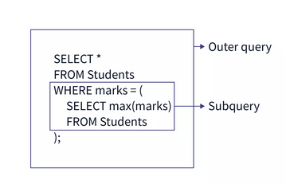

In a subquery, the outer query's result is dependent on the result-set of the inner query. This is the reason why subqueries are also called nested queries.

There are a few rules that subqueries must follow-

* Subqueries must be enclosed within parentheses.
* Subqueries always runs first followed by the main query.
* A subquery can have only one column in the SELECT clause, unless multiple columns are in the main query for the subquery to compare its selected columns.
* An ORDER BY command cannot be used in a subquery, although the main query can use an ORDER BY. The GROUP BY command can be used to perform the same function as the ORDER BY in a subquery.
* Subqueries that return more than one row can only be used with multiple value operators such as the IN operator.
* The SELECT list cannot include any references to values that evaluate to a BLOB, ARRAY, CLOB, or NCLOB.
* A subquery cannot be immediately enclosed in a set function.
* The BETWEEN operator cannot be used with a subquery. However, the BETWEEN operator can be used within the subquery.

Example:

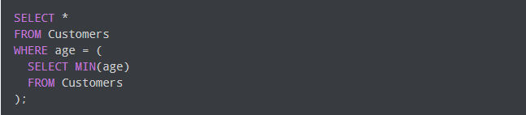

In a subquery, the outer query's result is dependent on the result-set of the inner subquery. That's why subqueries are also called nested queries.

Here, the SQL command

1. executes the subquery first; selects minimum *age* from the *Customers* table.
2. executes the outer query; selects rows where *age* is **equal to the result of subquery.**

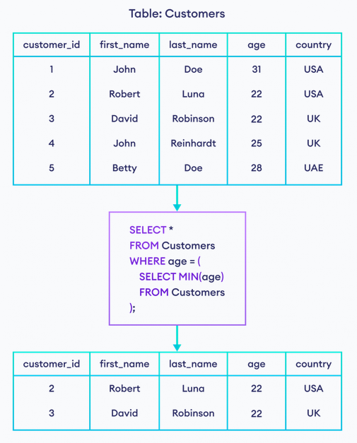

## **SQL Subquery and JOIN:**

In some scenarios, we can get the same result set using a subquery and [the JOIN clause](https://www.programiz.com/sql/join). For example,

The result set of this query

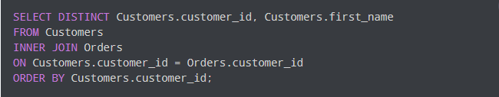

will be the same as

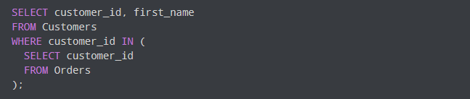

Types of Sub-query:

https://www.scaler.com/topics/sql/types-of-subqueries-in-sql/

# Correlated Subquery:

https://www.scaler.com/topics/sql/correlated-subquery/

SQL Views

SQL CREATE VIEW Statement

In SQL, a view is a virtual table based on the result-set of an SQL statement.

A view contains rows and columns, just like a real table. The fields in a view are fields from one or more real tables in the database.

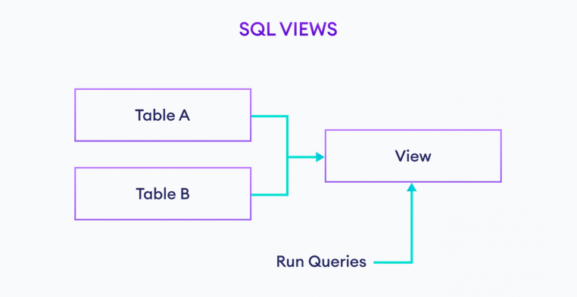

You can add SQL statements and functions to a view and present the data as if the data were coming from one single table.

A view is created with the CREATE VIEW statement.

CREATE VIEW Syntax

CREATE VIEW view_name AS  
SELECT column1, column2, ...  
FROM table_name  
WHERE condition;

Example:  
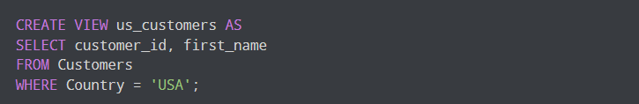

Here, a view named us_customers is created from the customers table.

NOTE: A view always shows up-to-date data! The database engine recreates the view, every time a user queries it.

SQL Updating a View

A view can be updated with the CREATE OR REPLACE VIEW statement.

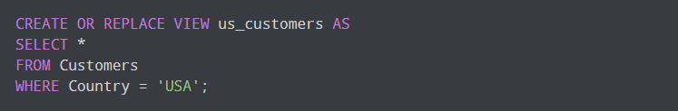

Here, the us_customers view is updated to show all the fields.

SQL CREATE OR REPLACE VIEW Syntax

CREATE OR REPLACE VIEW view_name AS  
SELECT column1, column2, ...  
FROM table_name  
WHERE condition;

SQL Dropping a View

A view is deleted with the DROP VIEW statement.



SQL DROP VIEW Syntax

DROP VIEW view_name;

SQL Window Functions

In SQL, window functions, also known as **analytical functions**, operate similarly to aggregate functions, which compute all table rows in a set. However, window functions differ in that they do not aggregate all rows into a single output row. Instead, these functions return all rows in a table, with a computed column showing the specific function applied to each row.

Window functions applies aggregate and ranking functions over a particular window (set of rows).

Common examples of window functions include

* + **ROW_NUMBER()**
  + **RANK()**
  + **DENSE_RANK()**
  + **LEAD()**
  + **LAG()**

## What are the Window Functions in SQL?

Window functions are used to perform some operation on a group of rows and provide a resultant value for each row in the table. The word **window** in the term "window function" refers to a set of rows in the table on which the function will run. By knowing the working of window functions in SQL, we can solve most of the **complex SQL problems** easily.

For instance, if you need to fetch the top earners from each department in your employee table or show the minimum and maximum salary in each department corresponding to each employee record, you'll likely need to use window functions. Without these functions, such queries could be difficult to write and execute efficiently. This article will explore various examples of SQL queries that benefit from the use of window functions.

Let's first look at the types of functions on which we can apply a window in SQL:

* **Aggregate Window Functions in SQL**
  + SUM()
  + MIN()
  + MAX()
  + COUNT()
  + AVG()
* **Ranking Window Functions in SQL**
  + ROW_NUMBER()
  + RANK()
  + DENSE_RANK()
* **Value Window Functions in SQL**
  + LEAD()
  + LAG()

<https://www.scaler.com/topics/window-function-in-sql/>

<https://www.geeksforgeeks.org/window-functions-in-sql/>

More combinations to consider. With the "UNBOUNDED PRECEDING" and "UNBOUNDED FOLLOWING" clauses, along with the "RANGE" and "ROWS" options, we have a total of eight combinations.

Here are all the combinations:

1. **RANGE BETWEEN UNBOUNDED PRECEDING AND UNBOUNDED FOLLOWING:** Includes all rows within the partition based on the values in the ORDER BY column.
2. **ROWS BETWEEN UNBOUNDED PRECEDING AND UNBOUNDED FOLLOWING:** Includes all rows within the partition based on their physical row positions.
3. **RANGE BETWEEN UNBOUNDED PRECEDING AND CURRENT ROW:** Includes all rows with values in the ORDER BY column from the first row in the partition up to and including the current row.
4. **RANGE BETWEEN CURRENT ROW AND UNBOUNDED FOLLOWING**: Includes all rows with values in the ORDER BY column from the current row up to and including the last row in the partition.
5. **ROWS BETWEEN UNBOUNDED PRECEDING AND CURRENT ROW:** Includes all rows from the first row in the partition up to and including the current row based on their physical row positions.
6. **ROWS BETWEEN CURRENT ROW AND UNBOUNDED FOLLOWING:** Includes all rows from the current row up to and including the last row in the partition based on their physical row positions.
7. **RANGE BETWEEN PRECEDING AND CURRENT ROW:** Includes all rows with values in the ORDER BY column from the row immediately preceding the current row up to and including the current row.
8. **ROWS BETWEEN PRECEDING AND CURRENT ROW:** Includes all rows from the row immediately preceding the current row up to and including the current row based on their physical row positions.

SQL Functions

Suppose SQL function allows you to encapsulate a set of SQL statement into reusable block.

It accepts parameter and return value.

**Syntax:**

CREATE [OR REPLACE] FUNCTION *function_name (parameter1 datatype, parameter2 datatype, ...)*

RETURNS *return_datatype* AS

DECLARE

*-- Optional local variables declaration*

BEGIN

*-- SQL statements or logic here*

RETURN *value; -- Return statement*

END;

**Example:** Write a function such that whatever input the user gives is increment by 100.

CREATE FUNCTION ***add*** *(ip int)*

RETURNS INTEGER

DETERMINISTIC

BEGIN

DECLARE op int;

SET op = ip + 100;

RETURN *op;*

END;

SQL Stored Procedures

In SQL, stored procedure is a set of statement(s) that perform some defined actions. We make stored procedures so that we can reuse statements that are used frequently.r

A stored procedure is a prepared SQL code that you can save, so the code can be reused over and over again.

So, if you have an SQL query that you write over and over again, save it as a stored procedure, and then just call it to execute it. **Stored procedures are similar to functions in programming.**

You can also pass parameters to a stored procedure, so that the stored procedure can act based on the parameter value(s) that is passed.

In stored procedures, there is no mandatory return

### Stored Procedure Syntax

### 

### Execute a Stored Procedure

### 

## Creating a Procedure

We create stored procedures using the CREATE PROCEDURE command followed by SQL commands. For example,

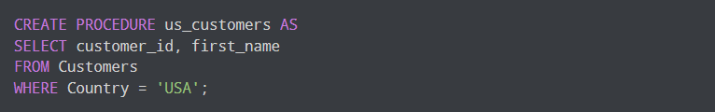

## Executing Stored Procedure

Now whenever we want to fetch all customers who live in the **USA**, we can simply call the procedure mentioned above. For example,

**SQL Server, Oracle**



**PostgreSQL, MySQL**



## Stored Procedure With One Parameter

The following SQL statement creates a stored procedure that selects Customers from a particular City from the "Customers" table:

Example:

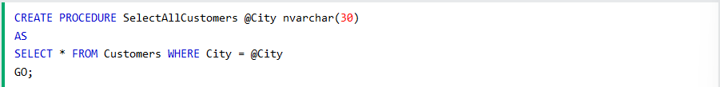

Execute the stored procedure above as follows:



## Stored Procedure With Multiple Parameters

Setting up multiple parameters is very easy. Just list each parameter and the data type separated by a comma as shown below.

The following SQL statement creates a stored procedure that selects Customers from a particular City with a particular PostalCode from the "Customers" table:

Example:

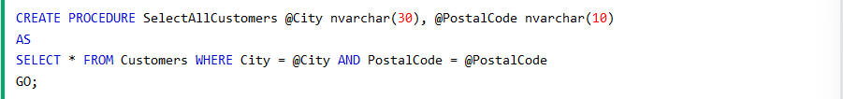

Execute the stored procedure above as follows:



SQL Partition

Suppose you have a data for year 2015 & 2016. If you have to filter the data for year 2016 only, how you will do ?

Simply you can apply WHERE clause. But in where caluse it will scan the whole data and give True where year = 2016 and False where year = 2015 and then filter the rows.

So the problem here is, if we have millions of the data and it takes to much time to scan the whole data.

Here the Partition technique comes,

**Partition technique is mostly used in DB/DBH to divide the data into smaller , more manageable parts.** If you’ve used s3 bucket in AWS, you can understand this, in s3 bucket the data is stored in Partition format.

Because of this it improve the performance, but how ?

Suppose we have a table:

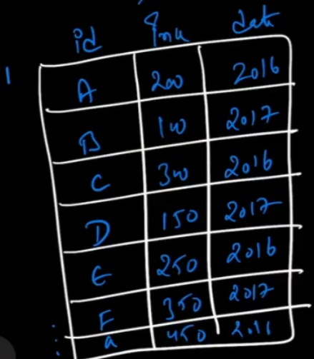

Partition will do:

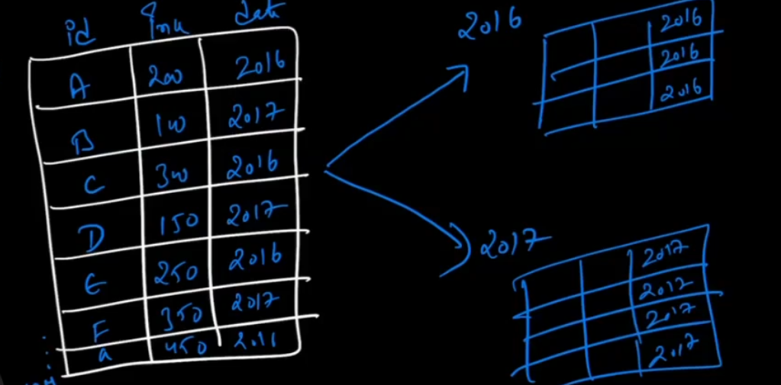

Divide the data into 2 table, 1st for 2016 and 2nd for 2017.

So how can we decide for which column we can do partition ?

Partition is mostly done on data/timestamp column. If you don’t have that column then choose a column that have most repetitive values.

**Syntax:**

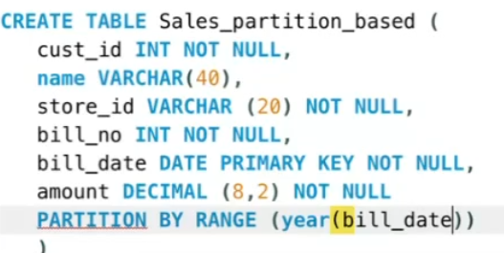

There are three algorithms for partitioning:

* + **Range**: Hardcoding, in this case you will decide that our data will divide in how many parts.

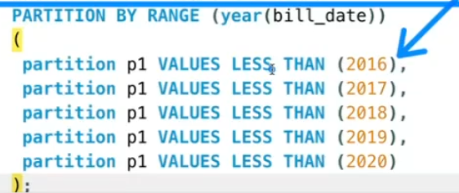

This is the hard coding.

To check if the table is partitioned or not:

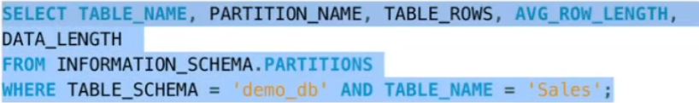

* + **List Partition:**

List is also hardcoded.

Syntax:

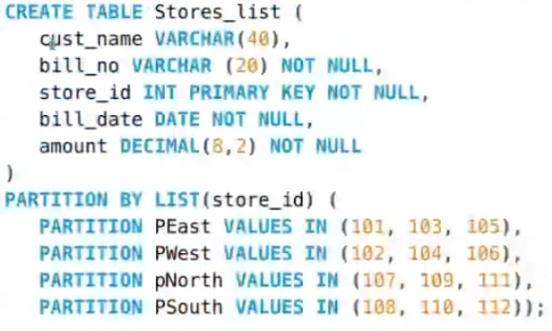

* + **Hash Partition:**

Hash partition is mostly used in industry.

It is same like ntile.

It will use formula to partition.

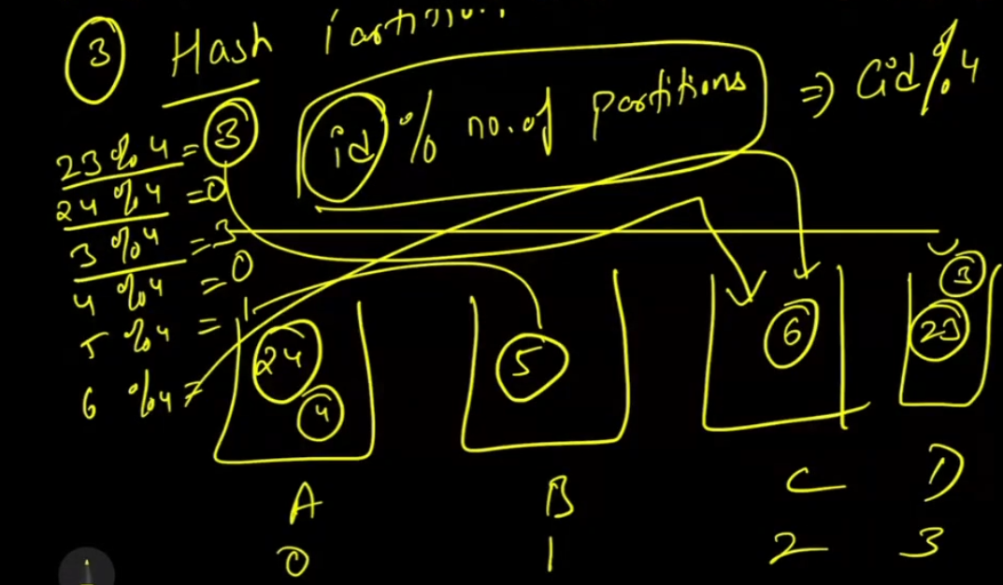

SQL Index

Index is made to execute your query faster. But how ?

Because it store the some info about data, where it stored. If you want to find some info, it will not scan the whole data, it will look into index and then directly go there.

If you want some information about the query, use keyword **EXPLAIN** in front of query.

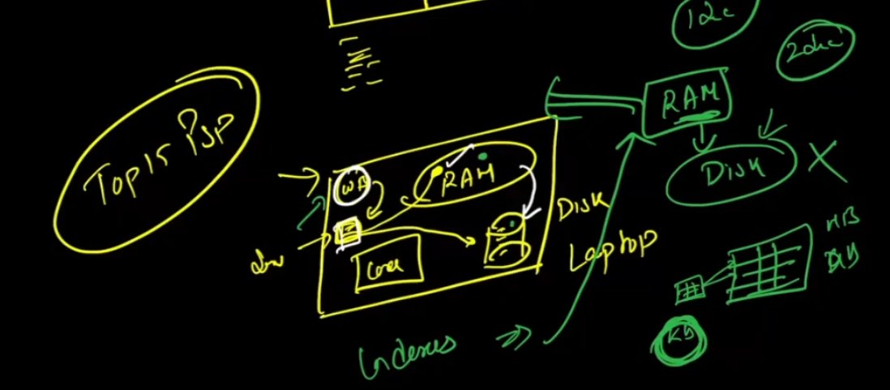

Index is a separate query.

Syntax:



**Without Index:**

It will store into your disk, that’s why it will take more time. And it will scan all the rows.

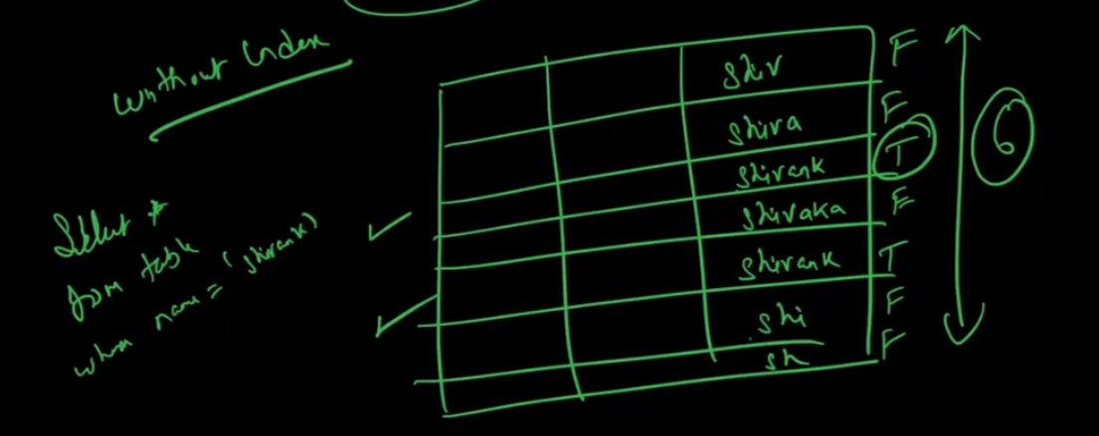

**With Index:**

Asyou create a index, it will store in Ram.

SQL Query Optimisation

If you have three query:

**COUNT(*)**

**COUNT(1)**

**COUNT(COL_NAME)**

Which query will run fast ?

So the answer is, in 2015 the **COUNT(1)** is always gives you the fast response. But now all the three query will give you the same response time.

Always get the relevant number of columns from the table/server. If you use select * from table, it is kill for you.

If you are applying LIMIT, it will not save time/cost, it will filter the data on client server, it will fetch all data from the server and then filter.

Use EXISTS() instead of COUNT().

Use Approximate Aggregate function.

* + APPROX_COUNT_DISTINCT()
  + APPROX_TOP_COUNT()
  + APPROX_TOP_SUM()
  + Etc…………

**Self Join VS Window Function:**

Self join is always inefficient, always try to use window function. Use self join only it is necessary.

**Trim your data Early:**

If you are using CTE/ JOIN/ SUB-QUERY, then filter the data as early as possible.

**WHERE sequence matters:**

Example:

Condition1: Name = ‘Mrunal’

Condition2: Name like ‘M%’

Condition3: Name like ‘%l’

So for this use cond1 first and then 2nd and 3rd condtion.

Use max() instead of Rank()

Part - 3

--------------------SQL Database-------------------

Introduction

There are two types of Database.

* + Paid
  + Open Source (Free)

SQL Create Database

The SQL CREATE DATABASE Statement

The CREATE DATABASE statement is used to create a new SQL database.

The database developers and the users use this statement in SQL for creating the new database in the database systems. It creates the database with the name which has been specified in the CREATE DATABASE statement.

**Syntax**

CREATE DATABASE database_name;

Example:



Here, the SQL command creates a database named my_db.

The Make sure you have the admin privilege before creating any database. Once a database is created, you can check it in the list of databases.

Following are the most important points which are required to learn while creating a database.

* The database we want to create should be a simple and unique name, which can be easily identified.
* Database name should be no more than 128 characters.

## **CREATE DATABASE IF NOT EXISTS:**

If there is already a database with the same name, SQL will throw an error while creating a database.

In such situations, we can use the CREATE DATABASE IF NOT EXISTS statement to create a database only if there is no existing database with the same name. For example,



Here, the SQL command creates a database named my_db only if there is no existing database with the same name.

## **List all Databases**

There could be multiple databases in a database management system. To show the list of databases, we can run the following statement.



Here, the SQL command lists all the available databases in the DBMS.

**Switch Databases**

We have to work across multiple databases from time to time. To switch between available databases, we can run the following statement.



This code selects the my_db database and all SQL operations will be performed inside this database.

SQL Drop Database

The SQL DROP DATABASE Statement

The SQL DROP DATABASE statement deletes the existing database permanently from the database system.

This statement deletes all the views and tables if stored in the database, so be careful while using this query in SQL.

Following are the most important points which are required to learn before removing the database from the database system.

* This statement deletes all the data from the database. If you want to restore the deleted data in the future, you should keep the backup of data of that database which you want to delete.
* Another most important point is that you cannot delete that database from the system which is currently in use by another database user. If you do so, then drop statement shows the following error on screen.

Cannot drop database "name_of_the_database" because it is currently in use.

**Syntax**

DROP DATABASE databasename;

Example:



Here, the SQL command will delete a database named my_db.

Also make sure you have **admin** or **DROP** permission to run this command.

## **List all Databases:**

To verify the drop database, we can run the following command to list the available databases.



Here, the SQL command lists all the available databases in the DBMS.

**NOTE:** Be careful before dropping a database. Deleting a database will result in loss of complete information stored in the database

SQL Backup Database

The SQL BACKUP DATABASE Statement

The BACKUP DATABASE statement is used in SQL server to create a full back up of an existing SQL Datbase.

**Syntax**

BACKUP DATABASE databasename  
TO DISK = 'file_path';

The SQL BACKUP WITH DIFFERENTAL Statement

A differential back up only backs up the parts of the database that have changed since the last full database backup.

**Syntax**

BACKUP DATABASE databasename  
TO DISK = 'filepath'  
WITH DIFFERENTIAL;

SQL Rename Database

In some situations, database users and administrators want to change the name of the database for some technical reasons. So, the RENAME DATABASE statement in SQL is used to change the name of the existing database.

**Syntax**

ALTER DATABASE old_database_name MODIFY NAME = new_database_name

SQL Create Table

The SQL CREATE TABLE Statement

The CREATE TABLE statement is used to create a new table in a database. This involves naming the table and defining its columns and each column’s data type.

**Syntax**

CREATE TABLE table_name (  
    column1 datatype,  
    column2 datatype,  
    column3 datatype,  
   ....  
);

The column parameters specify the names of the columns of the table.

The datatype parameter specifies the type of data the column can hold (e.g. varchar, integer, date, etc).

Example:

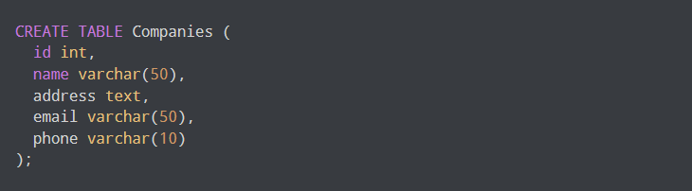

Here, the SQL command creates a database named companies. The table contains column (field) id, name, address, email and phone.

The int, varchar(50) and text are data types that tell what data could be stored in that field. Some commonly used data types are as follows.

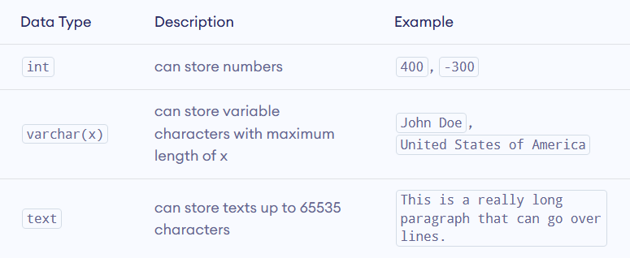

Create table using another table

A copy of an existing table can also be created using CREATE TABLE.

The new table gets the name column definitions. All columns or specific columns can be selected.

If you create a new table using an existing table, the new table will be filled with the existing values from the old table.

**Syntax**

CREATE TABLE new_table_name AS  
    SELECT column1, column2,...  
    FROM existing_table_name  
    WHERE ....;

## **CREATE TABLE IF NOT EXISTS**

While creating a table that already exists, throws an error. To fix this issue, we can add the optional IF NOT EXISTS command while creating a table. For example,

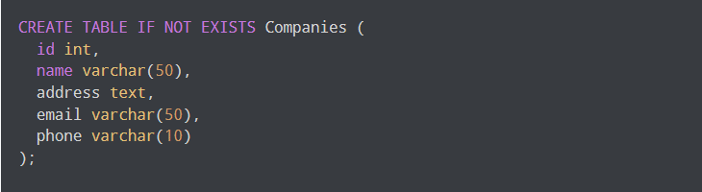

Here, the SQL command will only create a table if there is not one with a similar name.

## **CREATE TABLE AS**

We can also create a table using records from any other existing table using the CREATE TABLE AS command. For example,

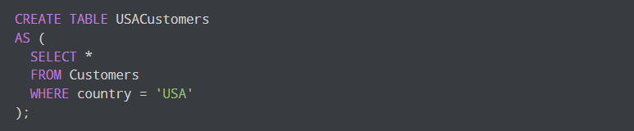

Here, the SQL command creates a table named USACustomers and copies the records of the nested query into the new table.

SQL Drop Table

The SQL DROP TABLE Statement

The DROP TABLE statement is used to remove a table definition and all the data, indexes, triggers, constraints and permission specifications for that table.

**Syntax**

DROP TABLE table_name;

Example:



Here, the SQL command will delete a table named my_table.

Also make sure you have **admin** or **DROP** permission to run this command.

## **DROP TABLE IF EXISTS**

While dropping a table that does not exist, throws an error. To fix this issue, we can add an optional IF EXISTS command while dropping a table. For example,



Here, the SQL command will only drop a table if there is one with a same name.

**NOTE:** Be careful before dropping a table. Deleting a table will result in loss of complete information stored in the table!

SQL TRUNCATE TABLE

The TRUNCATE TABLE statement is used to delete the data inside a table, but not the table itself.

**Syntax**

TRUNCATE TABLE table_name;

SQL Rename Table

In some situations, database administrators and users want to change the name of the table in the in the SQL database because they want to give a more relevant name to the table.

Any database user can easily change the name by using the RENAME TABLE and ALTER TABLE statement in Structured Query Language.

The RENAME TABLE and ALTER TABLE syntax help in changing the name of the table.

**Syntax**

RENAME old_table_name To new_table_name;

SQL Alter Table

SQL ALTER TABLE STATEMENT

The ALTER TABLE statement is used to add, delete, or modify columns in an existing table.

The ALTER TABLE statement is also used to add and drop various constraints on an existing table.

We can change the structure of a table using the ALTER TABLE command. We can

* Add a column
* Rename a column
* Modify a column
* Delete a column
* Rename a table

ALTER TABLE – ADD COLUMN

To add a column in a table, use the following syntax:

ALTER TABLE table_name  
ADD column_name datatype;

Example:

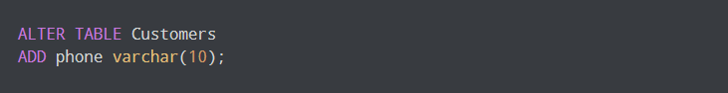

Here, the SQL command adds a column named phone in the Customers table.

## Add Multiple Columns in a Table

We can also add multiple columns at once in a table. For example,



Here, the SQL command adds the phone and age column in the Customers table.

## Rename Column in a Table

We can rename columns in a table using the ALTER TABLE command with the RENAME COLUMN clause. For example,

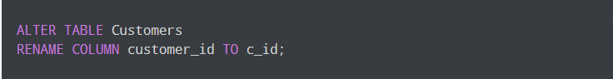

Here, the SQL command changes the column name of customer_id to c_id in the Customers table.

ALTER TABLE – DROP COLUMN

To delete a column in a table, use the following syntax (notice that some database systems don’t allow deleting a column):

ALTER TABLE table_name  
DROP COLUMN column_name;

Example:



Here, the SQL command removes the phone column from the Customers table.

ALTER TABLE – ALTER/MODIFY COLUMN

To change the data type of a column in a table, use the following syntax:

ALTER TABLE table_name  
MODIFY COLUMN column_name datatype;

SQL Constraints

SQL constraints are the rules enforced on the data columns of a table. These are used to limit the type of data that can go into a table. This ensures the accuracy and reliability of the data in the database.

Constraints can be column level or table level. Column level constraints apply to a column, and table level constraints apply to the whole table.

SQL Create Constraints

Constraints can be specified when the table is created with the CREATE TABLE statement, or after the table is created with the ALTER TABLE statement.

**Syntax**

CREATE TABLE table_name (  
    column1 datatype *constraint*,  
    column2 datatype *constraint*,  
    column3 datatype *constraint*,  
    ....  
);

The following constraints are commonly used in SQL:

* NOT NULL- Ensures that a column cannot have a NULL value.
* UNIQUE – Ensures that all values in a column are different.
* PRIMARY KEY – A combination of a NOT NULL and UNIQUE. Uniquely identifies each row in a table.
* FOREIGN KEY – Prevents actions that would destroy links between tables.
* CHECK – Ensures that the values in a column satisfies a specific condition.
* DEFAULT – Sets a default value for a column if no value is specified.
* CREATE INDEX – Used to create and retrieve data from the database very quickly.

SQL Not Null

SQL NOT NULL CONSTRAINT

By default, a column can hold NULL Values.

The NOT NULL constraint enforces a column to NOT accept NULL values.

This enforces a field to always contain a value, which means that you cannot insert a new record, or update a record without adding a value to this field.

SQL Unique Constraint

The UNIQUE constraint ensures that all values in a column are different.

Both the UNIQUE and PRIMARY KEY constraints provide a guarantee for uniqueness for a column or set of columns.

A PRIMARY KEY constraint automatically has a UNIQUE constraint.

However, you can have many UNIQUE constraints per table, but only one PRIMARY KEY constraint per table.

SQL Primary Key Constraint

The PRRIMARY KEY constraint uniquely identifies each record in a table.

Primary key must contain UNIQUE values, and cannot contain NULL values.

If you want to create a primary key, you should define a PRIMARY KEY constraint when you create or modify a table.

A table can have only One primary key; and in the table, this primary key can consist of single or multiple columns (Fields).

When multiple columns are used as a primary key, it is known as **composite primary key.**

Points to remember for primary key:

* Primary key enforces the entity integrity of the table.
* Primary key always has unique data.
* A primary key length cannot be exceeded than 900 bytes.
* A primary key cannot have null value.
* There can be no duplicate value for a primary key.
* A table can contain only one primary key constraint.

SQL primary key for one column:

The following SQL command creates a PRIMARY KEY on the “S_ID” column when the “students” table is created.

**MySQL:**

CREATE TABLE students

(

S_Id int NOT NULL,

LastName varchar (255) NOT NULL,

FirstName varchar (255),

Address varchar (255),

City varchar (255),

PRIMARY KEY (S_Id)

)

**SQL Server, Oracle, MS Access:**

CREATE TABLE students

(

S_Id int NOT NULL,  PRIMARY KEY ,

LastName varchar (255) NOT NULL,

FirstName varchar (255),

Address varchar (255),

City varchar (255),

)

SQL primary key for multiple columns:

**MySQL, SQL Server, Oracle, MS Access**

CREATE TABLE students

(

S_Id int NOT NULL,

LastName varchar (255) NOT NULL,

FirstName varchar (255),

Address varchar (255),

City varchar (255),

CONSTRAINT pk_StudentID PRIMARY KEY (S_ID, LastName)

)

**NOTE:** You should note that in the above example there is only one PRIMARY KEY (pk_StudentsID). However it is made up of two columns (S_Id and LastName)

Example:

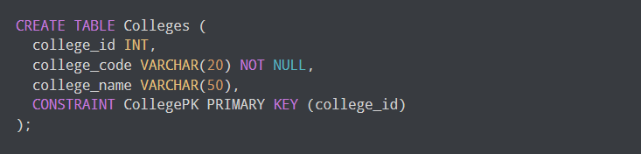

Here, the college_id column is the PRIMARY KEY. This means, the values of this column must be unique as well as it cannot contain NULL values.

SQL primary key on ALTER TABLE

When table is already created and you want to create a PRIMARY KEY constraint on the “S_Id” column you should use the following SQL:

**Primary key on one column:**

ALTER TABLE students

ADD PRIMARYKEY   (S_Id)

**Primary key on multiple column:**

ALTER TABLE students

ADD CONSTRAINT pk_StudentID PRIMARYKEY (S_Id,Last_Name)

How to DROP a PRIMARY KEY constraint ?

If you want to DROP (remove) a primary key constraint, you should use following syntax:

**MySQL:**

ALTER TABLE students

DROP PRIMARY KEY

**SQL Server/ Oracle/ MS Access**

ALTER TABLE students

DROP CONSTRAINT pk_StudentID

SQL Foreign Key Constraint

SQL FOREIGN KEY CONSTRAINT

In the relational databases, a foreign key is a field or a column that is used to establish a link between two tables.

The FOREIGN KEY constraint is used to prevent actions that would destroy links between tables.

A FOREIGN KEY is a field (or collection of fields) in one table, that refers to the PRIMARY KEY in another table. In simple words you can say that, a foreign key in one table used to point primary key in another table.

The table with the foreign key is called the child table, and the table with the primary key is called the referenced or parent table.

Look at the following two tables:

**Person table**

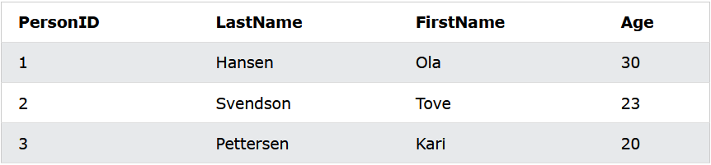

**Orders table**

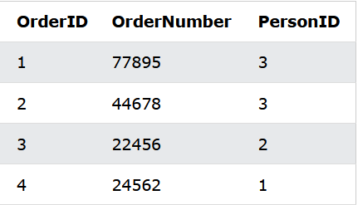

Notice that the “PersonID” column in the “Orders” table points to the “PersonID” column in the “Persons” table.

The “PersonID” column in the “Persons” table is the PRIMARY KEY in the “Persons” table.

The “PersonID” column in the “Orders” table is a FOREIGN KEY in the “Orders” table.

The FOREIGN KEY constraint prevents invalid data from being inserted into the foreign key column, because it has to be one of the values contained in the parent table.

SQL FOREIGN KEY constraint ON CREATE TABLE:

To create a foreign key on the “S_Id” column when the “Orders” table is created:

**MySQL:**

CREATE TABLE orders

(

O_Id int NOT NULL,

Order_No int NOT NULL,

S_Id int,

PRIMArY KEY (O_Id),

FOREIGN KEY (S_Id) REFERENCES Persons (S_Id)

)

**SQL Server/ Oracle/ MS Access:**

CREATE TABLE Orders

(

O_Id int NOT NULL PRIMARY KEY,

Order_No int NOT NULL,

S_Id int,

S_Id int FOREIGN KEY REFERENCES Persons (S_Id)

)

SQL FOREIGN KEY constraint for ALTER TABLE:

If the order table is already created and you want to create a FOREIGN KEY constraint on the “S_Id” column, you should write the following syntax:

**MySQL/ SQL Server/ Oracle/ MS Access:**

ALTER TABLE Orders

ADD CONSTRAINT fk_PerOders

FOREIGN KEY (S_Id)

REFERENCES Students (S_Id)

DROP SYNTAX for FOREIGN KEY CONSTRAINT:

If you want to drop a FOREIGN KEY constraint, use the following syntax:

**MySQL:**

ALTER TABLE Orders

ROP FOREIGN KEY fk_PerOrders

**SQL Server/ Oracle/ MS Access:**

ALTER TABLE Orders

DROP CONSTRAINT fk_PerOrders

Difference between primary key and foreign key in SQL:

These are some important difference between primary key and foreign key in SQL:

* Primary key cannot be null on the other hand foreign key can be null.
* Primary key is always unique while foreign key can be duplicated.
* Primary key is uniquely identify a record in a table while foreign key is a field in a table that is primary key in the table.
* There is only one primary key in the table on the other hand we can have more than one foreign key in the table.
* By default primary key adds a clustered index on the other hand foreign key does not automatically create an index, clustered or no-clustered. You must manually create an index for foreign key.

SQL Check

SQL CHECK CONSTRAINT

The CHECK constraint is used to limit the value range that can be placed in a column.

If you define a CHECK constraint on a column it will allow only certain values for this column.

If you define a CHECK constraint on a table it can limit the values in certain columns based on values in other columns in the row.

SQL CHECK on CREATE TABLE

The following SQL creates a CHECK constraint on the ‘Age’ column when the ‘persons’ table is created. The CHECK constraint ensures that the age of a person must be 18, or older:

CREATE TABLE Persons (  
    ID int NOT NULL,  
    LastName varchar(255) NOT NULL,  
    FirstName varchar(255),  
    Age int,  
    CHECK (Age>=18)  
);

SQL CHECK on ALTER TABLE

To create a CHECK constraint on the “Age” column when the table is already created, use the following SQL:

ALTER TABLE Persons  
ADD CHECK (Age>=18);

To allow naming of a CHECK constraint, and for defining a CHECK constraint on multiple columns, use the following SQL syntax:

ALTER TABLE Persons  
ADD CONSTRAINT CHK_PersonAge CHECK (Age>=18 AND City='Sandnes');

DROP a CHECK Constraint

To drop a CHECK constraint, use the following SQL:

ALTER TABLE Persons  
DROP CHECK CHK_PersonAge;

SQL Default Constraint

SQL DEFAULT Constraint

The DEFAULT constraint is used to set a default value for a column.

The default value will be added to all new records, if no other value is specified.

SQL DEFAULT on CREATE TABLE

The following SQL sets a DEFAULT value for the “City” column when the “Person” table is created:

CREATE TABLE Persons (  
    ID int NOT NULL,  
    LastName varchar(255) NOT NULL,  
    FirstName varchar(255),  
    Age int,  
    City varchar(255) DEFAULT 'Sandnes'  
);

The DEFAULT constraint can also be used to insert system values, by using functions like GETDATE():

CREATE TABLE Orders (  
    ID int NOT NULL,  
    OrderNumber int NOT NULL,  
    OrderDate date DEFAULT GETDATE()  
);

SQL DEFAULT on ALTER TABLE

To create a DEFAULT constraint on the “City” column when the table is already created, use the following SQL:

ALTER TABLE Persons  
ALTER City SET DEFAULT 'Sandnes';

DROP a DEFAULT Constraint

To drop a DEFAULT constraint, use the following SQL:

ALTER TABLE Persons  
ALTER City DROP DEFAULT;

SQL Create Index

SQL CREATE INDEX Statement

The CREATE INDEX statement is used to create indexes in tables.

Indexes are used to retrieve data from the database more quickly than otherwise. The users cannot see the indexes, they are just used to speed up searches/queries.

NOTE: Updating a table with indexes takes more time than updating a table without (because the indexes also need an update). So, only create indexes on columns that will be frequently searched against.

CREATE INDEX Syntax

Creates an index on a table. Duplicate values are allowed:

CREATE INDEX index_name  
ON table_name (column1, column2, ...);

CREATE UNIQUE INDEX Syntax

Creates a unique index on a table. Duplicate values are not allowed:

CREATE UNIQUE INDEX index_name  
ON table_name (column1, column2, ...);

DROP INDEX Statement

ALTER TABLE table_nameDROP INDEX index_name;The

SQL Auto Increment Field

AUTO INCREMENT FIELD

Auto-increment allows a unique number to be generated automatically when a new record is inserted into a table.

Often this is the primary key field that we would like to be created automatically every time a new record is inserted.

Syntax for MySQL

The following SQL statement defines the “Personid” column to be an auto-increment primary key field in the “Person” table:

CREATE TABLE Persons (  
    Personid int NOT NULL AUTO_INCREMENT,  
    LastName varchar(255) NOT NULL,  
    FirstName varchar(255),  
    Age int,  
    PRIMARY KEY (Personid)  
);

MySQL uses the AUTO_INCREMENT keyword to perform an auto-increment feature.

By default, the starting value for AUTO_INCREMENT is 1, and it will increment by 1 for each new record.

To let the AUTO_INCREMENT sequence start with another value, use the following SQL statement:

ALTER TABLE Persons AUTO_INCREMENT=100;

To insert a new record into the “Person” table, we will NOT have to specify a value for the “Personid” column (a unique value will be added automatically):

INSERT INTO Persons (FirstName,LastName)  
VALUES ('Lars','Monsen');

The SQL statement above would insert a new record into the “Persons” table. The “Personid” column would be assigned a unique value. The “FirstName” column would be set to “Lars” and the “LastName” column would be set to “Monsen”.

SQL Dates

SQL DATES

The most difficult part when working with dates is to be sure that the format of the date you are trying to insert, matches the format of the data column in the database.

As long as your data contain only the date portion, your queries will work as expected. However, if a time portion is involved, it gets more complicated.

SQL DATE DATA TYPES

SQL Server comes with the following data types for storing a date or a data/time value in the database:

* DATE – Format YYYY-MM-DD
* DATETIME – Format: YYYY-MM-DD HH:MI:SS
* SMALLDATATIME – Format: YYYY-MM-DD HH:MI:SS
* TIMESTAMP – Format: a unique number

SQL Working with Dates

Look at the following table:

**Orders Table**

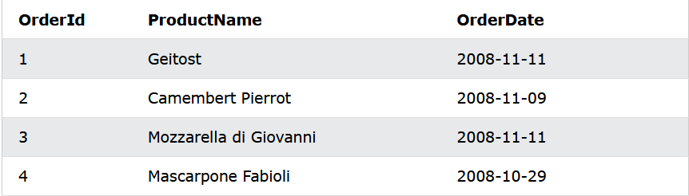

Now we want to select the records with an OrderDate of “2008-11-11” from the table above.

We use the following SELECT statement:

SELECT * FROM Orders WHERE OrderDate='2008-11-11'

The result-set will look like this:

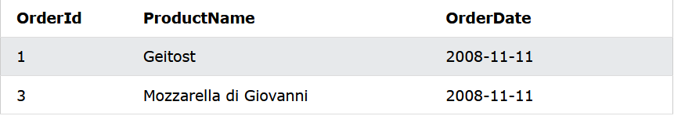

NOTE: Two dates can easily be compared if there is no time component involved!

References:

1. *Learning SQL book (By Alan Beaulieu)*
2. *W3School (Website)*
3. *Tutorialpoint (website)*
4. *Javatpoint (website)*
5. *Guru99 (website)*
6. *Geeksforgeeks (website)*
7. *The Complete SQL Bootcamp 2022: Go from Zero to Hero (Udemy)*
8. *Programming Foundations: Databases (Linkedin)*
9. *SQL Essential Training (Linkedin)*

To find the symbol in row/string, use following syntax:

SELECT *

FROM table_name

WHERE col_name LIKE '%/_%' ESCAPE '/';

It will return all the rows that contain the ‘/’ .

Mathematical Function in SQL:

* **ABS(X):**

This function returns the absolute value of X. For example –

Select abs(-6);

This return 6.

* **MOD(X,Y):**

The variable X is divided by Y and their remainder is returned. For example –

Select mod(9,5);

This returns 4.

* **SIGN(X):**

This method returns 1 if X is positive, -1 if it is negative and 0 if the value of X is 0.

For example-

Select sign(10);

This returns 1.

* **FLOOR(X):**

This returns the largest integer value that is either less than X or equal to it. For example-

Select floor(5.7);

This returns 5.

* **CEIL(X):**

This returns the smallest integer value that is either more than X or equal to it. For example-

Select ceil(5.7);

This return 6.

* **POWER(X,Y):**

This function returns the value of X raised to the power of Y. For example-

Select power(2,5);

This returns 32.

* **ROUND(X):**

This function returns the value of X rounded off to the whole integer that is nearest to it. For example –

Select round(5.7);

This returns 6.

* **SORT(X):**

This function returns the square root of X. For example-

Select sqrt(9);

This returns 3.

* **ASIN(X):**

This function accepts a Sin value as the input and returns the angle in radians. For example-

Select asin(0);

This return 0

* **ACOS(X):**

This function accepts a Cos value as the input and returns the angle in radians. For example –

Select acos(1);

This returns 0.

* **ATAN(X):**

This function accepts a Tan value as the input and returns the angle in radians. For example-

Select atan(0);

This returns 0.

* **SIN(X):**

This function accepts an angle in radians as its parameter and returns its sine value. For example-

Select sin(0);

This returns 0.

* **COS(X):**

This function accepts an angle in radians as its parameter and returns its cosine value. For example-

Select cos(0);

This returns 1.

* **TAN(X):**

This function accepts an angle in radians as its parameter and returns its Tan value. For example –

Select tan(0);

This returns 0.

**OVER clause:**

* If you want to understand the over clause, go through below link.

<https://learnsql.com/blog/over-clause-mysql/>

SQL Keywords

* **ADD**: Adds a column in an existing table.
* **ADD** **CONSTRAINT**: Adds a constraint after a table is already created.
* **ALL**: Returns true if all of the subquery values meet the passes condition.
* **ALTER**: Adds, deletes, or modifies columns in a table, or changes the data type of a column in a table.
* **ALTER** **TABLE**: Adds, deletes or edits columns in a table. It can also be used to and delete constraints in a table, as per the above.
* **ALTER** **COLUMN**: Change the data type of a table’s column.
* **AND**: Used to join separate conditions within a WHERE clause. Only includes rows where both conditions is true.
* **ANY**: Returns true if any of the subquery values meet the given condition.
* **AS**: Renames a table or column with an alias value which only exists for the duration of the query.
* **ASC**: Used with ORDER BY to return the data in ascending order.
* **BETWEEN**: Selects values within the given range.
* **CASE**: Changes query output depending on conditions.
* **CHECK**: Adds a constraint that limits the value which can be added to a column.
* **COLUMN**: Changes the data type of a column or deletes a column in a table.
* **CONSTRAINT**: ADDs or deletes a constraint.
* **CREATE**: Creates a database, index, view, table or procedure.
* **CREATE** **DATABASE**: Creates a new SQL database.
* **CREATE** **INDEX**: Creates an index on a table (allows duplicate values)
* **CREATE** **OR** **REPLACE** **VIEW**: Updates a view
* **CREATE** **TABLE:** Creates a new table in the database.
* **CREATE** **PROCEDURE**: Creates a stored procedure.
* **CREATE** **UNIQUE** **INDEX**: Creates a unique index on a table( No duplicate values )
* **CREATE** **VIEW**: Creates a view based on the result set of a SELECT statement.
* **DATABASE**: Creates or deletes an SQL database.
* **DEFAULT**: A constraint that provides a default value for a column.
* **DELETE**: Deletes rows from a table.
* **DESC**: Sorts the result set in descending order.
* **DISTINCT**: Selects only distinct (different) values.
* **DROP**: Deletes a column, constraint, database, index, table or view.
* **DROP** **COLUMN**: Deletes a column in a table.
* **DROP** **CONSTRAINT**: Deletes a UNIQUE, PRIMARY KEY, FOREIGN KEY, or CHECK constraint.
* **DROP** **DATABASE**: Deletes an existing SQL database.
* **DROP** **DEFAULT**: Deletes a DEFAULT constraint.
* **DROP** **INDEX**: Deletes an index in a table.
* **DROP** **TABLE**: Deletes an existing table in the database.
* **DROP** **VIEW**: Deletes a view.
* **EXEC**: Executes a stored procedure.
* **EXISTS**: Tests for existence of any record in a subquery.
* **FOREIGN** **KEY**: A constraint that is a key used to link two tables together.
* **FROM**: Specifies which table to select or delete data from.
* **FULL** **OUTER** **JOIN**: Returns all rows when there is a match in either left table or right table.
* **GROUP** **BY**: Groups the result set (used with aggregate functions: COUNT, MAX, MIN, SUM, AVG)
* **HAVING**: Used instead of WHERE with aggregate functions.
* **IN:** Allows you to specify multiple values in a WHERE clause.
* **INDEX**: Creates or deletes an index in a table.
* **INNER** **JOIN**: Returns rows that have matching values in both tables.
* **INSERT** **INTO**: Inserts new rows in a table.
* **INSERT** **INTO** **SELECT**: Copies data from one table into another table.
* **IS** **NULL**: Tests for empty values.
* **IS** **NOT** **NULL**: Tests for non-empty values.
* JOIN: Joins tables.
* **LEFT** **JOIN**: Returns all rows from the left table, and the matching rows from the right table.
* **LIKE**: Searches for a specified pattern in a column.
* **LIMIT**: Specifies the number of records to return in the result set.
* **NOT**: Only includes rows where a condition is not true.
* **NOT** **NULL**: A constraint that enforces a column to not accept NULL values.
* **OR**: Includes rows where wither condition is true.
* **ORDER** **BY**: Sorts the result set in ascending or descending order.
* **OUTER** **JOIN**: Returns all rows when there is a match in either left table or right table.
* **PRIMARY** **KEY**: A constraint that uniquely identifies each record in a database table.
* **PROCEDURE**: A stored procedure.
* **RIGHT** **JOIN**: Returns all rows from the right table, and the matching rows from the left table.
* **ROWNUM**: Specifies the number of records to return in the result set.
* **SELECT**: Selects data from a database.
* **SELECT** **DISTINCT**: Selects only distinct(different) values.
* **SELECT** **INTO**: Copies data from one table into a new table.
* **SELECT** **TOP**: Specifies the number of records to return in the result set.
* **SET**: Specifies which columns and values that should be updated in a table.
* **TABLE**: Create a table, or odds, deletes, or modifies columns in table, or deletes a table or data inside a table.
* **TOP**: Specifies the number of records to return in the result set.
* **TRUNCATE** **TABLE**: Deletes the data inside a table, but not the table itself.
* **UNION**: Combines the result set of two or more SELECT statements (only distinct values)
* **UNION** **ALL**: Combines the result set of two or more SELECT statements (allows duplicate values)
* **UPDATE**: Updates existing rows in a table.
* **VALUES**: Specifies the values of an INSERT INTO statement.
* **VIEW**: Creates, updates or deletes a view.
* **WHERE**: Filters a result set to include only records that fulfil a specified condition.

MySQL Functions:

MySQL String Functions:

* **ACSII**: Returns the ASCII value for the specific character.
* **CHAR_LENGTH**: Returns the length of a string (in characters).
* **CHARACTER_LENGTH**: Returns the length of a string (in characters)
* **CONCAT**: Adds two or more expressions together.
* **CONCAT_WS**: Adds two or more expressions together with a separator.
* **FIELD**: Returns the index position of a value in a list of values.
* **FIND_IN_SET**: Returns the index position of a string within a list of strings.
* **FORMAT**: Formats a number to a format like “#,###,###..##”, rounded to a specified number of decimal places.
* **INSERT**: Inserts a string within a string at the specified position and for a certain number of characters.
* **INSTR**: Returns the position of the first occurrence of a string in another string.
* **LCASE**: Converts a string to lower-case.
* **LEFT**: Extracts a number of characters from a string (starting from left)
* **LENGTH**: Returns the length of a string (in bytes)
* **LOCATE**: Returns the position of the first occurrence of a substring in a string.
* **LOWER**: Converts a string to lower-case.
* **LPAD**: Left-pads a string with another string, to a certain length.
* **LTRIM**: Removes leading spaces from a string.
* **MID**: Extracts a substring from a string (starting at any position)
* **POSITION**: Returns the position of the first occurrence of a substring in a string.
* **REPEAT**: Repeats a string as many times as specified.
* **REPLACE**: Replaces all occurrences of a substring within a string, with a new substring.
* **REVERSE**: Reverses a string and returns the result.
* **RIGHT**: Extracts a number of characters from a string (starting from right)
* **RPAID**: Right-pads a string with another string, to a certain length.
* **RTRIM**: Removes trailing spaces from a string.
* **SPACE**: Returns a string of the specified number of space characters.
* **STRCMP**: Compares two strings.
* **SUBSTRING**: Extracts a substring from a string (starting at any position)
* **SUBSTRING_INDEX**: Returns a substring of a string before a specified number of delimiter occurs.
* **TRIM**: Removes leading and trailing spaces from a string.
* **UCASE**: Converts a string to upper-case.
* **UPPER**: Converts a string to upper-case.

MySQL Numeric Functions:

* **ABS**: Returns the absolute value of a number.
* **ACOS**: Returns the arc cosine of a number.
* **ASIN**: Returns the arc sine of a number.
* **ATAN**: Returns the arc tangent of one or two numbers.
* **ATAN2**: Returns the arc tangent of two numbers.
* **AVG**: Returns the average value of an expression.
* **CEIL**: Returns the smallest integer value that is >= to a number.
* **CEILING**: Returns the smallest integer value that is >= to a number.
* **COS**: Returns the cosine of a number.
* **COT**: Returns the cotangent of a number.
* **COUNT**: Returns the number of records returned by a select query.
* **DEGREES**: Converts a value in radians to degrees.
* **DIV**: Used for integer division.
* **EXP**: Returns a raised to the power of a specified number.
* **FLOOR**: Returns the largest integer value that is <= to a number.
* **GREATEST**: Returns the greatest value of the list of arguments.
* **LEAST**: Returns the smallest value of the list of arguments.
* **LN**: Returns the natural logarithm of a number.
* **LOG**: Returns the natural logarithm of a number, or the logarithm of a number to a specified base.
* **LOG10**: Returns the natural logarithm of a number to base 10.
* **LOG2**: Returns the natural logarithms of a number to base 2.
* **MAX**: Returns the maximum value in a set of values.
* **MIN**: Returns the minimum value in a set of values.
* **MOD**: Returns the remainder of a number divided by another number.
* **PI**: Returns the value of PI.
* **POW**: Returns the value of number raised to the power of another number.
* **POWER**: Returns the value of number raised to the power of another number.
* **RADIANS**: Converts a degree value into radians.
* **RAND**: Return a rand number.
* **ROUND**: Rounds a number to a specified number of decimal places.
* **SIGN**: Returns the sign of a number.
* **SIN**: Returns the sine of a number
* **SORT**: Returns the square root of a number.
* **SUM**: Calculates the sum of a set of values.
* **TAN**: Returns the tangent of a number.
* **TRUNCATE**: Truncates a number to the specified number of decimal places.

MySQL Date Functions

* **ADDDATE**: Adds a time/date interval to a date and then returns the data.
* **ADDTIME**: Adds a time interval to a time/datetime and then returns the time/datetime.
* **CURDATE**: Returns the current date.
* **CURRENT_DATE**: Returns the current date.
* **CURRENT_TIME**: Returns the current time.
* **CURRENT_TIMESTAMP**: Returns the current date and time.
* **CURTIME**: Returns the current time.
* **DATE**: Extracts the date part from a datetime expression.
* **DATEDIFF**: Returns the number of days between two data values.
* **DATE_ADD**: Adds a time/data interval to a date and then returns the date.
* **DATE_FORMAT**: Formats a date.
* **DATE_SUB**: Subtracts a time/date interval from a date and then returns the date.
* **DAY**: Returns the day of the month for a given date.
* **DAYNAME**: Returns the weekday name for a given date.
* **DAYOFMONTH**: Returns the day of the month for a given date.
* **DAYOFWEEK**: Returns the weekday index for a given date.
* **DAYOFYEAR**: Returns the day of the year for a given date.
* **EXTRACT**: Extracts a part from a given date.
* **FROM_DAYS**: Returns a date from a numeric datevalue.
* **HOUR**: Returns the hour part for a given date.
* **LAST_DAY**: Extracts the last day of the month for a given date.
* **LOCALTIME**: Returns the current date and time.
* **LOCALTIMESTAMP**: Returns the current date and time.
* **MAKEDATE**: Creates and returns a date based on a year and a number of days value.
* **MICROSECOND**: Returns the microsecond part of a time/datetime.
* **MINUTE**: Returns the minute part of a time/datetime.
* **MONTH**: Returns the month part for a given date.
* **MONTHNAME**: Returns the name of the month for a given date.
* **NOW**: Returns the current data and time.
* **PERIOD_ADD**: Adds a specified number of months to a period.
* **PERIOD_DIFF**: Returns the difference between two periods.
* **QUARTER**: Returns the quarter of the year for a given date value.
* **SECOND**: Returns the seconds part of a time/datetime.
* **SEC_TO_TIME**: Returns a time value based on the specified seconds.
* **SEC_TO_DATE**: Returns a date based on a string and a format.
* **SUBDATE**: Subtracts a time/date interval from a date and then returns the date.
* **SUBTIME**: Subtracts a time interval from a datetime and then returns the time/datetime.
* **SYSDATE**: Returns the current data and time.
* **TIME**: Extracts the time part from a given time/datetime.
* **TIME_FORMAT**: Formats a time by a specified format.
* **TIME_TO_SEC**: Converts a time value into seconds.
* **TIMEDIFF**: Returns the difference between two time/datetime expressions.
* **TIMESTAMP**: Returns the difference value based on a date and datetime value
* **TO_DAYS**: Returns the number of days between a date and date “0000-00-00”
* **WEEK**: Returns the week number for a given date.
* **WEEKDAY**: Returns the weekday number for a given date.
* **WEEKOFYEAR**: Returns the week number for a given date.
* **YEAR**: Returns the year part for a given date.
* **YEARWEEK**: Returns the year and week number for a given date.

MySQL Advanced Functions:

* **BIN**: Returns a binary representation of a number.
* **BINARY**: Converts a value to a binary string.
* **CASE**: Goes through conditions and return a value when the first condition is met.
* **CAST**: Converts a value (of any type) into a specified datatype.
* **COALESCE**: Returns the first non-null value in a list.
* **CONNECTION_ID**: Returns the unique connection ID for the current connection.
* **CONV**: Converts a number from one numeric base system to another.
* **CONVERT**: Converts a value into the specified datatype or character set.
* **CURRENT_USER**: Returns the user name and host name for the MySQL account that the server used to authenticate the current client.
* **DATABASE**: Returns the name of the current database.
* **IF**: Returns a value if a condition is TRUE, or another value if a condition is FALSE.
* **IFNULL**: Return a specified value if the expression is NULL, otherwise return the expression.
* **ISNULL**: Returns 1 and 0 depending on whether an expression is NULL.
* **LAST_INSERT_ID**: Returns the AUTO_INCREMENT id of the last row that has been inserted or updated in a table.
* **NULLIF**: Compares two expressions and returns NULL if they are equal. Otherwise, the first expression is returned.
* **SESSION_USER**: Returns the current MySQL user name and host name.
* **SYSTEM_USER**: Returns the current MySQL user name and host name.
* **USER**: Returns the current MySQL user name and host name.
* **VERSION**: Returns the current version of the MySQL database

## Below are 100 SQL functions and statements with brief explanations and examples:

**Data Retrieval and Filtering (SELECT Statements):**

1. **SELECT**: Retrieves data from one or more tables. Example: SELECT * FROM employees;
2. **FROM**: Specifies the source table(s) for a query. Example: SELECT name, age FROM employees;
3. **WHERE**: Filters rows based on a condition. Example: SELECT * FROM orders WHERE status = 'Shipped';
4. **ORDER BY**: Sorts the result set based on specified columns. Example: SELECT product_name, price FROM products ORDER BY price DESC;
5. **GROUP BY**: Groups rows with similar values in specified columns. Example: SELECT department, AVG(salary) FROM employees GROUP BY department;
6. **HAVING**: Filters groups created by GROUP BY clause. Example: SELECT department, AVG(salary) FROM employees GROUP BY department HAVING AVG(salary) > 50000;
7. **JOIN**: Combines rows from multiple tables based on related columns. Example: SELECT customers.name, orders.order_date FROM customers INNER JOIN orders ON customers.id = orders.customer_id;
8. **LEFT JOIN**: Retrieves all records from the left table and matching records from the right table. Example: SELECT customers.name, orders.order_date FROM customers LEFT JOIN orders ON customers.id = orders.customer_id;
9. **RIGHT JOIN**: Retrieves all records from the right table and matching records from the left table. Example: SELECT orders.order_date, customers.name FROM orders RIGHT JOIN customers ON orders.customer_id = customers.id;
10. **FULL JOIN**: Retrieves all records when there's a match in either the left or right table. Example: SELECT customers.name, orders.order_date FROM customers FULL JOIN orders ON customers.id = orders.customer_id;
11. **COUNT**: Counts the number of rows. Example: SELECT COUNT(*) FROM employees;
12. **SUM**: Calculates the sum of values in a column. Example: SELECT SUM(quantity) FROM order_items;
13. **AVG**: Calculates the average value of a column. Example: SELECT AVG(salary) FROM employees;
14. **MIN**: Returns the minimum value from a column. Example: SELECT MIN(price) FROM products;
15. **MAX**: Returns the maximum value from a column. Example: SELECT MAX(age) FROM customers;
16. **DISTINCT**: Removes duplicates from the result set. Example: SELECT DISTINCT department FROM employees;
17. **LIKE**: Searches for a specified pattern in a column. Example: SELECT name FROM customers WHERE name LIKE 'J%';
18. **IN**: Checks if a value matches any value in a list. Example: SELECT product_name FROM products WHERE category_id IN (1, 3, 5);
19. **BETWEEN**: Filters rows within a range. Example: SELECT order_date FROM orders WHERE order_date BETWEEN '2023-01-01' AND '2023-03-31';
20. **NULL**: Filters rows with NULL values. Example: SELECT name FROM employees WHERE manager_id IS NULL;
21. **CASE**: Performs conditional logic in queries. Example: SELECT name, CASE WHEN age < 18 THEN 'Minor' ELSE 'Adult' END AS age_group FROM customers;
22. **COALESCE**: Returns the first non-NULL value in a list. Example: SELECT COALESCE(preferred_name, first_name) AS name FROM employees;
23. **CONCAT**: Concatenates strings. Example: SELECT CONCAT(first_name, ' ', last_name) AS full_name FROM employees;
24. **UPPER**: Converts a string to uppercase. Example: SELECT UPPER(product_name) FROM products;
25. **LOWER**: Converts a string to lowercase. Example: SELECT LOWER(city) FROM customers;
26. **LENGTH/LEN**: Returns the length of a string. Example: SELECT LENGTH(description) FROM products;
27. **SUBSTRING/SUBSTR**: Extracts a substring from a string. Example: SELECT SUBSTRING(title, 1, 10) FROM books;
28. **LTRIM/RTRIM/TRIM**: Removes spaces from the left/right/both sides of a string. Example: SELECT TRIM(' hello ') FROM dual;
29. **DATEFORMAT**: Formats a date or time value. Example: SELECT DATEFORMAT(order_date, 'YYYY-MM-DD') FROM orders;
30. **GETDATE/NOW/CURRENT_TIMESTAMP**: Retrieves the current date and time. Example: SELECT GETDATE();
31. **DATEPART/EXTRACT**: Extracts parts (year, month, etc.) from a date or time. Example: SELECT DATEPART(year, order_date) FROM orders;
32. **DATEDIFF**: Calculates the difference between two dates. Example: SELECT DATEDIFF(day, start_date, end_date) FROM projects;
33. **IS NULL/IS NOT NULL**: Checks for NULL values. Example: SELECT name FROM employees WHERE manager_id IS NOT NULL;
34. **COUNT(CASE WHEN... END)**: Conditional count in aggregate functions. Example: SELECT department, COUNT(CASE WHEN salary > 50000 THEN 1 ELSE NULL END) AS high_earners FROM employees GROUP BY department;
35. **SUM(CASE WHEN... END)**: Conditional sum in aggregate functions. Example: SELECT department, SUM(CASE WHEN status = 'Shipped' THEN total_amount ELSE 0 END) AS total_shipped FROM orders GROUP BY department;
36. **EXISTS**: Checks if a subquery returns any rows. Example: SELECT name FROM customers WHERE EXISTS (SELECT * FROM orders WHERE customers.id = orders.customer_id);
37. **UNION**: Combines the result sets of two or more SELECT statements. Example: (SELECT first_name FROM employees) UNION (SELECT company_name FROM customers);
38. **UNION ALL**: Similar to UNION, but includes duplicate rows. Example: (SELECT product_name FROM products) UNION ALL (SELECT product_name FROM archived_products);
39. **INNER JOIN**: Retrieves records that have matching values in both tables. Example: SELECT customers.name, orders.order_date FROM customers INNER JOIN orders ON customers.id = orders.customer_id;
40. **LEFT JOIN**: Retrieves all records from the left table and matching records from the right table. Example: SELECT customers.name, orders.order_date FROM customers LEFT JOIN orders ON customers.id = orders.customer_id;
41. **RIGHT JOIN**: Retrieves all records from the right table and matching records from the left table. Example: SELECT orders.order_date, customers.name FROM orders RIGHT JOIN customers ON orders.customer_id = customers.id;
42. **FULL JOIN**: Retrieves all records when there's a match in either the left or right table. Example: SELECT customers.name, orders.order_date FROM customers FULL JOIN orders ON customers.id = orders.customer_id;
43. **SELF JOIN**: Joining a table with itself to create relationships between rows. Example: SELECT e1.name, e2.name AS manager FROM employees e1 INNER JOIN employees e2 ON e1.manager_id = e2.id;
44. **LIMIT/OFFSET (for pagination)**: Limits the number of rows returned and sets an offset. Example: SELECT * FROM products LIMIT 10 OFFSET 20;
45. **CASE Expression**: Returns a value based on a condition. Example: SELECT name, CASE WHEN age < 18 THEN 'Minor' ELSE 'Adult' END AS age_group FROM customers;
46. **COALESCE**: Returns the first non-null value in a list. Example: SELECT COALESCE(preferred_name, first_name) AS name FROM employees;
47. **INNER JOIN with Multiple Conditions**: Joining tables with multiple matching conditions. Example: SELECT orders.order_id, customers.name FROM orders INNER JOIN customers ON orders.customer_id = customers.customer_id AND orders.status = 'Shipped';
48. **UPDATE**: Modifies existing records in a table. Example: UPDATE products SET price = price * 1.1 WHERE category_id = 2;
49. **DELETE**: Removes records from a table. Example: DELETE FROM customers WHERE last_purchase_date < '2022-01-01';
50. **INSERT INTO**: Adds new records to a table. Example: INSERT INTO employees (name, age, salary) VALUES ('John Smith', 30, 60000);

## Data Manipulation (INSERT, UPDATE, DELETE):

1. **INSERT INTO**: Adds new records to a table. Example: INSERT INTO employees (name, age, salary) VALUES ('John Smith', 30, 60000);
2. **UPDATE**: Modifies existing records in a table. Example: UPDATE products SET price = price * 1.1 WHERE category_id = 2;
3. **DELETE**: Removes records from a table. Example: DELETE FROM customers WHERE last_purchase_date < '2022-01-01';
4. **INSERT INTO with SELECT**: Inserts rows into a table based on the result of a SELECT query. Example: INSERT INTO archived_orders SELECT * FROM orders WHERE order_date < '2022-01-01';
5. **UPDATE with JOIN**: Updates records using a join with another table. Example: UPDATE products SET category_id = 5 FROM categories WHERE products.category_name = categories.old_category_name;
6. **DELETE with JOIN**: Deletes records using a join with another table. Example: DELETE FROM employees USING old_employees WHERE employees.id = old_employees.id;
7. **MERGE (or UPSERT)**: Updates existing rows and inserts new rows based on a condition. Example:MERGE INTO target_table AS target USING source_table AS source ON target.id = source.id WHEN MATCHED THEN UPDATE SET target.column1 = source.column1 WHEN NOT MATCHED THEN INSERT (column1, column2) VALUES (source.column1, source.column2);

## Data Definition (CREATE, ALTER, DROP):

1. **CREATE TABLE**: Creates a new table. Example:CREATE TABLE customers ( id INT PRIMARY KEY, name VARCHAR(50), email VARCHAR(100) );
2. **ALTER TABLE**: Modifies an existing table. Example: ALTER TABLE employees ADD COLUMN department_id INT;
3. **DROP TABLE**: Deletes a table and its data. Example: DROP TABLE products;
4. **CREATE INDEX**: Creates an index on one or more columns to improve query performance. Example: CREATE INDEX idx_customer_name ON customers (name);
5. **CREATE VIEW**: Creates a virtual table based on the result of a SELECT query. Example: CREATE VIEW high_salary_employees AS SELECT * FROM employees WHERE salary > 75000;
6. **ALTER VIEW**: Modifies an existing view. Example: ALTER VIEW high_salary_employees AS SELECT * FROM employees WHERE salary > 80000;
7. **DROP VIEW**: Deletes a view. Example: DROP VIEW high_salary_employees;
8. **CREATE DATABASE**: Creates a new database. Example: CREATE DATABASE new_db;
9. **ALTER DATABASE**: Modifies the settings of an existing database. Example: ALTER DATABASE old_db SET AUTOCOMMIT = OFF;
10. **DROP DATABASE**: Deletes a database and its contents. Example: DROP DATABASE old_db;

### Aggregate Functions:

1. **COUNT**: Counts the number of rows. Example: SELECT COUNT(*) FROM employees;
2. **SUM**: Calculates the sum of values in a column. Example: SELECT SUM(quantity) FROM order_items;
3. **AVG**: Calculates the average value of a column. Example: SELECT AVG(salary) FROM employees;
4. **MIN**: Returns the minimum value from a column. Example: SELECT MIN(price) FROM products;
5. **MAX**: Returns the maximum value from a column. Example: SELECT MAX(age) FROM customers;
6. **GROUP_CONCAT (MySQL) / STRING_AGG (SQL Server)**: Concatenates values from a column within a group. Example (MySQL): SELECT department, GROUP_CONCAT(name) FROM employees GROUP BY department;
7. **ARRAY_AGG (PostgreSQL)**: Aggregates values into an array within a group. Example (PostgreSQL): SELECT department, ARRAY_AGG(name) FROM employees GROUP BY department;
8. **LISTAGG (Oracle)**: Concatenates values from a column within a group, with a separator. Example (Oracle): SELECT department, LISTAGG(name, ', ') WITHIN GROUP (ORDER BY name) FROM employees GROUP BY department;
9. **XMLAGG (Oracle)**: Aggregates values into an XML document within a group. Example (Oracle): SELECT department, XMLAGG(XMLELEMENT(name, name || ', ')) FROM employees GROUP BY department;

### Subqueries and Joins:

1. **SUBQUERY (Subselect)**: A query nested inside another query. Example: SELECT name FROM employees WHERE department_id = (SELECT id FROM departments WHERE name = 'HR');
2. **EXISTS**: Checks if a subquery returns any rows. Example: SELECT name FROM customers WHERE EXISTS (SELECT * FROM orders WHERE customers.id = orders.customer_id);
3. **NOT EXISTS**: Checks if a subquery returns no rows. Example: SELECT name FROM customers WHERE NOT EXISTS (SELECT * FROM returns WHERE customers.id = returns.customer_id);
4. **ANY/ALL**: Compares a value to a set of values returned by a subquery. Example: SELECT name FROM employees WHERE age > ANY (SELECT age FROM employees WHERE department_id = 2);
5. **SELF JOIN**: Joining a table with itself to create relationships between rows. Example: SELECT e1.name, e2.name AS manager FROM employees e1 INNER JOIN employees e2 ON e1.manager_id = e2.id;
6. **CROSS JOIN (Cartesian Product)**: Combines all rows from one table with all rows from another table. Example: SELECT * FROM colors CROSS JOIN sizes;
7. **NATURAL JOIN**: Joins tables using columns with the same name. Example: SELECT * FROM employees NATURAL JOIN departments;
8. **UNION**: Combines the result sets of two or more SELECT statements. Example: (SELECT first_name FROM employees) UNION (SELECT company_name FROM customers);
9. **UNION ALL**: Similar to UNION, but includes duplicate rows. Example: (SELECT product_name FROM products) UNION ALL (SELECT product_name FROM archived_products);

## Data Modification (INSERT, UPDATE, DELETE):

1. **INSERT INTO**: Adds new records to a table. Example: INSERT INTO employees (name, age, salary) VALUES ('John Smith', 30, 60000);
2. **UPDATE**: Modifies existing records in a table. Example: UPDATE products SET price = price * 1.1 WHERE category_id = 2;
3. **DELETE**: Removes records from a table. Example: DELETE FROM customers WHERE last_purchase_date < '2022-01-01';
4. **INSERT INTO with SELECT**: Inserts rows into a table based on the result of a SELECT query. Example: INSERT INTO archived_orders SELECT * FROM orders WHERE order_date < '2022-01-01';
5. **UPDATE with JOIN**: Updates records using a join with another table. Example: UPDATE products SET category_id = 5 FROM categories WHERE products.category_name = categories.old_category_name;
6. **DELETE with JOIN**: Deletes records using a join with another table. Example: DELETE FROM employees USING old_employees WHERE employees.id = old_employees.id;
7. **MERGE (or UPSERT)**: Updates existing rows and inserts new rows based on a condition. Example:MERGE INTO target_table AS target USING source_table AS source ON target.id = source.id WHEN MATCHED THEN UPDATE SET target.column1 = source.column1 WHEN NOT MATCHED THEN INSERT (column1, column2) VALUES (source.column1, source.column2);

These SQL functions and statements cover a wide range of operations you can perform in SQL to retrieve, manipulate, and manage data in a database. The examples provided illustrate how each function or statement can be used in practice. As always, practice makes perfect.

Execution Order

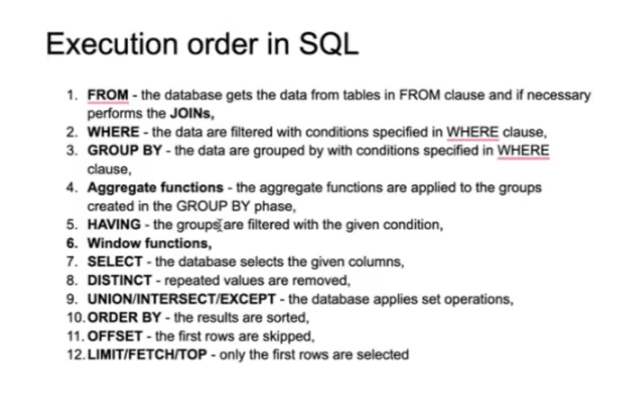

Miscellaneous

* Want to show all column expect one column, but don’t want to type all columns manually.

*SELECT*

*\*,*

*EXCEPT columnNameToExclude*

*FROM*

*yourTableName;*

* + DDL: Create, Drop, Alter, Truncate
  + DML: Insert, update, delete, call
  + TCL: Commit, roll back, savepoint
  + DQL: Select
  + DCL: Grant, Revoke.